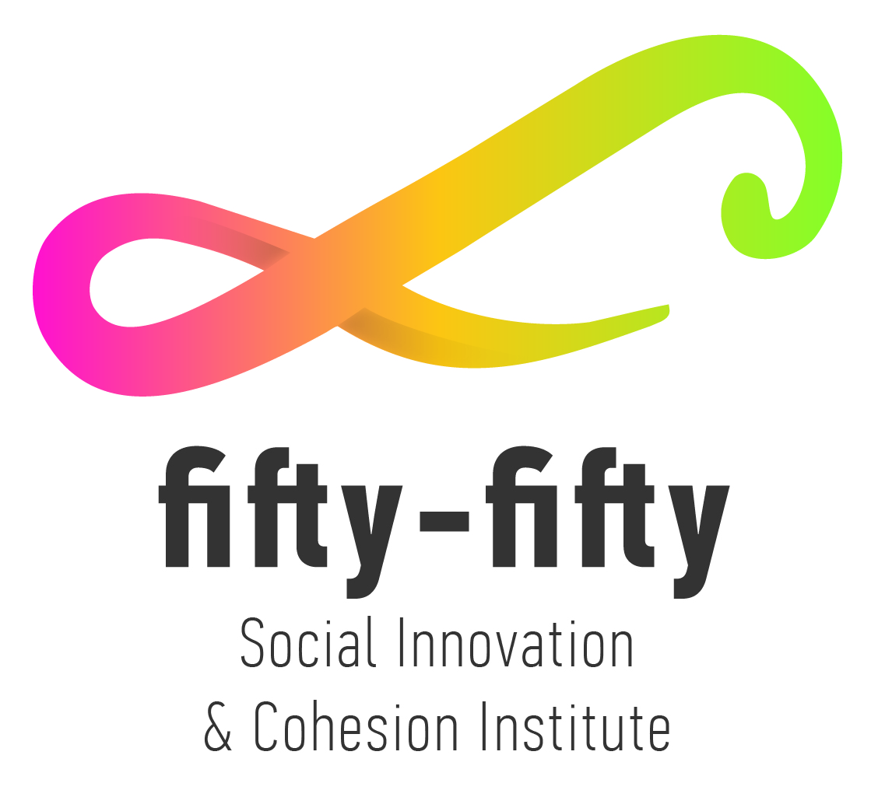
EUROPE FOR CITIZENS PROGRAMME 2014-2020
Networks of Towns

Project Title: “Forwarding Democratic EU Participation - FORCEP”
Project duration: 24 months
Project Budget: approx. 150.000 euros
Deadline: 03 September 2018 12.00h (CET)

Summary
This project seeks to foster European citizenship and to improve conditions for civic and democratic participation at Union level. This can be achieved by developing a network of municipalities and strengthening the e-democracy process through e-consultation and e-initiative to make citizens' understand the Union policy making-process and promote opportunities for societal engagement of a specific target group: the long-term unemployed, the group that is gravely affected by the social exclusion.
The project aims to establish a network of towns that have to cope with a common target: to get their unemployed citizens involved in the Union making process with the aim of reducing social exclusion by European legislation and policies.
The activity plan has six key steps to deliver the project's needs and objectives:
- Kick-off meeting
- 5 interregional meetings
- 5 meetings one in each country
- Group information sessions
- 1 European conference
The objectives of the project are:
- to raise citizens’ awareness about employment and unemployment rights and obligations
- to give citizens the opportunity to raise their voice on issues they are interested in
- to increase the level of active citizenship and consequently build social conscience for democratic participation both in a local and European level
- to provide to citizens the opportunity to develop their competences on tackling personal problems such as lack of education
- to promote active participation of all citizens in the Balkan as well as in the European area in the development of policies that concern them
- to support the EU to achieve the overall EU targets on the subject of the social exclusion through the e-democracy process
Partnership
LEGAL STATUS: ALL applicants/partners must be either PUBLIC BODIES or NON PROFT ORGANISATIONS with legal personality
All Project Partners must have a PIC Number
APPLICANTS/PARTNERS can be:
- Towns/Municipalities
- Town Twinning committees/networks
- Other levels of local/regional authorities
- Federations/associations of local authorities
- Non-profit organizations representing local authorities
- Non – profit civil society organisations

Contact person: Exarhopoulou Vicky
vicky@fifty-fifty.gr

