Infopack:
2019

We are opening our yearly EVS project with public libraries. Six public libraries established in cities and small towns of Lithuania is hosting EVS volunteers from European Countries.

Deineta has been closely working with some of the best public libraries in Lithuania and over the course of the last few years we`ve managed to successfully implement a few EVS projects together. This time we are shifting our common focus towards to the new and innovative services that public libraries provide for the local communities as this is an excellent area for EVS volunteers to help and learn. With this project we aim to suggest opportunities to find new perceptions into own cultural identity also suggest opportunity to get new skills by using innovative environment with educative activities.

The scope of tasks proposed to volunteers includes:

- Programs for children: educational workshops, games, creative activities, funny readings, basic English lessons, etc.
- Cultural events for library visitors and local community.
- Organization of projects for youth.
- Variety of activities with the elderly (arts, sports, self-expression tasks, etc.).
- Daily library tasks: maintenance of publications’ fund, client service.
- Possibility to work with teenagers: creative workshops, basic English lessons, cinema club, making films, clips, young photographer’s club, robotic clubs, etc.
- Possibility to work with adults: basic English club, discussion’s club.
- Possibility to work with seniors: computer courses in bigger groups or eye-to-eye.

Project activities will start on 2019 September 1`th and end in 2020 June 30`th.

If you are interested to participate as partner in this project and prepare EVS volunteers to send to Lithuania you are welcome to contact us for more information:

Jaunimo savanoriškos veiklos centras “Deineta”
Savanorių pr. 16-7, 44253 Kaunas, Lithuania
Tel.: +37037204055; +37061678461
migle@deineta.lt; www.deineta.lt;
www.facebook.com/deineta


Some information about the libraries:

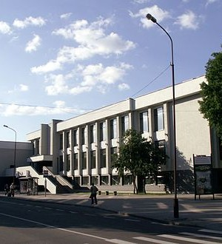
Siauliai Povilo Visinskio public library
http://www.savb.lt/lt/

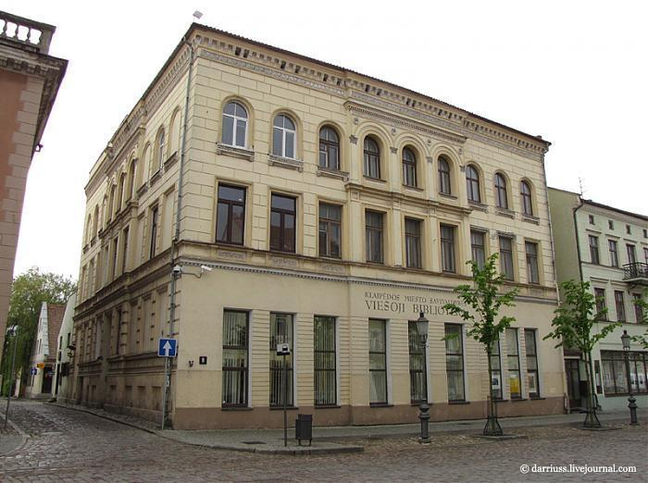
Klaipeda municipality public library
http://www.biblioteka.lt/lt/
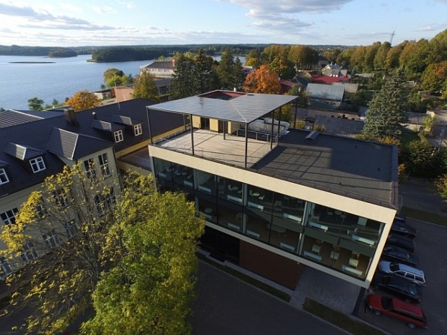
Zarasai region public library
http://www.zarasubiblioteka.lt/lt/
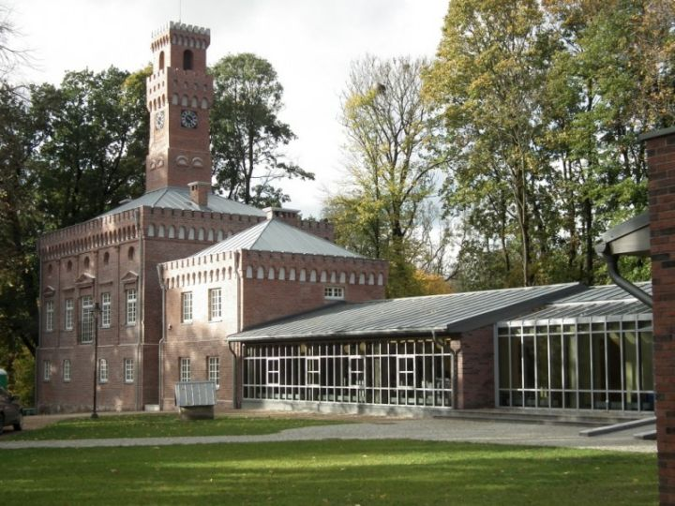
Plunge region public library
http://www.plunge.rvb.lt/lt/
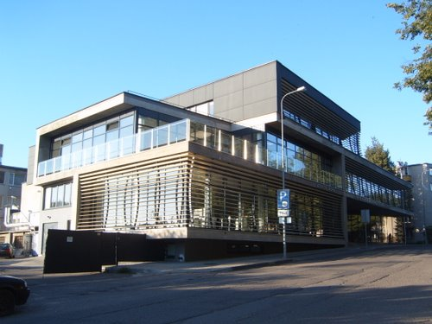
Utena region public library
http://www.uvb.lt/lt/

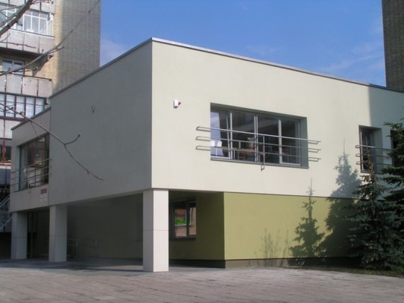

Šiauliai municipality public library:
http://biblioteka.smsvb.lt/lt/

