oLiveWork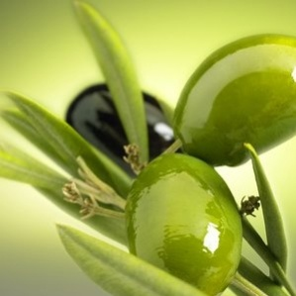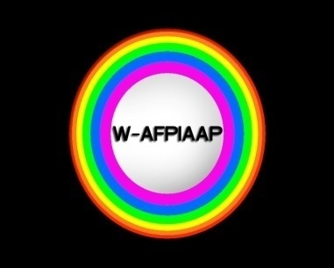
Agricultural Work - Ecological Work - Peace Work - Youth Work - Art Work
@ Nature-Country side
12th october - 22nd of october 2018 - 11 days -- to be applied for april 2018 period...
Mobility of Youth Workers - KA105 @ KUSADASI-AYDIN TURKEY
http://w-afpiaap.blogspot.com.tr/
We as “ WORLDWIDE - ARTISTS FOR PEACE INTERNATIONAL ART ACTION PROJECT “ group in this mobility project we want to make youth workers to get together in the middle of olive harvesting time in Aegean Turkey countryside near to Kuşadası to know all about olive harvesting - olive oil and olive paste making where is a symbol of peace and health.
Demonstration of a brand-design about olive production within artistic creations trough the eternal olive tree and share our experiences in fighting against unemployement of youth within job-creation in ecologic brand-making and peace-making.
a live oLive mobility !
All transport is covered as in EU comission distance budget system with hotel & daily meals.
No age limit. Please reply if you are interested to join please send your organisation's PIF document and wait for mandate forms..
wafpiaap@gmail.com

