Kulturanova

Activity Report

ABOUT US
Kulturanova’s mission is to develop contents of independent culture in order to encourage positive social change and improve the position of creative people in Novi Sad and the region by promoting peaceful co-existance, minorities’ and human rights, including vulnerable groups in it’s projects and advocating that creativity is a tool for economic development and entrepreneurship

Our projects in the previous 3 years were supported by Culture/Creative Europe program of European Commission, Ministry of culture of the Republic of Serbia, Development Agancy of Serbia, The City of Novi Sad, Creative Force program of the Swedish Institute and Fulbright Program by the U.S. government. We have realized 6 major projects and organized dozen of small artistic interventions, meet-ups engaging more than 400 people as direct beneficiaries and about 3000 as indirect beneficiaries. Our main partners in this period were Lava-Dansproduktion (Stockholm, Sweden), Foundry Theatre (New York, USA), Moussem (Brussels, Belgium), Museum of Contemporary art of Vojvodina and Art Academy of Novi Sad.

PROJECTS

Kaleidoscope of Contemporary Culture and Creative Industries - K3CI (2017-2019)
The projects main objective is to strengthen cooperation between contemporary cultural and creative scenes of Hungary and Serbia by enhancing professional competencies, artistic production and transfer of knowledge between 70 young cultural managers & artists.
Through a series of 8 educational, networking and promo-events as Producers’ Forums (2), Artistic Residencies (2), concerts & screenings (4) the projects intends to enforce knowledge within the creative sector, spark artistic collaboration between local scenes, emphasize the role of young women artists and enable greater visibility of cultural products among audiences in the border region, intensifying the feeling of the belonging to a common area. Additionally, improved quality of the cultural production should lead to multiple positive effects on local touristic offer since contemporary exhibitions and festivals represent attractive mixtures of local culture, global trends, identity and hospitality.
Project is supported by IPA Cross-border-cooperation funds of European Commission.

FeeLMS for Creativity (2017-2018)
„FeeLMS for creativity” is a capacity building project involving 5 partner organizations from the Western Balkans and the program countries, gathered around the common partners’ belief that we can bring in truly innovative approach to youth work by combining it with cultural industry and youth entrepreneurship in a fresh way. The objectives of the project will be realized through 2 mobility activities – Capacity building training of youth workers on creativity and entrepreneurship and a seminar, online platform for exchange (LMS) as well as implementation of lessons learned in between those two activities, mentorship process throughout the project, learning and support. The main aim of this project is to empower youth workers active in the cultural field to use creative industries as a mean for socio-economies valorization of youth creativity in order to create new jobs for youth or to ensure sustainability of cultural programs. Project is supported by Erasmus + program of European Commission.
Western Balkans Creative Clash / WBCC (2016-2018)
The project aims at empowering the creative community in the Western Balkans (project partner being from FYRO Macedonia and Montenegro) by bringing together professional artists and business representatives to foster the development of creative industry and introducing them the concept of Artistic Interventions in the Organizations /AIO (as a method developed by organization TILLT from Sweden, our project partner). AIO is a concept of art-based processes in which people, products and/or practices from the art world enter organizations (businesses, public bodies, NGOs) with the aim to support development, focusing on sustainable innovation and change. AIO is one of the most direct ways of stimulating innovative thinking, change of perspective and experimentation – artists are skilled in engaging people's emotions, creativity and senses, and they are trained in creating conceptual objects which can disrupt the established routines, thereby opening space for fresh ways of thinking and acting. Working with artists can help individuals and the groups of which they are part re-assess themselves with new eyes and to question what they do, how they do it, and go beyond the descriptive or informative dimension of dialogue. This method has already given excellent results in countries such as France, Spain, Sweden, Switzerland and the United Kingdom. We would like to implement this method in Serbia as well. Project is supported by Balkan Arts and Culture Fund which is supported by the Government of Switzerland and the European Cultural Foundation, Ministry of culture of the Republic of Serbia, Development Agency of Serbia and City of Novi Sad
The Journey / Drom (2016-2018)
A collaborative work with Roma and non-Roma artists and communities in partnership between organizations from Berlin, Budapest and Novi Sad. We will collect true stories of asylum seekers coming from Novi Sad through Budapest to Berlin and use these stories as material for an artistic collaboration. The project will result in a theater piece which will tour internationally, as well as a printed product (book, etc.) which can be distributed independently of the theater performances. The style and artistic expression the project takes will be decided together with the collaborating Roma and non-Roma artists. It is a production in collaboration with Roma, not about them, and the final say of how the stories are told will stay with them. Project is supported by Robert Bosch Stiftung, International Theatre Institute and Allianz Foundation
ViSet - creating virtual scenographies (2014-2016)
Partner from UK, Spain, Italy and Serbia collaborated on this project to promote cutting-edge digital technologies that can greatly contribute to the performing arts, with the aim to highlight the many social, economic, commercial and cultural benefits that technology can offer to artistic creation. We promoted the use of virtual design in the performing arts, including the use of interactive technology, virtual and augmented reality, and remote control applications.
Our goal was to use these technologies to improve the aesthetics and overall cultural experience, as well as to encourage creativity of artist and cultural workers by creating new technical capabilities, we strived to increase international cooperation and market in the creative sector.
Project supported by Creative Europe / Culture program of European Commission

Taktfest 2014-ongoing
The aim of the festival is to bring, connect and help to affirm the copyright of musical creativity. The right to participate in the festival have both individuals and groups, regardless of their geographic origin, genre of music ... We strive to become a traditional annual event which will be held every year on the first weekend of July.
Project supported by The City of Novi Sad

Archeological bodies, dance and video project (2014-2015)
Project was targeting the position of the Hungarian minorities in the province of Vojvodina in relation to the Serbian majority and is aiming at young people in this region.
At the core of the project were capacity building workshops in the field of movement, video and text production. The project took place in 4 stages during 18 months. At the end of the last session in September 2015 we created and an installation/exhibition with movement, video and text material for a wider audience. The artistic project was directed by Sybrig Dokter and Nadja Voorham.
We were looking at the physicality of living in a conflict area or situation and how the lived situation manifests in the body and physical strategies while navigating the public space; the body as an archaeological site.
The project is done in cooperation with Lava-Dansproduktion (Stockholm, Sweden) and supported by the Creative Force program of the Swedish Institute.

EXCEPT (Exchange of Community Based Cultural Practices) (2013-2015)
This two-years project involved 6 countries (Germany, France, Italy, Poland, Serbia and Hungary) with an aim to fortificate tradition of social theatre in Europe including the Balkan, by several interwoven threads of knowledge-transfer between NGOs involved in social-arts activities. We are to construct shared knowledge through common creative work in new “vehicles” capable to move underprivileged youngsters and their communities from hopeless, idle states towards positive, initiative manners of being. We are going to apply the same methodology of with the artists crew, as with the target communities: common creation - the most efficient way of learning and human development. EXCEPT is about unifying various competences that social arts may require and sharing them. We are willing to achieve this in many different ways: by learning from each other, by teaching other partners, by co-producing social theatrical performances, by the application of common knowledge in real settings, work with groups of youngsters and to facilitate the multiplied level mobility of artists, participants and performances, making a film and organizing a conference about the findings of the project.
Project supported by Culture (2007-2013) program of European Commission

Open house, the play (2013)
OPEN HOUSE is an open source theater, performed in your home. The source code is a play called Open House. OPEN HOUSE is a play written by Aaron Landsman, commissioned and produced by the Foundry Theatre in 2008, in 24 New York City apartments. The piece is made through researching the way cities are changing throughout the world, from industrial, economic, political and cultural viewpoints. Many of us, in many places, were experiencing the same kinds of turbo-gentrification and displacement, as well as incredibly localized bright spots, where communities began to control their own futures. This play was adapted for Novi Sad and Serbia and was successfully played in several homes during November and December 2013.
Cast: Višnja Obradović, Dániel Huszta and Jelena Galović.
Project supported by Fulbright

Papergirl NOVI SAD (2013-2014)
Papergirl is a community street art project originating in Berlin in 2006,^{[1]} which is now produced in cities worldwide. Art is collected from the local creative community, exhibited, and then, in the style of American paperboys , rolled up and distributed by bicycle in city centres, to random passers-by. The project was started in response to it being a criminal offense to post art in public places within Berlin. As placarding is an integral part of urban art, local artist Aisha Ronniger conceived an alternative way of sharing art in public spaces, without focusing on any particular target demographic. Hence Papergirl was founded whereby works of art are handed directly to the general public at random, similar to how newspapers were distributed in decades past.
Kulturanova organized for a second time and we collected more than 150 art works
Project supported by The City of Novi Sad

Moussem.eu (2012-2013)
The project moussem.eu 2012-13 starts as a coordinator an intercultural dialogue on a European scale with the Flemish nomadic art centre Moussem (BE), and with co-organisers as the Centre Choréographique National de Caen/Basse-Normandie/Compagnie Fattoumi-Lamoureux (FR), the Liverpool Arabic Arts Festival (GB), Re :Orient (SE) and the Association Kulturanova (RS) and the Bluecoat Liverpool as additional associated partner.
Moussem.eu 2012-13 seeks to expand trans-national mobility of art(ists) and intercultural dialogue by developing a common identity without frontiers focusing on new and old migratory flows. The enlargement of the European Union, coupled with increasing mobility linked to the common market, new and old migratory flows, the new trade ties with the rest of the world, the education, leisure and globalization in general, have led to increased contacts between cultures, religions, ethnic groups and languages. Within this framework, the development of intercultural skills and the expansion of intercultural dialogue are essential. In this case a European project is needed for a critical reflection on the European canon from the perspective of the presence of European artists with an Arabic background. For this purpose Moussem.eu emphasises on sharing the good practices and experiences to enlarge the intercultural dialogue. First by the development of an artistic practice with European artists with Arabic background who reflect critically today's and yesterday's canons to jointly enlarge the contemporary canon. Second by discussion and preliminary research to promote the introduction, selection and participation of artists with extra-European backgrounds to the regular European art institutions. And this all to empower the different partners and artists in their contemporary European intercultural ambitions. Moussem.eu 2012-13 launches with 4 artistic exchanging productions by artists with Arabic roots, working in the common European space. The productions are proposed by the different partners in different fields of the arts.
Kulturanova participated in sub-project of this project called Waiting: a theatre research project curetted by Mokhallad Rasem (BE). Premiere of this play in Serbia was on 15.06.2013. at 20h in Bitef theatre in Belgrade presenting the works of Kristian Al Droubi, Lotte van den Berg, Yousif Abbas, Gokhan Shapolski Girginol.
We also participated in Colloquium ‘L’Arabe de Service / Do your Arab thing’ on 14th of Octobre 2013 at deBuren, Brussels, where we reflected on the classical Western canon from the perspective of artists with a link to the Arab World living and working in Europe.
Project supported by Culture (2007-2013) program of European Commission

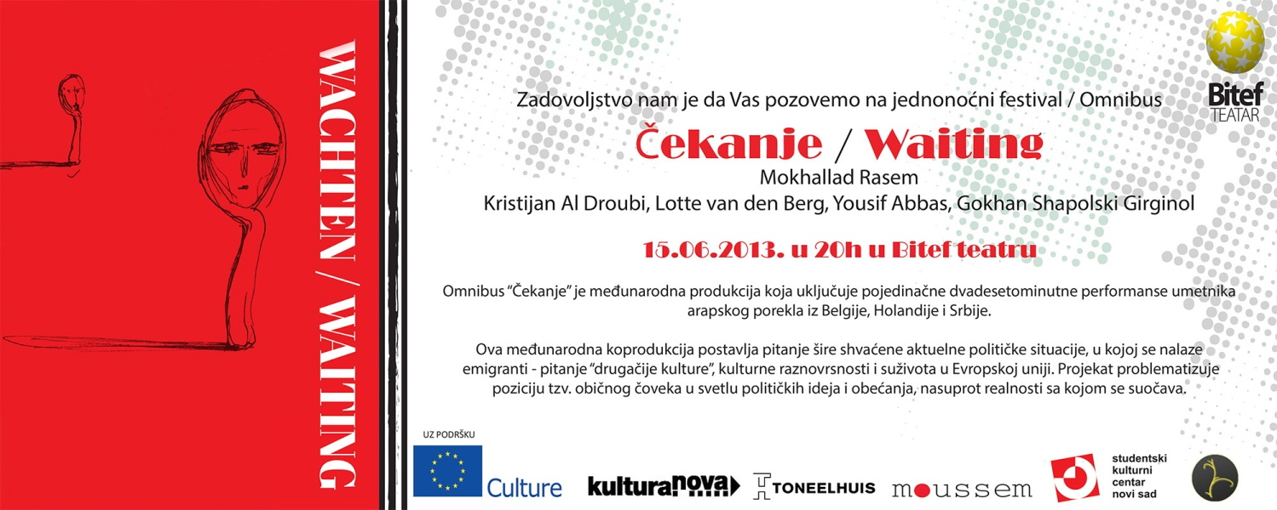

Balcan Can Contemporary (2009 – 2012)
The BCC Project is designed to connect South Eastern Europe's fragmentary performing arts scenes. It draws on existing regional platforms which connect performing artists, creating a solid framework for the development of a unique art scene which intersects national boundaries & institutional forms.
BCC is done in cooperation with CDU | Drugo More | KulturaNova | Maska | Domino | Qendra | tanzelarija | TkH.
http://www.balcancancontemporary.net/
Project was supported by IPA Civil Society Facility program of the European Commision

Revive the castle, site-specific performance, 2012
Interdisciplinary artists, using dance, music, effects of light, sound and video projection, authentic photographs and other art installations, completely changed the interior of the ruined former Hungarian pearl of secession architecture. Visitors had the opportunity to explore the interior of the castle and discover the secrets in each room and become spectators and participants present. Gyula Cserepes (author), Veljko Zejak, sculptor from Belgrade, Časnji Flora Blanca, contemporary dancer from Hungary and Ćerimagić Ibis, a student of the Department of New Media at the Academy of Arts in Novi Sad. Project supported by Ministry of Culture.
http://www.youtube.com/watch?v=5kfh1VG39hk
http://www.youtube.com/watch?v=93iL_EeE7d4
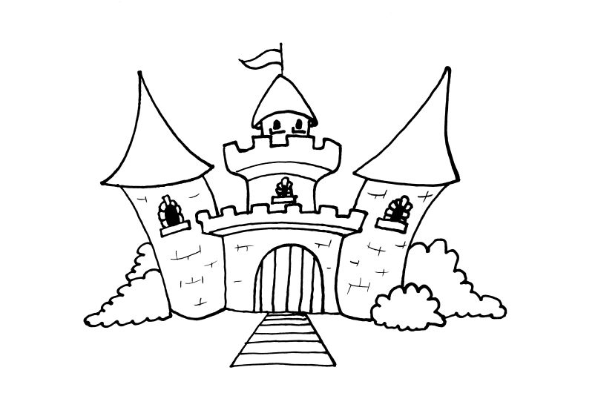

Patriotic Hypermarket, theatre show, 2012
The cultural dialogue between Kosovo and Serbia has perished in the last 20 years. This project aims at exposing our mutual history through personal stories and testimonies of ordinary people, creating a theater play that will present the relations between Albanians and Serbs, their differences and similarities. The project partners believe that, after 10 years of the conflict in Kosovo, the time has come to present the success story of fruitful cooperation between artists from Kosovo and Serbia. Based on the stories of the anonymous interviewees and the exhibition, Milena Bogavac, a dramaturge from Belgrade, and Jeton Neziraj, a dramaturge from Prishtina, collaborated in writing a documentary, post-dramatic text, which Dino Mustafić, a Sarajevo based director, will direct for Belgrade's Bitef Theatre with actors and actresses from Belgrade, Prishtina, Skopje and Tirana. Another interesting aspect of the play is that it will be bilingual, in Serbian and Albanian language, which makes the piece unique and innovative for this region. This theater play was made as a follow up of the project:
This play was a final stage of longer project "Views: Personal histories of Serbs and Albanians" (View from my window). It is a project which aims at enabling Albanians and Serbs to tell their life stories to each other: stories from the past and from the present, always told from a subjective perspective. We believe that a great deal of misunderstanding, distrust and hate between Serbs and Albanian is based on generalized perceptions of the other ethnic group which creates prejudices and keeps them alive. If on the opposite the stories are clearly marked as subjective, it expresses, that a story from one side can be true, even if the other tells a story which is different. In this way both sides are able to accept and listen to the stories of the other. This project is aiming at involving especially young people. Telling these stories and listening to them will be done in two different forms: oral history interviews and a three-national theater play.
http://www.youtube.com/watch?v=1xqOqX_AtWk
http://www.youtube.com/watch?v=PwiaKQf7qDU&feature=related

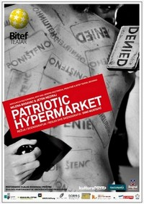

CREDE (2012)
"Creative Democracy Exchange"
10-days, youth exchange which seeks to address three general topics: youth (un)employment, poverty and social exclusion. This project aims to present and explore possibilities for addressing concrete social issues/problems using various methods, primarily performance
Project supported by Youth in action program of European Commission

Gradionica/the whole city is a workshop (2011 – ongoing):
A series of workshops, performances, lectures and an interdisciplinary based research of the open public spaces. Three major interconnected social dimensions of open public space are political, economic and cultural dimension. Here we focus on political and cultural dimension. This project's intention is to make a physical intervention in the open public space, through performance of modern dance and theater, with site-specific choreographies, and active collaboration of different actors - architects, artists, sociologists, cultural managers. Main objective of this project is to promote the principle of active citizenship, democratic values and encouraging public participation through the active process of (re)inventing, (re)claiming and (re)mapping of the open public spaces in the city of Novi Sad. So far we worked with Sybrig Dokter from Sweden (supported by Swedish Institute/ Creative Force Western Balkans 2011 and performed in Fabrika/SKCNS), Sara Ostertag from Austria (supported by Austrian Cultural Forum and performed at the main railway station in Novi Sad), Andreas Liebman from Switzerland (supported by Pro Helvetia and performed in one abandoned, former bicycle shop in centre of Novi Sad). “Revolution is my favorite game” - The idea of performance was to observe the rules of action in a public space, and then through the game and disruption change usual paths . Performed by a group of young people (dancers, architects, actors, etc..) Led by choreographer Sara Ostertag (Austria) and Marcel Grissmera (Germany). “House: Bricks vs. Suitcase” - in cooperation with the Student Cultural Centre and dance productions LAVA of Sweden, led by by choreographer Sybrig Dokter (Sweden) and “Eat the City” by Andreas Liebmann - Aim of this performance was to point to the problem of the use of public space in the city and to offer models for revitalization of public space through cultural/ site-specific events.
http://www.youtube.com/watch?v=pPU6xAzIXME

Hidden Sessions,performance 2007 - 2012
Streamline project is based on the fluid and horizontal approach to creative processes, on the exploration of spectators-performers relation and on the questioning of conventions and protocols of both creation and perception of the performative event. Streamline devises a series of changeable performance-events (Hidden Sessions) created live at each presentation and realized in collaboration with experienced artists from the field of contemporary dance, theater, performance, contemporary music, sound design and video art. The interaction among artists amplifies the reciprocal inputs, multiplying them through frequencies and resonances that transpierce different languages, exploring and pushing forward the limits of their possible relations. The events are both the instant autobiography of each participating artist and the performative documentary in real time about the creation of the event itself. The artists exposes themselves not only as performers but also as real persons, linking tightly their professional role with their every-day personality, they appear simultaneously as the material and the content of the work. Overlapping of the real body(s) and the imaginary body(s) makes performers move across the territories of an unstable, hybrid identity.streamlineproject.blogspot.com Producer YANVII (Cesena); in coproduction with Kulturanova (Novi Sad), in cooperation with Museum of Contemporary art of Vojvodina and Art Academy of Novi Sad.
Producent YANVII (Cesena, Italy); in coproduction with: Kulturanova (Novi Sad), in cooperation with Museum of Contemporary Art of Vojvodina and Art Academy, Novi Sad.
streamlineproject.blogspot.com

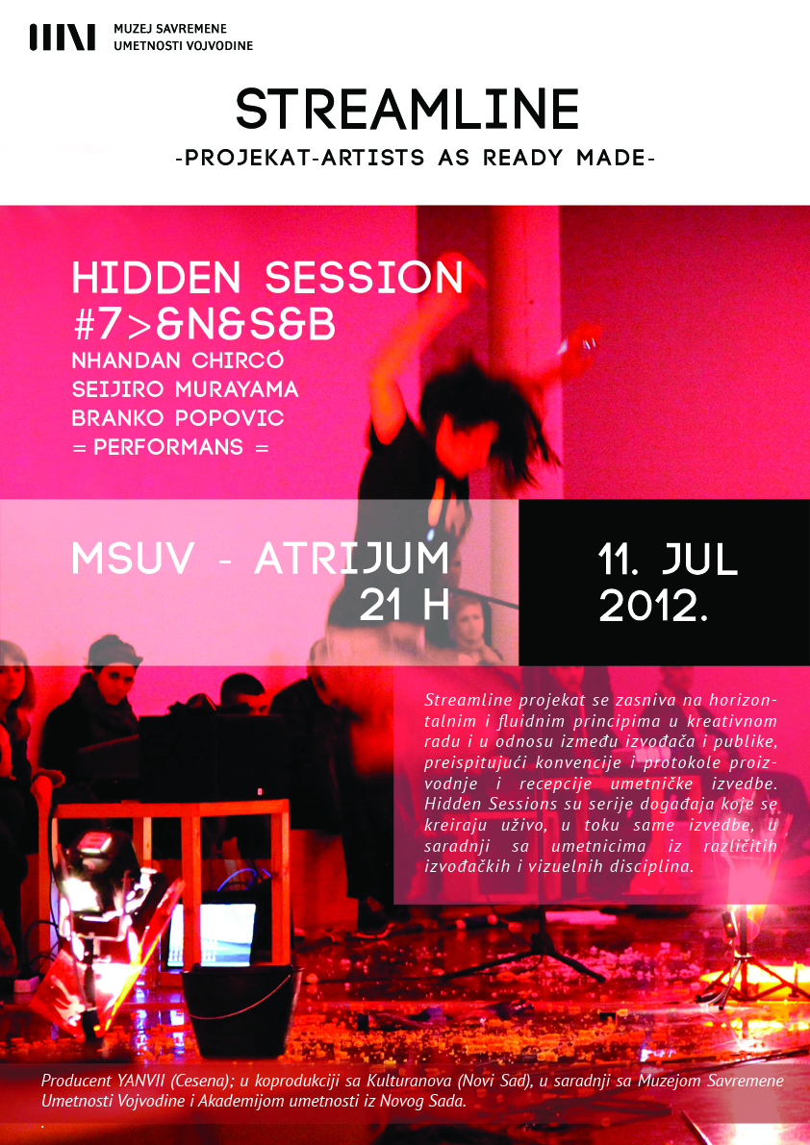

Some of the previous projects by Kulturanova

-Quanta, perfromans, 2009
"Quanta" is the further step of research that started with "Mislim Reku" performance on the same concept with an international team of artists, with the participation of the Slovenian dancer and choreographer Mala Kline, of the Serbian performing artist Branko Popovic and with the collaboration of Serbian electronic musicians Milan Aleksić and Igor Lečić. The performance "Quanta"deals with the movement and breath stream, its waves and vibrations in the female-performer's bodies, and it deals with the flow of conscience, stream of images, sensations and movements. Choreography and scenic languages are challenged by a non-theatrical approach to the performers "presence" in which the aim is a self exploration, a freedom - the freedom also of accepting limitations – comprehending the whole span of possible manifestations, from the daily gestures to the attempt of conquering an utopist integrated body, non representative, un-educated, un-divided

A3.Format: A3:ID typographic issue, Vol:4 (2009)
We stand before you once again with a low-budget issue, a publication that came to life as the result of competition called “Ideology of Design” for the fourth publication thematically marked ‘typographical issues’. This compilation of works presents specific modified fonts, hand-written typographies, experimental illustrated letters, modular fonts and so on. We have shown a unique display of typographical tendencies of a number of younger-generation artists from ex Yugoslavia. The requirement was simple this time, one color - the black. Artists: Dušan Đorđević, Rajko Ivanišević, Miladin Miletić, Lina Kovačević, Matija Drozdek, Katarina Šoškic, Ana Kraš, Mihail Mihaylov, Bardhi Haliti, Ian Griffith, Nenad Ponjević, Miodrag Manojlović, Miha Artnak, Žiga Aljaž, Žiga Artnak, Branislav Milošević, Jovan Mikonjić, Milica Pantelić, Željko Lončar, Bratislav Milenković, Marko Gole, Nenad Trifunović, Lazar Bodroža, Jovan Obradović, Mirko Žarković, Marko Rakić, Filip Bojović.

A3.Format: CMYK Wars issue, Vol:3 (2009)
"CMYK Wars” represent the battle of colours and attitudes, different approaches and personal poetics, they are a battle against the budget, and an uncompromisable one. Exploring the subject of “Urban Violence”, we have realized that by these battles, we are winning the war as well, people want to talk about violence, condemn it, and together we manage to make ourselves visible. For the very hardship we went through in order to print in full color specter, we have called this issue a "war" issue. The war has been won, authors are more than thrilled, the print office even more. And all this in the year of crisis, recession, allowed than withdrawn financial support, emotional collapses and growing up together… We have gone through it all: exhibits, presentations, meetings, correspondence with the artists... spending time together which resulted in creating a family :-) Artists: Marko Gole, Katarina Šoškić, Nenad Radojčić, Nenad Ponjević, Nenad Trifunović, Primož Zorko, Ognjen Đurović, Žiga Aljaž, Branislav Milošević, Dušan Đorđević, Lazar Bodroža, Vesna Pešić, Žiga Artnak, Milica Stojšić, Ivan Petruševski, Vladimir Manovski, Rakić Marko i Filip Bojović.

A3.Format: Low-budget issue, Vol:2 (2009)
Basic idea of a design lies in it’s tendency to fit any given budget.The second publication from "Urban Violence” series is proudly marked as "a low budget issue",and consists of a selection of works self-initiatively created by artists in achromatic specter. They were not informed about financial limitations, which allowed us the privilege of avoiding all compromises between the design and the assets. Ideas we encountered put a different shade to our views on this publication. Drama imposed on us by the contemporary politization of art unjustifiably ignores the problem of creativity in its relation to material circumstances. With this publication, we have tried to contribute to the understanding that the lack of money should not be an excuse for the lack of creativity. Finally, we stand before you with an issue that owns its very existence to the fact that we have gone around the budget limitations with this selection, not design. Artists: Bratislav Milenković, Milan Sekiz, Dušan Đorđević, Nenad Trifunović, Branislav Milošević, Žiga Aljaž, Miha Artnak, Milica Pantelić, Nenad Radojčić, Katarina Šoškić, Željko Lončar, Nenad Ponjević, Ana Kraš, Đorđe Jovanović, Ian Griffith, Miroslav Dajč, Vladimir Manovski, Rakić Marko i Filip Bojović.

A3.Format: Urban Violence, Vol:1 (2009)
Violence... violence in the family, school violence, street violence, sports related violence, political violence, visual violence, media violence Internet violence, violence in video games, violence... It is hard to enumerate all the types and shapes of violence. These are just the most common varieties of the same phenomenon which is, unfortunately, a part of the modern society today. We need to speak out publicly about this problem, and try to find the solution, instead of just closing our eyes to this big social issue that is clearly visible in our neighbourhood, street, city and throughout society in general. That is why we've decided to start an awareness campaign against all aspects of violence and start up a series of workshops and exhibitions on the subject closest to our field of activity; visual violence in an urban environment – A3.Format: "Urban Violence". Design has a huge potential to become a reflection and impulse of change throughout popular culture. In it's best form, design can merge the cultural and political views of one society. It can make it more self confident, prevent it from looking backwards and induce the belief in presence. Artists: Bardhi Haliti, Zorana Blagojević, Branislav Milošević, Dragan Marković, Ian Griffith, Žiga Aljaž, Jovan Obradović, Miloš Pušić, Marko Ercegović, Isidora Todorović, Jovan Mikonjić, Žiga Artnak, Vladimir Manovski, Rakić Marko i Filip Bojović.

-Mislim reku / I think river, performans, 2008
Site-specific study for a dance performance. An inner and an outer voice echoing along the urban sections of the river. Lines conceived in the intimacy of a poet's room. Stranger's gaze sliding across the water as he passes by. The river. A flow of images. A being to live with for a lifetime. A coagulum of our past and present bleeds. A substance that fuels the e-motions. A mental space overflowed with symbols in dreams. A bridge between the near bank and the far bank, familiar side and strange side, known front and unknown front. Being both the riverbed and the river-flow. Looking at once from the bank and from the boat. Dancing the river's dangerous playfulness. Based on fragments of the book "Miroslav Mandić" by Miroslav Mandić, and fragments from the text "The freedom bridge - out and about in Novi Sad" by Horst Widmer (Austria).

FLOW - Festival of conversation between culture and science (2008)
In April/May 2008. in collaboration with Austrian ministry of foreign affairs and "Art Council" from Vienna, organised the first "Flow - festival of Conversation for Culture and Science" in Novi Sad which was announced and open by the Austrian Minister for foreign affairs Ursula Plasnik.

INTRO FEST (2008)
26. and 27 April 2008. We organized the first Intro Fest and hosted over 20 artists from country and region. Throughout the festival we presented some of the most interesting bands from the region and several films about music scene of several towns in Vojvodina, as well.

Urban Challenge (2007)
Urban Challenge was a part of a "All different all equal" Campaign of the Council of Europe with main aims of promoting differences, tolerance and equal opportunities. Regarding the fact that Serbia took presidental chair in European Commision in May 2007. – activities of that Campaign was intensified. We have organized international contest in graffity painting and breakdance.

-Second Life Project, performans, 2007
Project 'Second life' is an international artistic project with educational dimension run by performing arts groups in collaboration with cultural institutions in Kosovo, Serbia and Slovenia. This project, based on a contemporary drama and it's interaction with virtual world, (especially Second Life, abbreviated as SL) aims to examine the issues like alienated communication, "internal migration" among the people in the region and our notion about "the others"

-Urban art spaces/ Let's make spaces for art (research, seminar and workshops), 2006
Project had idea to explore, compare, and promote the use unconventional space for cultural events. The project consisted of research, a series of seminars and workshops that led to the production of an event in one of the abandoned spaces in Novi Sad (specifically the old Turkish bath, in which we have yet made a series of successful actions). Products of this work were placed on a Web site where you will experience the unconventional use of space will be available to all, which will hopefully lead to further exchange of experiences. Project partners were ARCI (Rome), Youth Cultural Center Abrašević (Mostar) and Kulturanova (Novi Sad).

Art and Activism Caravan (2006)
The AA Caravan is a border crossing project that was travelling from Greece (early June 2006) via Macedonia, Albania, Montenegro, Serbia, Bosnia Herzegovina and Hungary to the annual activist environmentalist gathering Ecotopia in Slovakia (August 6th). The main aim of the project was to support and connect local youth groups, their actions and campaigns with the power of Activist Art. The Caravan artists/trainers are specialized in different fields of art like video shooting & editing, creative writing, music and dance, sculpturing, street theater, drawing and painting. They visited host activist/youth groups for a week and gave workshops together with local artists. In Novi Sad, Caravan members were accomodated on an old Ukranian cruise ship in the Denube, where workshops took place too. The Mischief Makers build a giant bird as a symbolic way of opening up Serb borders and made an impressive mosaic on the same theme, possibly to be used in a new youth centre. Clowns trained and joked about at the final parade to end the week of workshops. An other impressive feature of the activities in Novi Sad was the quickly formed samba band, which did a couple of stunning performances in the centre of town. The video group made 3 videos and did several open air screenings. At the end of the first week a demonstration was held for the cultural youth centre as well as for the opening up of Serbian borders. During the second week some Caravan members worked at a Roma settlement and prepared a film screening and demonstration, demanding an electricity supply, which the settlement in its 33 year existence has had no access to.
Project supported by European Youth Foundation and Youth Program of European Commision

A different time (Neko drugo vreme) (2006)
"A different time" film, ARTklinika, Novi Sad, 2006. Words from the author Ana Lagator: Film "A different time" represents a timeline about some of the most important places for youth gathering in Novi Sad. It is a story about places that were used by young people to develop their creative side, to learn, exchange knowledge, ideas and socialize. The film covers an important period from the 60s to the mid 90s. How important were "Tribina mladih", "Dvadesetčetvorka" and "Žuta kuća" for the young people of that time and why are these places no longer present?

F.A.C.E. (2005)
“FACE” festival in Novi Sad and Belgrade, August 2005, gathering of 80 young and emerging artists from France, Holland, Bulgaria, Romania, Serbia & Montenegro and Bosnia & Herzegovina. The artists will gather around joint site-specific works of art which would emphasizes the role of a city and reflect their idea of what it means to be a European citizen.

xChanges (2003)
International festival "xChanges", Novi Sad, July 7th & 8th 2003. where we gathered 50 artists from France, Canada through a multidisciplinary and multimedia approach, in an attempt to present marginal forms of creation. The festival presented a summary of contemporary art scene of Novi Sad, but also established links with artists from France and Canada. The project was supported by Provincial Department for Education and Culture and by donations of Metals Bank.

