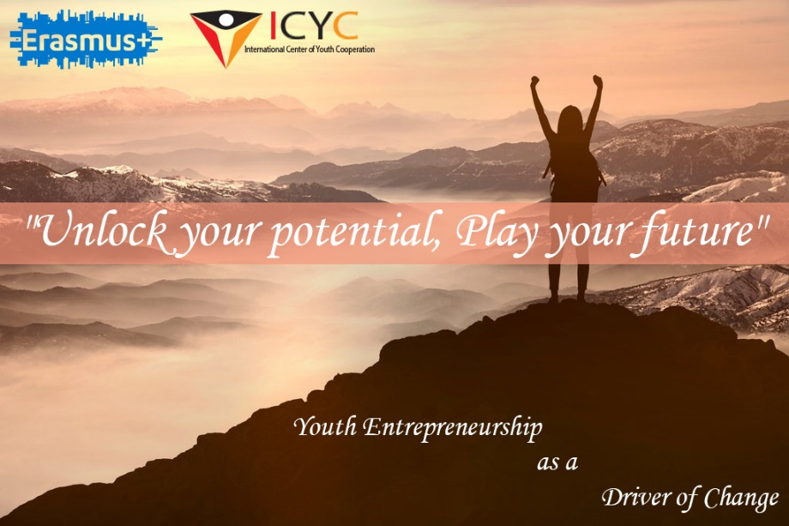
Project Description
Many young people in EU cannot find employment. One-in-five young people in the EU were unemployed in 2011 whilst youth unemployment in countries such as Spain was over 40%. Moreover evidence shows that the unemployed are unhappier, more likely to experience a range of health issues, and face difficulties in integrating back into the labour market place. One potential way of integrating young people into the labour market is to increase youth entrepreneurship. Today Europe needs a new generation of young entrepreneurs who will bring their innovative ideas, create jobs and reduce the level of youth unemployment. Becoming an entrepreneur potentially offers benefits to the young person through deepening their human capital attributes (self-reliance, skill development) and increasing their levels of happiness.
Increase in youth unemployment has serious consequences on the economy because young people are key-resource for economic growth. The youth unemployment represents financial cost to society, as it does not benefit from the acquired knowledge of youth. In case of long-term unemployment, youth are discouraged to even look for a job, which generates psychological impact and loss of professional skills. It also effects on poverty, quality of life, equity and decrease of demand for goods. The social context is particularly important, as certain crises on the individual personality from an early age can cause an increase in the vulnerable
That is why the development of youth entrepreneurship is one of the main problems that Europe needs to tackle.
During our cooperation with other european NGOs we have noticed that today many problems in this field are common. The absence or the lack of entrepreneurial education is the foremost problem that prevents young people to become entrepreneurs and to succeed in this field. Universities and schools don’t provide needed knowledge and skills. Extracurricular paid trainings are unfordable and unavailable for many young people with fewer opportunities. That is why most of them who have business ideas don’t know how to make them into a project, write a business plan, understand further steps that they need to do in order to succeed (e.g. market analysis, risk assessment, etc.). According to official statistics, 90 % of startups fail because of the absence of a business plan. For this reason the role of non-governmental organizations are crucial to cover this huge gap, to support young people who have business ideas and willing to become entrepreneurs to improve their skills and competences, which in turn will reduce the level of youth unemployment, promote youth participation in labour market, as well as promote social inclusion and solidarity. This will be also crucial to promote active citizenship and to engage them in economic life.
Objectives of the training are to
- raise awareness of young people about the importance and the role of entrepreneurship in community development,
- raise awareness of participants on social entrepreneurship,
- build a necessary set of competences for proficient use of non-formal education instruments and tools for youth empowerment at the local level;
- empower young people with knowledge and skills on business plan writing,
- equip the participants with the innovative tools and methods of project management,
- develop participants time management and self management skills
- pass to participants the methods of self-motivation,
- to work on personal and professional development in order to improve their and others’ employability prospects;
- provide participants platforms of discussions and exchanges of ideas,

Icyc.ngo@gmail.com

