A Seller’s Journey | - 1-10 July  - •  - Romania
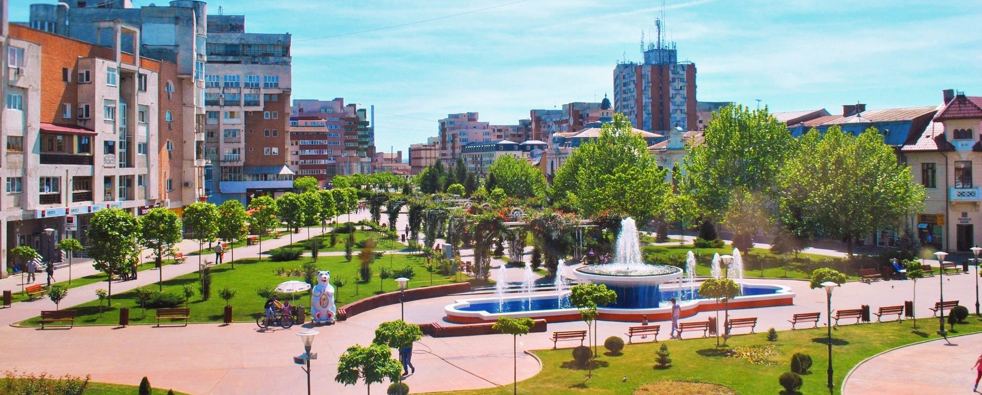  Scout Society  Our organisation aims to develop youths on physical, social, intelectual and spiritual areas using non-formal education methods.  We implemented more than 8 projects till now and participated in more de 20 projects.  We inolved 2000+ youths from Romania and 350+ youths from different countries in our projects in partnership with Croatia, Bulgaria, Slovenia, Poland, Lithuania, Spain, Turkey, Czech Republic, Hungary, Italy, Portugal, Greece, Latvia, Cyprus, Germany.  This Project Aims  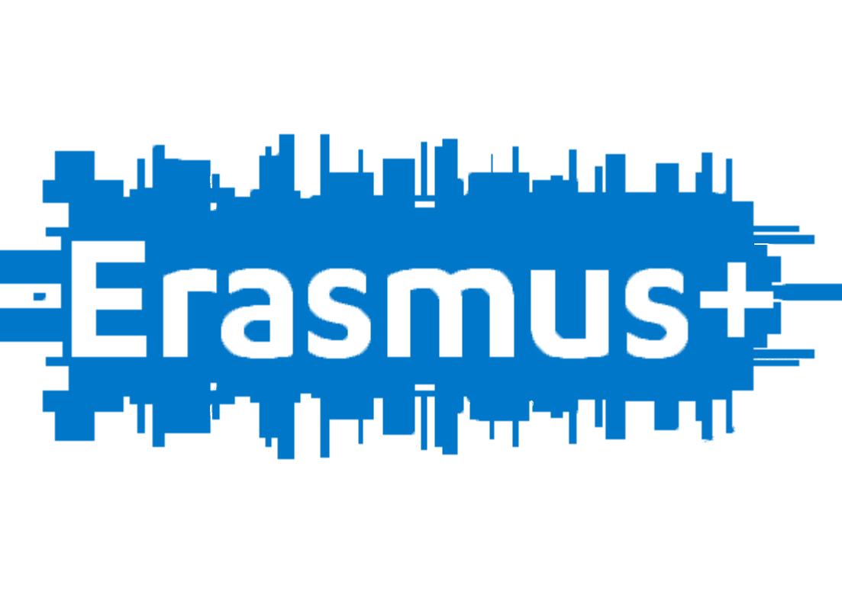  To increase employability level of 40 people (7 participants and 1 leader) from 5 countries and to sustain career orientation process and to promote tolerance and social inclusion toward others. | 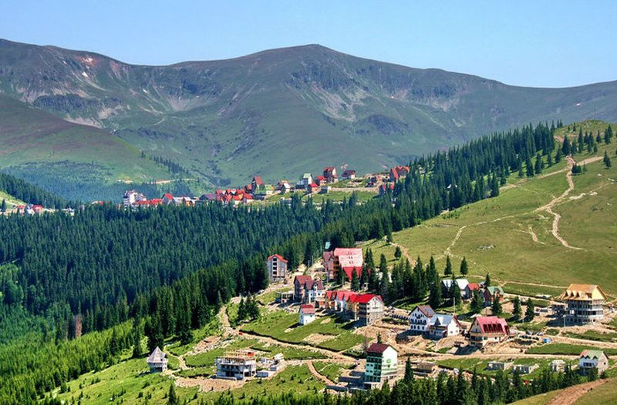  Contact  Rotaru Radu – Trainer  rotaruradu95@gmail.com  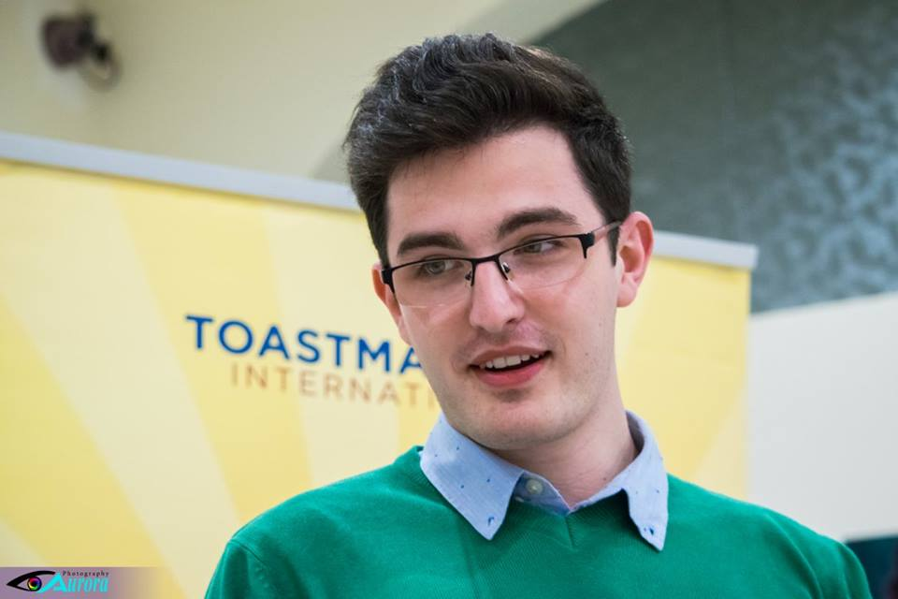  Sfirlogea Ciprian – Founder  ciprian.sfirlogea@scout.ro  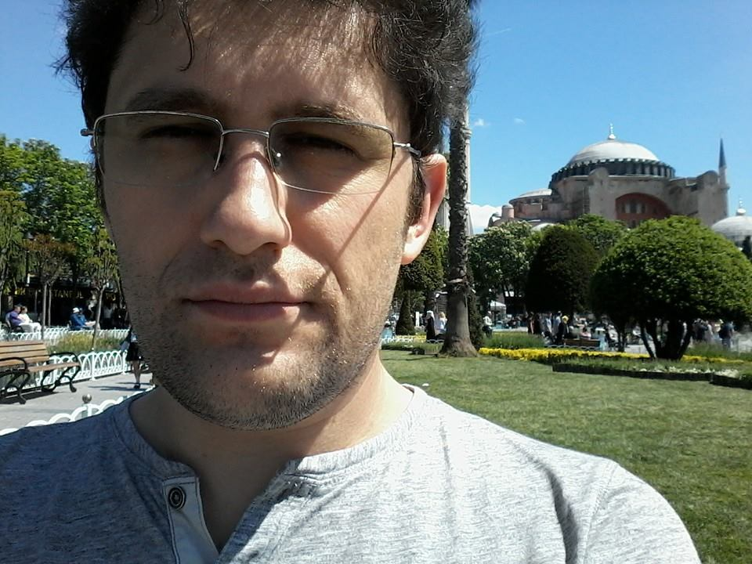

Expectations

We want 4 trustworthy partners with background and experience in vocational training, entrepreneurship, career orientation, employability, tolerance and social inclusion and with interest in this subject.
We expect to send us a portofolio of activity that can prove you have the experience and expertize we require, to get involved in preparing some task like a short presentation about educational and development opportunities form your country, to prepare a selection form for paticipants using a model that we created (google form), to select a group formed from 7 participants and 1 leader, to respect deadlines for skype meetings, e-mails.

Activities&Programme

We planned an attractive and usefull programme that involves debates, workshop on history of money, barter simulation, visit on vintage market, selling&negotiation techniques, vocational training, social games, sport activities, intercultural nights and so on.

