PIC number:
945650188

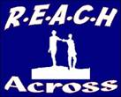 | R.E.A.C.H ACROSS  Residentials, Educational Activities, Community Holidays  10-14 Bishop Street, L’Derry, BT48 6PW  Tel.No. (028) 71 280048 Mobile No. 07854833371  www.reach-across.co.uk reach_across@hotmail.com  Registered Charity No. XR 11455

REACH ACROSS PROFILE INFORMATION

1) | Name of Partner Organisation and Main Contact for Exchange
- REACH Across
- Barney Mc Guigan ( Project Co-ordinator)
2) | Address of Organisation, Telephone, E-Mail and Website
- REACH Across, 10-14 Bishop Street, Derry, Northern Ireland BT48 6PW

- Tel: 0044 28 71 280048 Mobile: 07854833371

- E-Mail: reach_across@hotmail.com Website: www.reach-across.co.uk
3) | Age Group, Gender and Social Background of Group Members
- Project Age Group: 15 – 17 years Gender: Male and Female
- 12 young people per group. 6 male and 6 female if possible.
- 1 male and 1 female leader for each group.
- REACH Across Members are from towns in the North-West region of N. Ireland. Some members are from areas of low income and high unemployment.
4) | 3 Main Aims of REACH Across
- To create friendships between young Catholics and Protestants
- To provide opportunities for young people to gain new qualifications and
take part in training courses that will benefit their futures
- To provide international opportunities for young people that will increase
awareness of cultures, social conditions, youth matters etc in Europe
5) | a) Preferred Dates and Number of Days for Exchange  b) Possible Dates for Advance Visit
- Exchange –Stage 1 - Derry, N. Ireland (July) Stage 2- Partner Country (Aug)
Each stage should have a 10 day programme

- Advance Visits - Advance Visits in May or June
6) | Accommodation and Facilities To Be Used During Hosting Stage of Exchange
 | Our Partner Group will stay in fully-equipped apartments at our local University and the facilities will include a gymnasium, sports areas, laundry etc
7) | List of Activities, Workshops, Visits etc Proposed For Exchange
a) Drama b) Art & Craft session c) Water Activities/Swimming d) Various Sports
e) Cultural Learning f) Laser Quest g) Historical Visits h) Ice Skating
i) Visit N. Ireland Parliament j) Meet the Mayor of Derry k) Mini Olympics

8 | Currency And Additional Money Advice
- N. Ireland uses British Pounds. The Republic of Ireland uses the Euro.
- There are many banks and ATMs
- REACH Across will cover costs of food, accommodation, transport and activities during the local stage.
- In N. Ireland, REACH Across will be responsible for all costs relating to accommodation, activities, food and transport
9) | Types of Transport To Be Used During Exchange
 | - REACH Across will collect the partner group from the airport. During your visit we will use a minibus and large buses.
10) | Preferred Food Types of REACH Across Group
 | REACH Across members like pizza, curry, pasta, burgers, potatoes, chips, sandwiches (tuna, ham, salad etc), chicken, lasagna
 | Any Other Helpful Information
11) | - During the Advance Visits, representatives should visit the planned accommodation, meet selected young people and discuss food, activities, transport and workshops  - When participants are selected we can start a Facebook page to help with planning and group introductions  - During the exchange we will make a DVD of the activities  - Your group will have one free day so that you can relax at the accommodation,  go shopping, go on a tour of Derry or play sports
 | Previous International Projects
1) 1999 Germany
2) 2001 Sweden
3) 2002 Portugal, Sweden
4) 2003 Poland, Belgium
5) 2004 Denmark, Estonia
6) 2005 Romania,
7) 2006 Romania, Bulgaria
8) 2007 Romania, Bulgaria
9) 2013 Croatia, Lithuania
10) 2014 Bulgaria
11) 2015 Italy
12) 2016 Romania
13) 2017 Cyprus

DERRY CITY, N. IRELAND

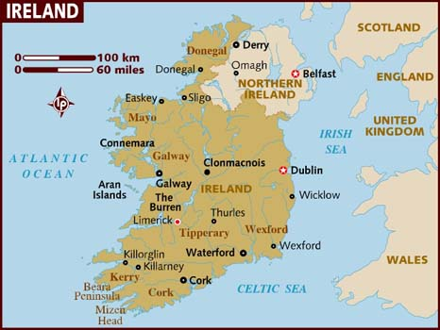
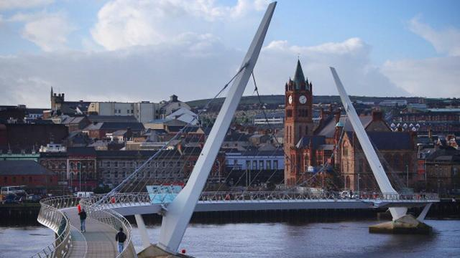

MAGEE UNIVERSITY STUDENT VILLAGE
SPORTS AREA AND ACCOMMODATION

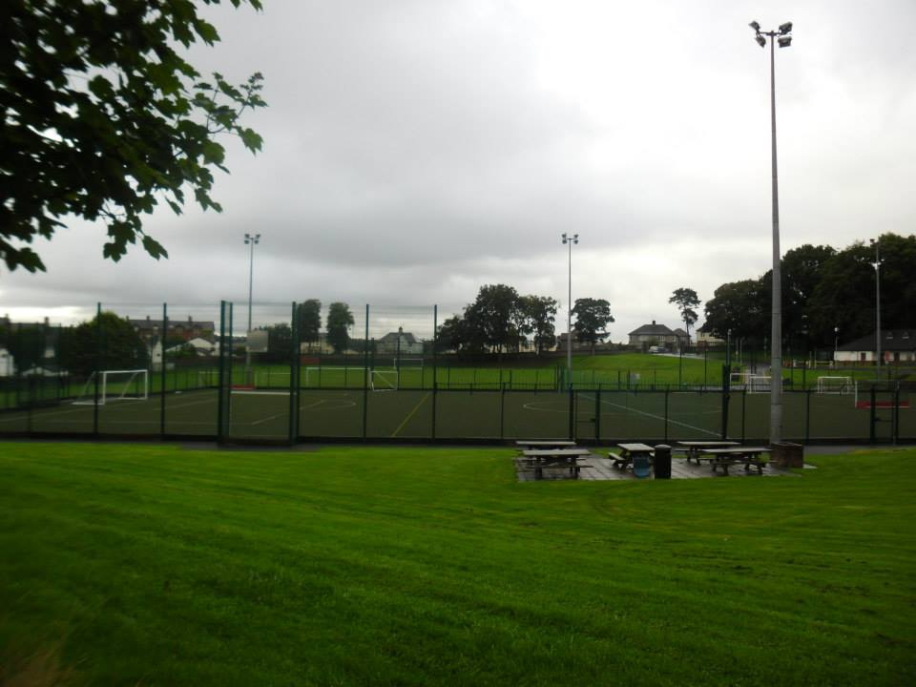
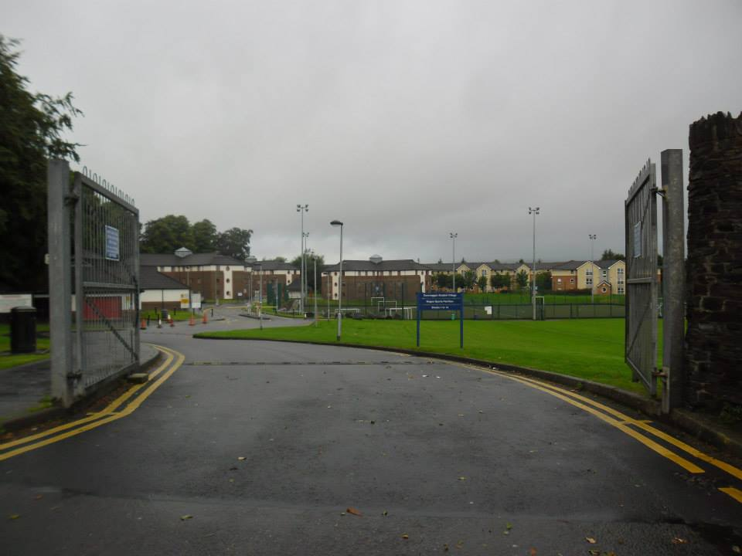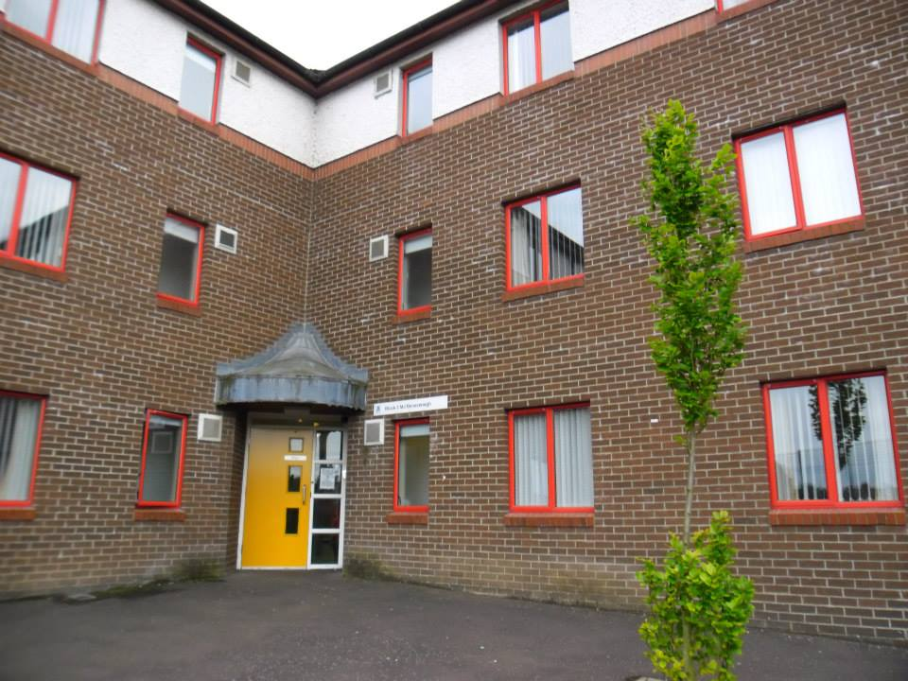

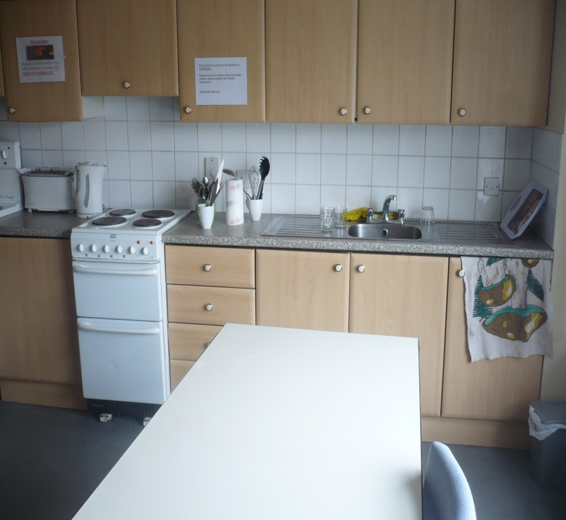
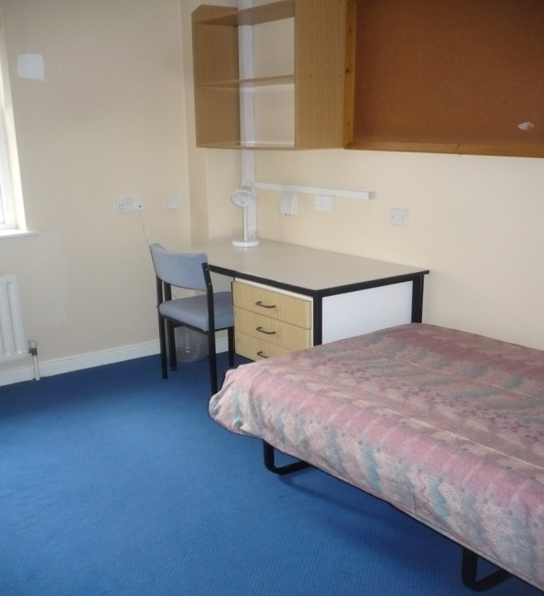

DERRY PROGRAMME: Romania Exchange - July 2016
DATE | A.M | P.M | EVENING | DETAILS
Tue  5th | Romania Group Arrive Belfast Int 2.25pm | Mary Murphy AccommOfficer  Tel: 02871 309960 | 5pm Buffet (@ Bishop St Resid. Asst 07872420107
Wed  6th | 10am Introductions,  Contract &  11am Project Schedule PPT  Noon Basic Language Class | 12.15pm Lunch  1.30 Cultural Treasure Hunt  3pm Peace Bridge  4pm Swimming or Tennis | 7pm JumpLanes& Dinner  71 371999 | 1) JumpLanes Is A Trampoline  Centre
Thr  7th | 9.30am Depart Magee  11.45am Giant’s Causeway  Nat Trust: 332784953 | 1pm Packed Lunch  2.30pm Carrick-A-Rede Bridge  Nat Trust: 332784953 | 4–6pm Ballintoy or Portrush  (Game of Thrones)  9pm International BBQ | 1) Giants Causeway Is A World Heritage Site  2) Ballintoy Is A Film Location For Game Of Thrones
Fri  8th | 10.45 Foyle Search &  Rescue | 1pm Lunch  2pm FabLab (Eamon) | 7pm Different Skins  Divided Past &Shared Future | 1) FabLab Is A Centre That Produces Items From Recycled Materials  2) Different Skins Is A Drumming Project
Sat  9th | 11am Tower Museum  (71 372411)  Tour of Bogside | CLIPPER FESTIVAL | MUSIC CITY | 1) Clipper Is A Yacht Festival
Sun  10th | FREE DAY | FREE DAY or Mini Olympics  4 – 6pm Circus Skills (Guildhall) | 6pm Workshop????
Mon  11th | 9.30am Depart Magee  11.30am PeaceLine Tour | 1.30pm Packed Lunch  2pm Stormont Tour90 521802  3.30pm Laser Quest07828476306  5pm Pizza @ Escaramouche | 8pm European Themes  (Prepare symbols, flags and PPT relating to a Euro country)  Give Each Group A Country Planner – Capital city, Towns , History Fact, Religions, People | 1) PeaceLine Is A Wall That Divides Religions  2) Stormont Is the N. Ireland Parliament  3) Laser Quest Is An Outdoor Activity
Tue  12th | 10am Orange Order Parade  11am Culture Crafts | 1-2pm Mini Olympics (Magee)  4pm Raft Building Session  (Enagh Lough) | 7pm European Theme Night  (Presentation of Countries)  Europe (United or Divided) | 1) Orange Order Is A Cultural Parade  2) Raft-building Is An Outdoor Activity
Wed  13th | 10,30am CLIPPER YACHT  (Laura Cowlishaw) | 2pm Tour of Town Hall  2.30pm Meet Mayor of Derry | 9pm Medal Presentation
Thr 14 | 11am Romanian Group Depart | 2.25pm Belfast Int.

