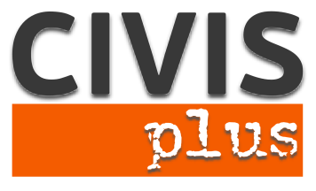

## Call for partners for a Youth Exchange in Athens

**Coordinating organization:** N.G.O. CIVIS PLUS

**Contact person:** Karka Sophia

**Host:** N.G.O. CIVISPLUS [www.civisplus.gr](http://www.civisplus.gr)

Short description of the project

Despite the strained efforts worldwide to combat racism, xenophobia and discrimination these phenomena have been proved particularly resistant and unfortunately, despite the need to be reduced, show increasing trends. It is a general fact that efforts to raise awareness of all and especially young people on these issues and to change attitudes and behaviors should be intensified.

In this context the project aims to inform young people about racism, hate speech and hate crimes, to develop a more positive attitude towards people coming from different countries and cultures, to promote good relations among young people, enable them to recognize inequality, injustice, racism, stereotypes and prejudices and to challenge these mechanisms whenever they face them in society.

Partners: 10

We are looking for 10 organizations that have experience in the field and are motivated to work on the topic.

Duration: 8 days

Project Location: Athens, Greece

Working language: English

## Procedure to apply:

## Please, fill in the partner identification form and send it via e-mail at civis.exchanges@gmail.com

Contact person: **Karka Sofia, Director of EU programs at NGO CIVIS PLUS**

Tel: +30 211 012 14 41

14, Patision(28 Oktovriou) street,

Athens, Greece