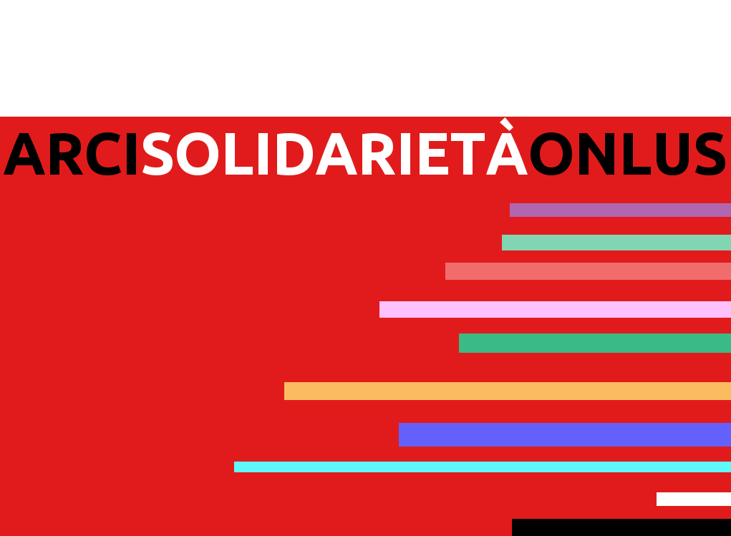

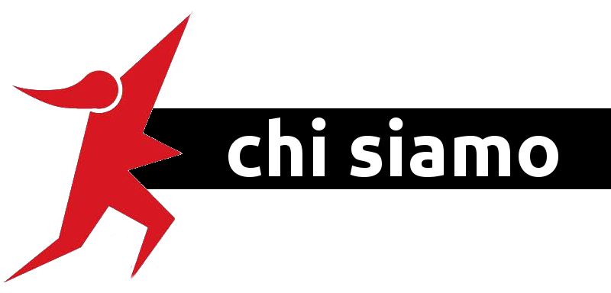

Our organization was born in 1995 in Rome, from the most significant experiences of the social engagement in those years: the Confederazione Arci, Ora d'Aria and Arci Donna. The Confederazoine Arci had started, in 1992 together with Opera Nomadi, the fisrt experimentation of a project supporting the schooling paths of Roma children; this experience will distinguish Arci Soldiarietà from its foundation until 2015, year in which the Municipality of Rome decide to stop the project.
Arci Solidarietà Onlus represents the social part of Arci; our mission is to combat the social exclusion and to promote values as coexistence, inlcusion and extention of the rights for all.

In those 20 years we have realized projects aimed to social promotion, adressed to group of people more fragile of the social fabric, promoting innovative methodologies of intervention.

One of the main guideline of our intervention is the valorization of the surroundings in which we are, favouiring the listening, the surfacing of the needs, the responsibility, turning down colonization approaches and cultural overlapping.
Through our projects, services, collaborations and events, we have adquired a sound experience in the following areas of intervention: Roma and Immigration; Youth and Childhood; Women; Housing and Rights; Culture.

Below some of our projects and services carried out during those years.

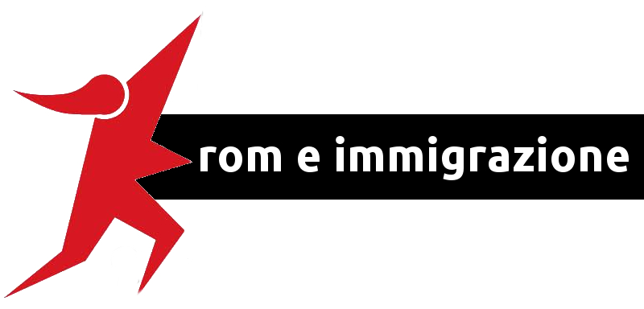

Our work with Roma communities began in the early nineties with the Schooling Project for Roma Children, strongly desired by the founders of the Assosiation, from Opera Nomadi and from the Municipality of Rome.
From its starting in an experimental form, in 1992, to its conclusion in 2015, the project have supported at least two generations of Roma people in dozens of camps, informal settlements and formal camps of Rome.

SCHOOLING PROJECT FOR ROMA CHILDREN
AND ADOLESCENTS

- Promotion of the registration to school
- Support to educational paths
- Support to the inclusion of minors in schools
- Mediation between school and family
- Vocational guidance
- Promotion of extracurricular activities
- Intercultural workshops for classrooms
- Training for teachers
- Contrast to drop-out phenomena

INFO AND HELP DESK IN ROMA CAMPS

- Orientation to social and health services
- Vocational guidance
- Promotion of health campaigns
- Network with public insitutions and NGOs
- Promotion of intercultutural dialogue
- Social and cultural mediation



FSE PROJECTS FOR THIRD COUNTRIES CITIZENS

- O.S.O.: Vocational guidance for 98 citizens of third countries
- Italian Language courses (as second language)

DENTRO I CONFINI
WITHIN THE BORDERS

Vocational training and cultural mediation for 15 Romanian
citizens imprironed in Regina Coeli

Mediation

Itinerant service of Intercultural Mediation for Roma
and migrant people in the city of Rome who are in poverty

VET4ROMA
(European project - LLP)

Building the European CV of the Mediator
working with Roma communities

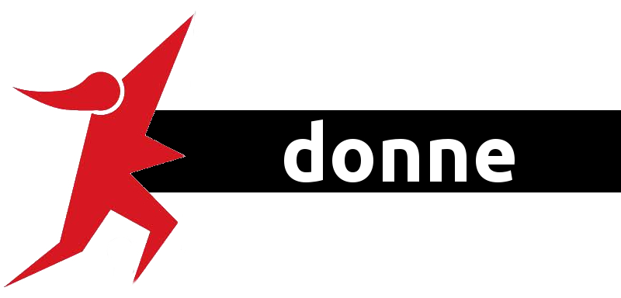

Gender issues are always been at the center of our interventions, starting from the work with Roma and immigrant communities, in which being women represents a double discrimination
Through the schooling project we observed a forward movement of the average marriage age for girls, as well as we helped women to find a job and to enter in the labor market. Thorugh these projects in 2015 was born the “Tavolo delle donne Rom”.
PARLA CON LEI
(Talk to her)

Service of orientation, mediation, vocational guidance,
support to women of the city of Rome

OR.ME

Educational training for 16 Roma women
in the field of health mediation

DONNE AL VOLANTE!
(WOMEN AT THE WHEEL)

Support to the achievement of the driving license

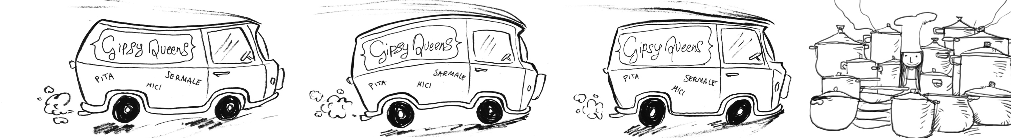

TAVOLO DELLE DONNE ROM

Group or Roma women debating about gender issues
related to the life in camps and to job.
Relationship with insitution
Enpowerment

GIPSY QUEENS

Starting from Tavolo delle Donne Rom was born Gipsy Queens,
A project of self-enterprise developed
by the women of Arci Solidarietà
Onlus and by a group of Roma women.
The Gipsy Queens wants to create a model of social caterer,
promoting the knowledge of the Roma culture
thorugh traditional food.

Link: Parla con Lei; Gipsy Queens

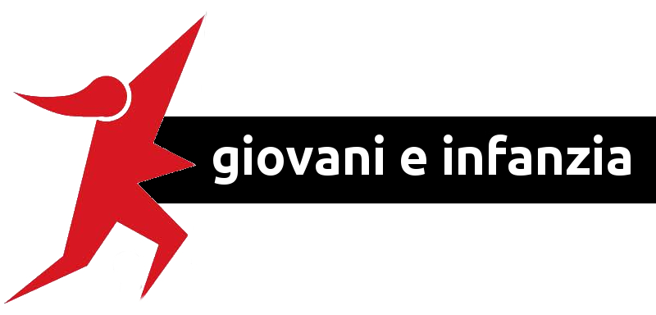

The respect and the application of the UN Convention on the Right od the Child guides our intervention form the beginning. The own Schooling project move from that.
Childhood and adolescence are for us the starting point for building an inclusive, solidaristic society, able to be careful to the needs of everybody.
Education is an inalienable element, as well as one of our founding principle talking about childhood: the rights to leisure time.
NATIONAL CIVIL SERVICE

Arci Solidarietà implements projects of
National Civil Service including volunteers in our projects,
offering them training and updates about issues like
immigration,
work with minors and adolecscents,
social and cultural mediation

YOUTH CENTERS

The Youth Centers are located in two
of the most “difficult”neighborhood of Rome,
Corcviale and Spinaceto,
in collaboration with the Municipalities.
The youth centers are meeting, sharing and leisure
space aimed to contrast the drop-out
and the social exclusion.
The Centers offer support to educational paths,
creative workshops, vocational training and guidance.

INTERCULTURAL PROJECTS IN SCHOOLS

School is the main place in which promote
the culture of respect
and the valorization of the diversity

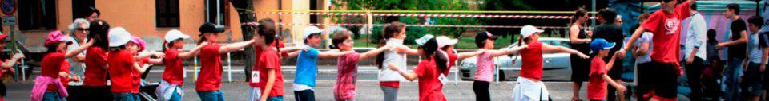

EUROPERAN PROJECTS ADDRESSED TO YOUNG PEOPLE

European partnership in youth exchange and projects of social
Inclusion addressed to young people under 30

- Week of the Rights of the Youth: Erasmus+ project
developed with Spain, Portugal and France
- Webtrotteur in Med: Erasmus+ project; promotion
of media independent journalism in the Mediterranean area
(France, Italy, Lebanon, Marocco, Tunisia
- TRESCA EUROPE: project promoted by Stavros Niarchos
Foundation,
aimed at support the work inclusion of young people
under 25 in Spain, Portugal and Italy

WORKSHOP OF INFORMATION TECHNOLOGY
IN NURSERY SCHOOLS

Funded by Fondazione IBM
that provided two Kidsmart® stations,
PC for children aged between
3 to 5 years old. The stations are used
by the school inclusion of Roma children.
From Kidsmart® borns “Mani in Pixel!”,
Worshop of information technology
for childredn in nursery schools.

Link: Centro di Aggregazione Giovanile “Luogo Comune”.

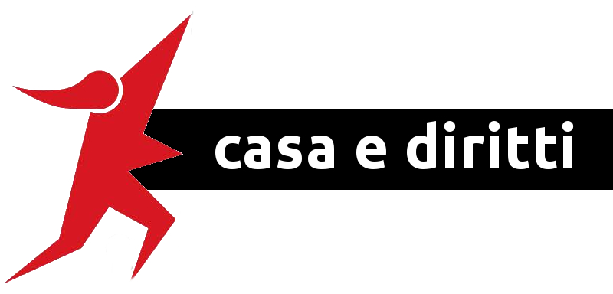

The promotion and the safeguard of the Fundamental Rights goes through the implementation of projects and interventions that distinguish our operation. In this framework develops more our Political dimension, in the simplest sense of the word: everything we do is aimed at protecting the rights of the weakest.
CORVIALE 3D

Promotion of the active aging
through a intergenerational
project between young people
of the youth center
and the elderly
of the neighborhood of Corviale.
Exchange of experiences, knowledge
and competences.
Reconstruction of the story
of the neighborhood.

UN PATTO PER L’INCLUSIONE SOCIALE

In collaboration with the Social Service
of the Municipality of Rome,
Service addressed to people living in poverty
Promotion of the “Bollino Social”,
a register of virtuous companies
hosting training and stage
for the beneficiaries of the project.

AGENZIA DIRITTI
NUOVA CITTADINANZA

Support and mediation related to housing
(combating undeclared rent, legal advice).
In the last years the service
includes activities
related to job, immigration and
active citizenship

PROMOTION OF THE ACTIVE CITIZENSHIP

Together with Roma communities,
migrants, prisoners, temporary employees: our organization
always is in the forefront in the promotion of Rights.

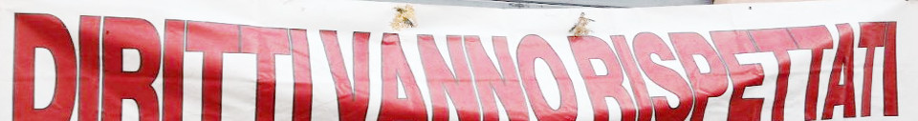
Link: Agenzia Diritti.

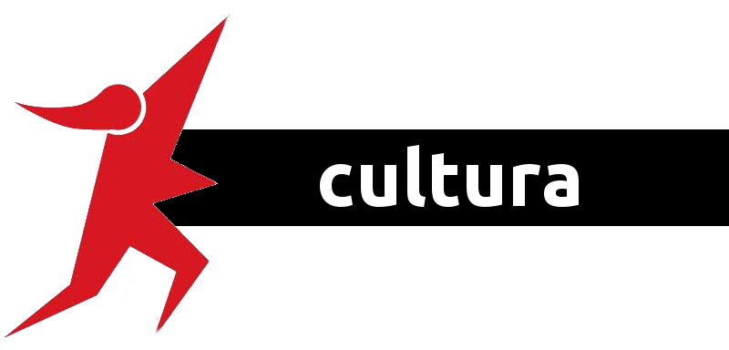

Being part of a national organization as ARCI for us means play our role in the promotion of the culture in the surrounding in which we work. During the years we have promoted, supported and participated to many cultural events, with a special focus of immigration and social exclusion.
PROMOTION OF INTERCULTURAL ACTIVITIES

Culture for us means promotion
of our projects and services.
We promote “open days”
in the places in which we work every day:
in Roma camps,
in youth centers and in every place
through which that can foster
the relationship between beneficiaries and society and
support the activities addressed
to children and young people

CASA DELLA PARTECIPAZIONE

Our office in Rome has become
the “Casa della Partecipazione”,
an open space for the promotion of cultural activities:
fairs, exposition, shows, launches

INTERMUNDIARVALIA

Organization of festival promoting
music and cultures of the World

CULTURAL FAIRS

Music, cinema, theatre, literature

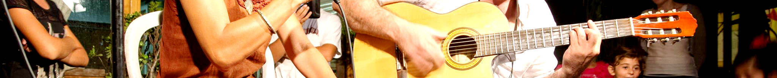

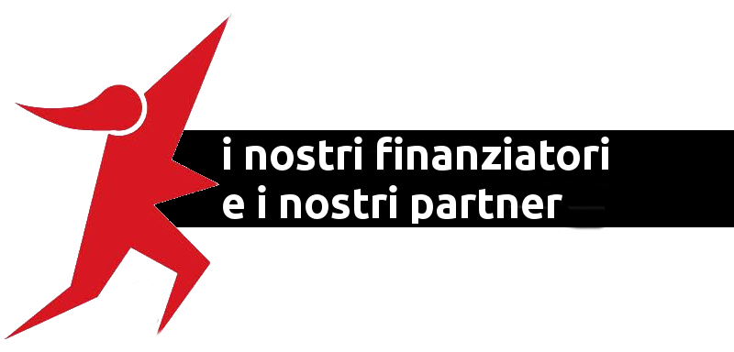

Public administration funding projects in the last 3 years:

- Commissione Europea DG Education and Culture
- Ministero dell’Interno
- Regione Lazio
- Provincia di Roma
- Roma Capitale – Dipartimento Politiche Sociali, Sussidiarietà e Salute
- Roma Capitale – Dipartimento Servizi Educativi e Scolastici
- Municipio VIII di Roma
- Municipio IX di Roma Capitale
- Municipio XI di Roma Capitale
- Fondazione IBM

Main partners:

- Il Laboratorio – Formazione e consulenze per il lavoro sociale
- Speha Fresia Società Cooperativa
- Cooperativa Sociale Il Cammino
- Cooperativa Sociale Magliana Solidale
- Associazione Culturale Enarché
- Casa Internazionale delle Donne

- ZeroViolenza Donne
- Spazio Etico
- Arci Servizio Civile Roma
- Altramente scuola per tutti

Main stakeholders:
- Roma Capitale
- Sapienza – Università di Roma; Università degli Studi Roma Tre; Università degli Studi di Roma Tor Vergata
- C.O.L. Corviale e Marconi
- Servizi Sociali dei Municipi VII, VIII, IX, XI
- ASL RM C e D
- Centro per l’impiego Roma Cinecittà
- Istituti Comprensivi e Scuole dei Municipi VII, VIII, IX, XI

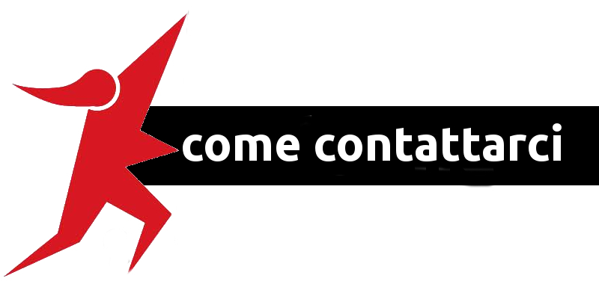

Legal head office:
Via Goito 35/b
00185
Roma
c/o Associazione Centofiori

Tel.: 0689566579
Fax: 0689566573
e-mail: solidarietalazio@arci.it
pec: solidarietalazio@legalmail.it

www.arcisolidarietaonlus.eu
Facebook
Twitter

