Call for partners to apply on deadline 26.04.2017
My home is...
Youth Exchange
Place:Bulgaria
Date: (8 days)

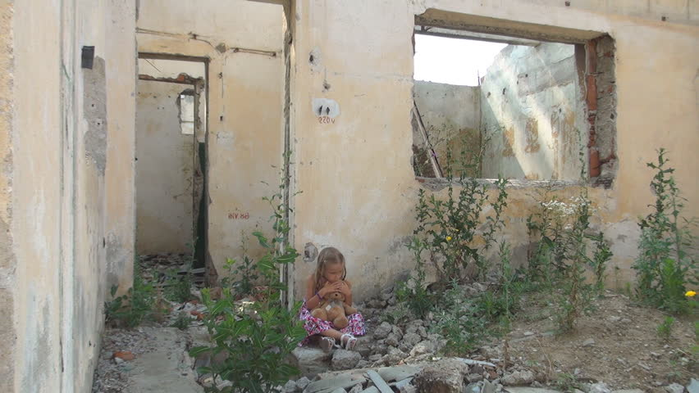

Description:
This project propose to teach youngsters interested in photography and/or journalism the basics of photography and photojournalism in a non-formal way, and increase their self-esteem by helping them to create and publish a photo albums and to make their own open photo exhibition. In parallel we aim to increase empathy towards marginalised groups and to present the tragic reality of their living conditions. The topic of the photo exhibition and photo albums will be the living conditions of marginalised groups. We will raise awareness about the way marginalised groups are living and their desperate cry for help that society ignores.

Number of participants per organisation: 5+1 youth leader

Objectives of the project:
- To learn about basics of professional photography and journalism in a non-formal way
- To raise awareness about the living conditions of marginalised groups
- Promotion of solidarity, empathy and social inclusion for refugees and other marginalised groups of European community
- Raising young people’s social and civic competence by including them in local community and resolving latest European social issues

Background of participants:
- at least 18 years old.
- able to communicate in English.
- motivated to participate in the project.
- interested in photography and / or journalism.
- interested to start using photography as a tool in their working context.
- willing to contribute with their knowledge, experience and good practice.
- wanting to be involved in raising awareness about european humanitarian issues.

Task-related and Intercultural task that each group should prepare and organize:
Prepare a presentation where you present your country through 5 photographs made you, take 5 photos of your neighborhood.

If you are interested in our project proposal we would kindly ask you to send your PIF to email: walktogetherassociation@gmail.com.

ONLY APPLICATIONS WHO HAVE EXPERIENCE IN THE FIELD OF THE PROJECT WILL BE CONSIDERED. GENERAL DISCRIPTIONS, ARE GOING TO BE IGNORED. WE WILL CONTACT ONLY THE SELECTED PARTNERS.

Thank you,
WalkTogether Team,

About WalkTogether: https://www.facebook.com/pages/WalkTogether/1546632572269496?fref=ts

