Preliminary agreement
- Parties to the agreement
1. DOREA Educational Institute Wtf, situated in 16 Iouniou 1943st. 9, office 201, 3022, Limassol, Cyprus, represented by Jolanta Banelyte Managing Director, called coordinating organization, with PIC code 948488893 in Programme Erasmus+, and
I.2. (Title of organisation}, situated in {address, post code} represented by {name and surname} called - partner organization, with PIC code xxxx in Erasmus + engages in partnership in the Erasmus+ project “Intern Power: Boost Your Competences”
Key Action: Learning Mobility of Individuals; Action: Mobility of learners and staff; Action Type: Youth mobility

- The obligations of the institutions under the partnership

- The obligations of the coordinating organization:
- To develop the project;
- To apply for funding;
(If funding is granted)
- To carry out the proposed activities in the project under financing contracts signed with the financing institution;
- To manage all phases of the project: preparation stage, implementation stage and post-project stage with the help of partners;
- To communicate with partners providing them all the possible information about the project activities, etc.;
- To disseminate the project;
- To evaluate the project;
- Make the payments within the 3 months subject to receiving the original tickets and travel documents to the organisation.

- The obligations of the partner organization:
- To provide for the coordinating organization the information necessary for funding application submission and for the project development;

(If funding is granted)

- To compose the project team and prepare the participants for the topic and practicalities of the project;
- To select, at a date notified by the coordinating organization, a number of participants for the main project activity (participants, group leaders, youth workers) according to the criteria (number, gender, age limit, language skills) requested in the document “Selection of Participants” and in the standards of the financing contract;
- To participate with selected participants to the all activities proposed by the project;
- To participate in promotion of the project;
- To participate in the dissemination of the project results;
- To be aware that taxi and car fuel expenses are not covered.
- To be aware that confirmation is need from coordinating organization before purchasing the tickets.

Coordinating organization  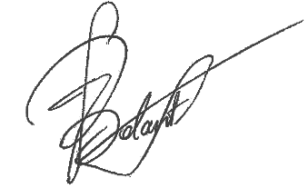 | Partner organization
DOREA Educational Institute | Name of the organisation
Representative | Representative
Jolanta Banelyte | Name and Surname

