Summer Work Camp in The North of Vietnam

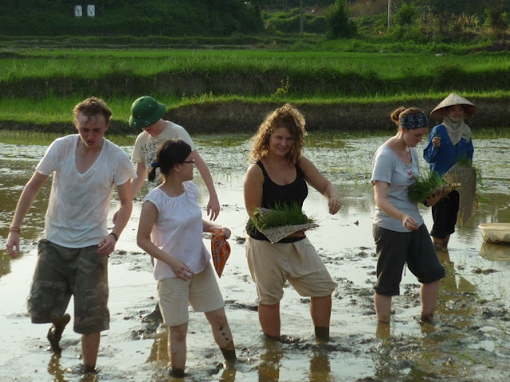 | In Vietnam, after the success of the annual International Summer camps, CDS has further developed our annual summer work camp. The program focuses on 3 themes: “Community, Culture and the Environment”.  CDS and the local Youth Union will coordinate another summer camp in order to share knowledge about agricultural production, health and hygiene awareness, education and forest preservation with the local community. Volunteers will live with the local community and gain a valuable insight and understanding of the daily hardships that these people face
This is a good opportunity for people to enjoy a multi-cultural environment. This is also a splendid occasion for volunteers to share their feelings and help disadvantaged people as well as join our environmental conservation activities. All Vietnamese and International volunteers will be accommodated in home stays and camping during the summer camp.

AT A GLANCE
 |  | Location |  | The north of Vietnam
Periods Camp 1: July 2th –July 14 ; Camp2: d July 18 – July 30;
Camp 3: August 3th – August 30

Duration 12 days per camp

Food Communal meals with local people

Accommodation Home-stay with Local people

Work Hours 5-6 hour per day
PARTICIPANT FEE $350 /person, No including Flights, Insurance, Visas
WHAT WE SUPPORT

1. Airport pick-up;
2. Half-day cultural orientation;
3. Transportation to the service place through public bus;
4. Vietnamese food and accommodations;
5. Support from local volunteers during your activities;
6. 24 hour emergency support hotline;
7. Participant certificate upon successful completion of the volunteer placement.

Y O U R R O L E A S A V O L U N T E E R

- Provide conversational English lessons to local youth broaden children’s knowledge and help improve education and studying conditions for the village children. Coaching rural kids in sporting activities
- Help people harvest crops and perform other everyday tasks unique to village life.
- Volunteers will contribute to raising awareness on basic health and hygiene conditions for the local community
- Working with the cadres of the reserve to educate and to raise the people’s
consciousness about natural forest protection
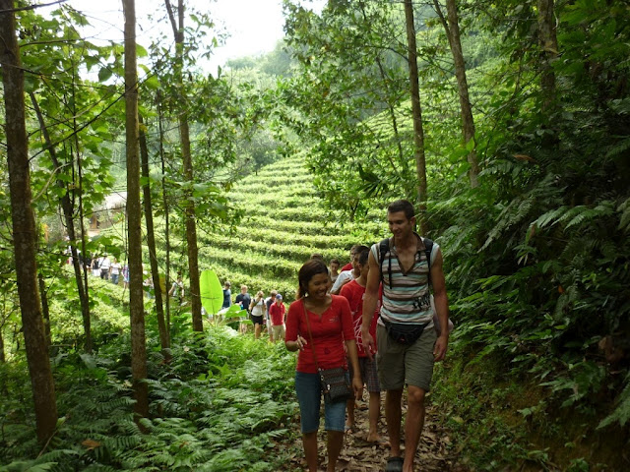
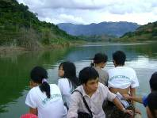

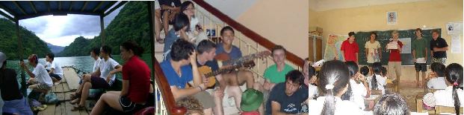

Some activities in Summer Workcamp 2008, 2009, 2010 in North-East of Vietnam

