BE WISE, THINK TWICE!

CALL FOR PARTNERS

Is a youth exchange aimed at reinforcing
the capacity of young people think critically about
information they receive, instead of blindly accepting
opinions occurring in their environment.
BY
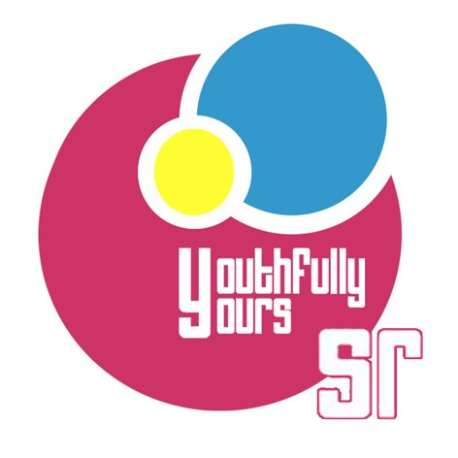

December 2017
Financial support: Erasmus+ Program( Key Action 1)
“Be Wise Think Twice” is a youth exchange which encourages 30 young people think critically and understand different forms of extremism. A creative and sophisticated design of activities will support both solidarity among people and tolerance toward different cultures and religions.
BE WISE, THINK TWICE
Youth exchange is aimed at reinforcing the capacity of young people think critically about information they receive, instead of blindly accepting opinions occurring in their environment. In addition, it will focus on raising their awareness about forms and signs of extremism, including finding possible ways of responding to them properly.
We will encourage the participants think critically about topics such as cultural and religious differences, current political events, extremism and how to respond to it,.
PARTICIPANTS

The youth exchange is planned for 30 participants, 18-25 years old, from 6 countries, who are interested in both the improving of their critical thinking and learning about extremism, its signs and forms.
VENUE

Recreation centre Jahodná which is located in the East part of Slovakia, near the city of Košice. We have chosen this place for its proximity to the urban area of Košice, where we plan to do some of our activities, but also for the fact that it offers a tranquil environment in nature for participants’ effective learning.
METHODS

In the course of the project, non-formal, experience-based education methods will be used, enabling the participants not only gain new knowledge but truly perceive what it means to be misinformed. We will encourage young people think critically about topics such as cultural and religious differences, current political events, extremism and ways of responding to it.
FINANCIAL ASPECTS

Project will cover 100% of accommodation and material costs during the youth exchange and follow- up activities days.
Traveling costs will be covered due to the Erasmus+ distance calculator
(http://ec.europa.eu/programmes/erasmus-plus/tools/distance_en.htm)
HOW TO APPLY ?

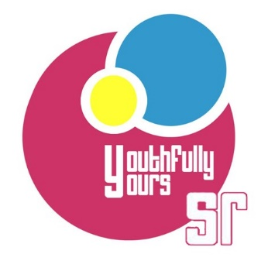
If your organization is interested in this project,
please contact: info@youthfullyyours.sk
Non-governmental organization Youthfully Yours SR (Slovakia)

