Call For Partners

Project Title: „HARMONY PARK – Music For Autism“
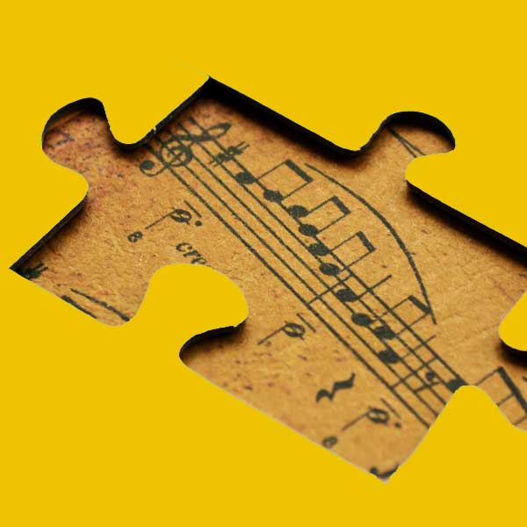

Project type: Erasmus+ KA2 Capacity building in the field of Youth (Western
Balkan Youth Window)

The dates of the project activities: 15th of August 2017 – 1st of September2018

The main idea of project:
The main idea of this long-term project is to empower participants who work with young people with autism with practical knowledge and skills to be able to include target group easier in society through music. Participants will acquire knowledge and skills to encourage communication, socialization and inclusion among young people with autism as well as to motivate them to interact more with the community. We will test new creative and innovative ways of inclusion of young people with autism. Through learning how to play different music instruments (partner organization countries) and exploring different cultures, participants will obtain knowledge on how to stimulate connection and social interaction of youngsters with autism. In order to reach our goals the set of activities planned during the project is based on interactive non-formal methods of education, learning-by-doing, simulations, role plays, creative workshops and using various exercises.
Target group: people actively involved in work with young people with autism. (Youth workers, NGO activists, school teachers, educators, social workers, etc.)

The main objectives of the project are:
- Exchange of experiences between partner organizations countries on inclusion of young people with autism especially in field of different metodologies using music;
- Promotion of European values and active citizenship, as well as non-formal education, solidarity, multiculturalism, diversity and tolerance among local and European youth;
- To exchange experiences and information about music culture in different countries;
- Learning how to break stereotypes and prejudices;
- To equip participants with practical knowledge on how to enhance the professional, personal and social skills of young people they work with, in order to involve young people with autism more in different social processes;
- Promotion of possibilities of Erasmus + program for youth with special focus on young people with autism

The main product of training course: Public event where the participants will make and play their music instruments helping young people with autism to communicate, learn and memorize as well to help them make social and family connections through a mutual shared interest. In the end of training course participants will create short video that promotes inclusion of young people with autism in order to help them to integrate in society.

Profile of partner organizations
We would like to get youth organizations who work with young people with autism from Erasmus+ Programmed Countries and Western Balkan Window Countries with special focus on partner organizations from Turkey, Greece, Macedonia, Albania, Bosnia and Herzegovina, Hungary, Croatia, Austria, Italy, France, Spain, Czech Republic, Slovakia, Portugal.
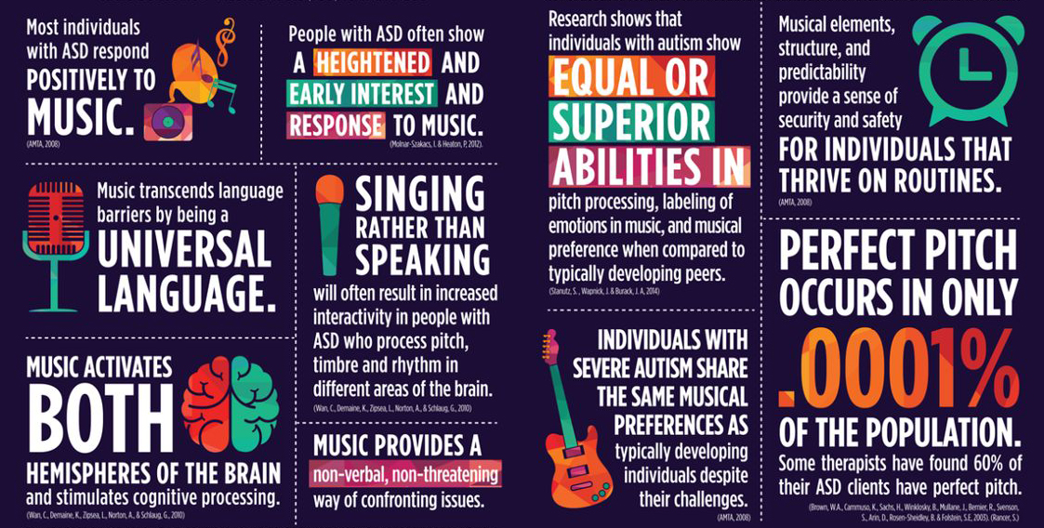

Activity’s

Activity 1
Study visit:
- Presentation of ERASMUS+ Program, its permanent and annual priorities and objectives;
- Partnership-building session – Through brief presentation and workshop, participants will connect and create synergy with topic and between each other;
- Session about social inclusion young people with autism, their integration into society, possibilities and openess of society for helping in inclusion
- Session about tolerance and antidiscrimination topics; how to make impact on society selfawereness; ways to spread knowledge and experience of good practices;
- Study visit to local NGO's and Governmental institutions which work in innovative anc creative way with young people with autism;

Activity 2
Training course:
• Session about program, its permanent and annual priorities and objectives
• Session about integration of young people with autism into society and ways to help them in this process
• Session about tolerance and antidiscrimination topics;
• Lession about Music therapy techniques and their effects;
• The modalities and methodology of work with autistic children through music;
• Workshop, making music instruments for Harmony Park;
• Session about social inclusion
• Session about music basics;
• Educative workshops on how to create project idea, develop it into the written project proposal, implement and evaluate a project

Activity 3
Partnership-building Activity
We will organize an event with a view to allow participants to find partners for transnational cooperation and further project development and continuation. Partnership-building Activity brings together potential partners and facilitates the development of new projects around a chosen topic.

The applicant organization:
Centre for sustainable and development and green economy (hereinafter: CSDGE) was first founded in September 2012 as an informal group consisting of young people who, at the time, were socially active and participated in various youth, civic and student organizations, as well as in student and youth representative bodies. Founders and the members are gathered in the framework of CSDGE with the aim to initiate and actively participate in cultural, social, civil and political transformation, and revitalization of cultural and historical heritage. CSDGE is a group of young people, enthusiasts, who are also the top experts in their fields: architects, artists and historians. They have all recognized the energy and professionalism that we cherish in our center, and offered their support, trust and professional advice. Main program principles of CSDGE are the promotion of cultural heritage as a link between the past, present and the future; affirmation of cultural heritage as a development resource; protection, reconstruction and revitalization of cultural and historical heritage; creation of conditions for meeting the criteria for a higher level of protection of the cultural and historical heritage in the context of national, regional and international institutions; branding the cultural and historical heritage; creating different forms and shapes of presentation that enhances the availability and sustainable use of cultural and historical heritage; organizing informative and educational, tourist, entertainment, recreational and similar facilities.

