- THE FOUNDATION OF SPECIAL NEEDS OF PEOPLE ?
THE FOUNDATION OF SPECIAL NEEDS OF PEOPLE ( ENGELLI EGITIM KULTUR SAGLIK SPOR VAKFI ) Take care of the children, youngsters and adult disables related to health, education, guidance and counselling, rehabilitation, employment, care and living, to provide their economical and social security. The Foundation of Special Needs has 6 training centers, disabled have an activities with speacialist (physiotherapists, child development experts, sports trainers, musicians, psychologists, social service experts). Furthemore The Foundation of Special Needs has a sport clubs where disabled are attended.
The Foundation of Special Needs is receiving, sending and coordinating organization.

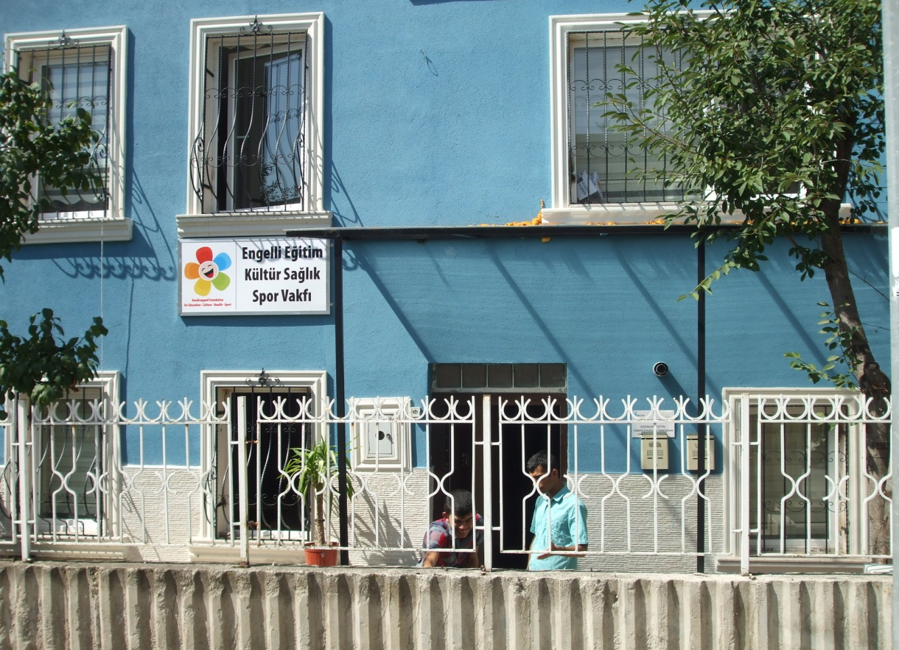
Main entrance to The Foundation of Special Needs of People new house, Rehabilitation Center (Batıkent -Ankara-Turkey )
- Something about volunteers…
The Foundation of Special Needs organizationshave a physical environment suitable for young people with physical, sensory or other disabilities (such as Wheel Chair Access and similar).
During the EVS volunteers are assist a teachers in special courses for Special Needs of People . They are participate in many activities such as a picnics, sightseeing trips and others. Volunteers should fill the free time of special Needs of People – by inventing a game sand plays. They work also in the office– helping with the documents etc.
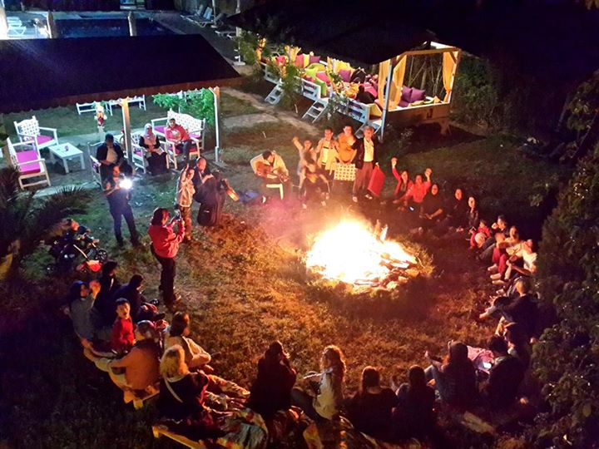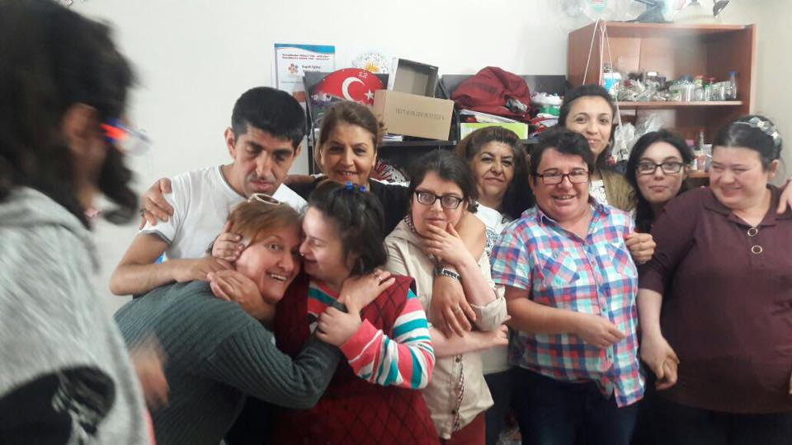
Children love singing and dancing near the fire.Children are very curious about a new people.

- Where volunteers are accommodated?
Volunteers are accommodated in theflatwhich is in this same building as an office on the third floor. For voluunters there are 3 rooms,and one extra with computer which volunters can use.
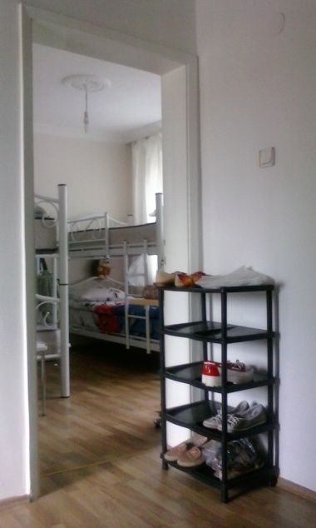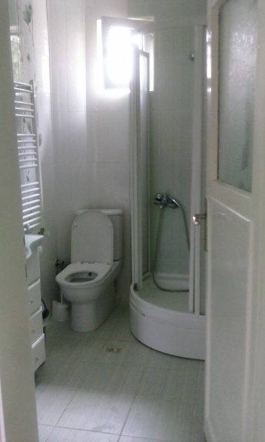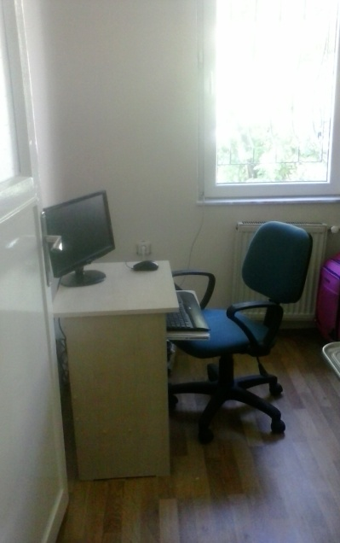

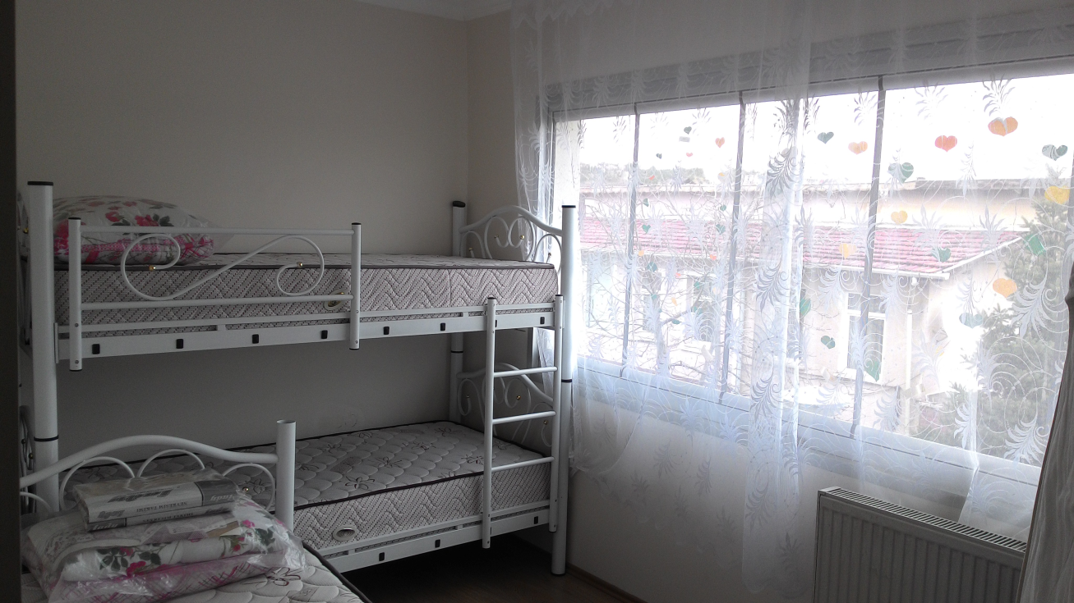
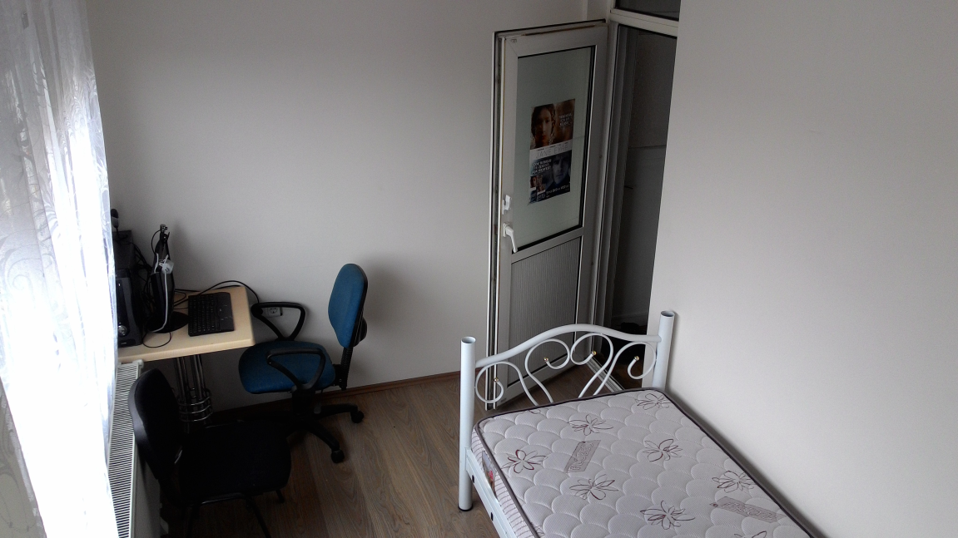
On the second floor is an office:
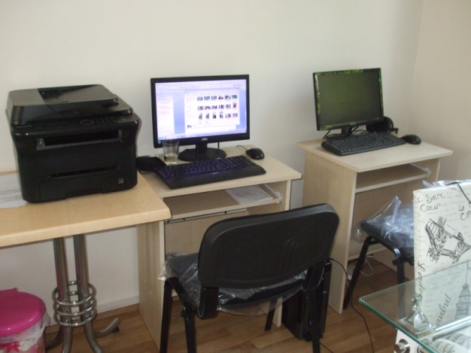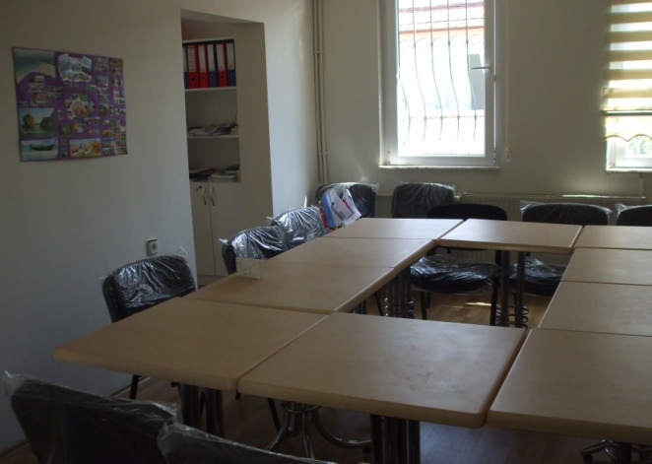
Kitchen: Garden:
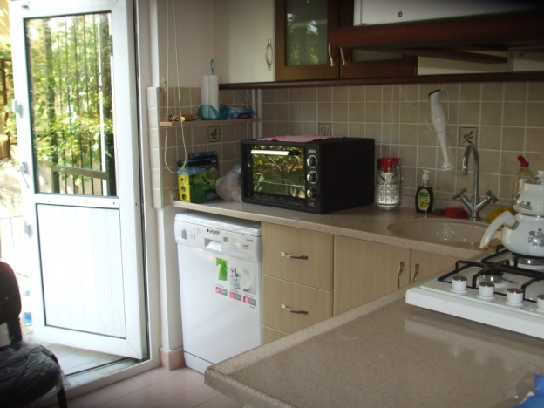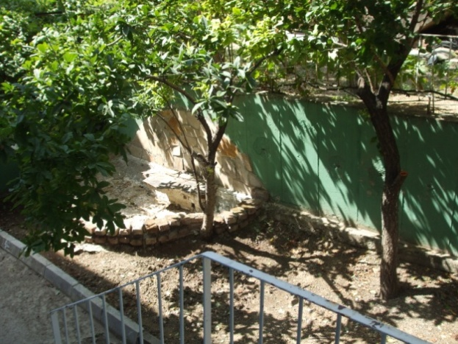

On the first floor is located class room:
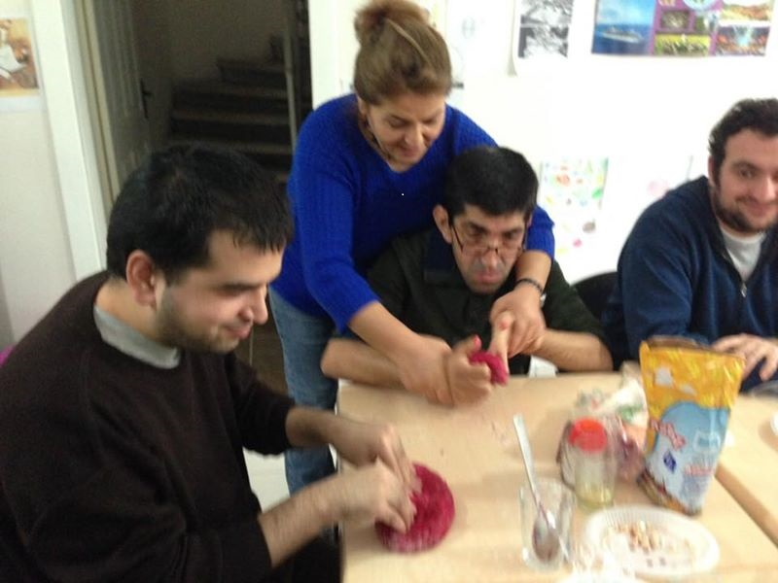
Here children have a courses, also they are learning how to use computer and internet.
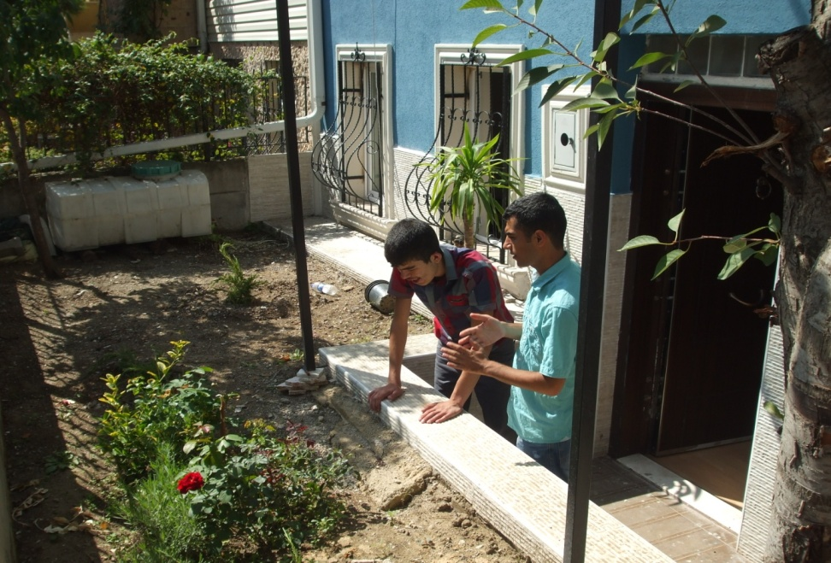
in the front of the house there is beautiful little garden.

Contact Address

Abdurrahman Kurtaslan(President of Foundation )
Engelli Vakfı (The Foundation of Special Needs of People )
Uğur Mumcu Mahallesi, 1657 Sokak, No: 5

Batıkent / Ankara - TURKEY
President of Foundation | : | Abdurrahman KURTASLAN
E-mail | : | engellivakfi@gmail.com
web | : | http://www.engellivakfi.org
Phone | : | 00 90 312 255 50 59
Fax | : | 00 90 312 231 96 36
Mobile Phone: | : | 0530 459 23 96

