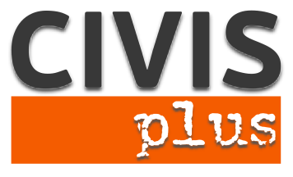

# Call for partners for a Strategic partnership in the youth field

# Key Action 2: Cooperation for innovation and the exchange of good practices.

Immigrants’ Labour Inclusion through Social Campaigns

**Coordinating organization:** N.G.O. CIVIS PLUS

**Contact person:** Karka Sophia

**Host:** N.G.O. CIVISPLUS [www.civisplus.gr](http://www.civisplus.gr)

#### Short description of the project

The increasing number of immigrant population in combination with the financial crisis in Europe have dramatically restricted the career opportunities of young immigrants, who face the highest unemployment rates. Young immigrants have to deal with a number of additional social and individual factors, such as stereotypical and discriminatory behaviors in the workplace and the society, that make them extremely vulnerable to unemployment. They are thus particularly vulnerable to poverty and social exclusion and their daily living is being hindered with dramatic effects at both individual and social level.

In this context, the proposed project aims to create in the long term more favorable conditions for the employment of young immigrants. To achieve this goal, the following main objectives have been set:

1) Promotion of social campaigns as a means to combat unemployment among young immigrants.

2) Increase partnerships and campaigns on the subject.

3) Qualitative and quantitative improvement of the skills of the youth sector on the implementation of social campaigns to promote the employability of young immigrants.

4) Promotion of the exchange of views and good practices between youth workers from different countries.

5) The creation of innovative and valuable tools on implementing a social campaign on the topic.

During the project research activities and workshops will take place in order to investigate the employment status of young immigrants in Europe, as well as to define the lifecycle and steps in organizing, implementing and monitoring a social campaign and to find examples of effective campaigns on the topic. The results of these activities will be used for the creation of a guide including theoretical guidelines for youth workers on how to organize, conduct and evaluate a social campaign for boosting young immigrants’ employability. The guide will be used to train youth workers and inspire them in drafting plans for such campaigns.

Partners: 4

We are looking for 4 partner organizations from program countries who are motivated to work on the topic and have experience in the field.

Duration: 22 months

Working language: English

## Procedure to apply:

## Please, fill in the partner identification form with the PIC number and all the fields required and send it via e-mail at civis.strategic@gmail.com. Please indicate as subject the title of the project.

Contact person: **Karka Sophia, Director of EU programs at NGO CIVIS PLUS**

Tel: +30 211 012 14 41

40-42 Koletti street,

Athens, Greece