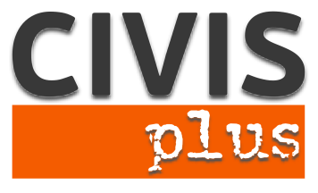

# Call for partners for a Youth Exchange in Athens

# Key Action 1: Mobility project for young people and youth workers

“The more aware – the closer to the Labour Market”

**Coordinating organization:** N.G.O. CIVIS PLUS

**Contact person:** Karka Sophia

**Host:** N.G.O. CIVISPLUS [www.civisplus.gr](http://www.civisplus.gr)

#### Short description of the project

The economic and social crisis that Europe is going through the last years has particularly affected young generations. Unemployment rates are particularly high in all European countries and in several of them have reached the rate of 50%. These figures are alarming and the European Union pays particular attention on addressing the problem by implementing policies and programs and pressing the Member States to take action. Increasing the employability of young people is a key objective of the Union and the program Erasmus +.

In this context, the proposed project has the overall objective to contribute to the Union's efforts to increase the employability of young people. In order to achieve the above, it aims to sensitize young people on the topic, empower them in order to take positive action and effectively look for job opportunities.

Partners: 12

We are looking for 12 partner organizations who are motivated to work on the topic and whose participants would be able to follow the project in English and attend the full duration of the event.

Duration: 8 days

Participants: 4 participants 18-30 years old and one youth leader per national group.

Project Location: Athens, Greece

Working language: English

## Financial Conditions:

## Travel costs up to limited amounts for countries according to program rules of Erasmus+

## 100% of accommodation and food will be covered from the project budget.

## Procedure to apply:

## Please, fill in the partner identification form with the PIC number and all the fields required and send it via e-mail at [civis.exchanges@gmail.com](mailto:civis.exchanges@gmail.com). Please indicate as subject the title of the project.

Contact person: **Karka Sophia, Director of EU programs at NGO CIVIS PLUS**

Tel: +30 211 012 14 41

40-42 Koletti street,

Athens, Greece