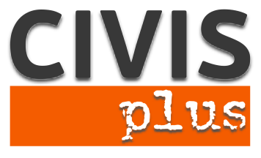

# Call for partners for a TC in Athens

# Key Action 1: Mobility project for young people and youth workers

Inclusive Youth Activities

**Coordinating organization:** N.G.O. CIVIS PLUS

**Contact person:** Karka Sophia

**Host:** N.G.O. CIVISPLUS [www.civisplus.gr](http://www.civisplus.gr)

#### Short description of the project

The influx of immigrants from third countries in Europe has increased rapidly in recent years, making the need for measures for their smooth integration into society more vital than ever. In the intense debate that has been created around the theme, has been recognized the contribution of youth organizations and the key role they can play in this direction as their activities offer opportunities for dialogue and mutual understanding between indigenous and immigrants but also for the personal development of the latter. In contrast to this, however, the percentages of participation of third country nationals in youth activities are too low.

In this context the proposed project aims to increase the participation of third country nationals in youth activities with a view to their smooth integration into society by strengthening the abilities of those active in youth work on the organization of joint activities and managing teams with a strong element of diversity.

Partners: 10

We are looking for 10 partner organizations from program countries who are motivated to work on the topic and whose participants would be able to follow the project in English and attend the full duration of the event.

Duration: 7 days

Participants: 3 participants (people active in the youth field) per partner organization

Project Location: Athens, Greece

Working language: English

## Financial Conditions:

## Travel costs up to limited amounts for countries according to program rules of Erasmus+

## 100% of accommodation and food will be covered from the project budget.

## Procedure to apply:

## Please, fill in the partner identification form with the PIC number and all the fields required and send it via e-mail at civisplus84@gmail.com. Please indicate as subject the title of the project.

Contact person: **Karka Sophia, Director of EU programs at NGO CIVIS PLUS**

Tel: +30 211 012 14 41

14 Patision street,

Athens, Greece