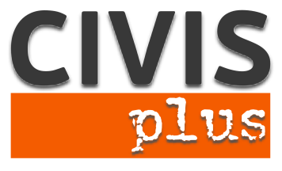

**Rebuilding Lives through Employment**

**Key Action 1: Mobility project for young people and youth workers**

***Coordinating organization*:** N.G.O. CIVIS PLUS

***Contact person*:** Karka Sophia

***Host:*** N.G.O. CIVISPLUS [www.civisplus.gr](http://www.civisplus.gr)

**Short description of the project**

The economic crisis strikes the European Union; unemployment has been escalating to record levels with the highest rates being reserved for young people and reaching even 50% in some Member States. In this context, young people with an immigrant background, who are now an integral part of European society, experience much stronger and longer the problem of unemployment than their indigenous peers, as beyond the general decline of job opportunities have to face a series of additional factors that complicate their employability.

In this context, the proposed project has the overall aim to contribute to promoting the employability of young immigrants in Europe.

**Partners:** 12

We are looking for 12 partner organizations from program countries who are motivated to work on the topic and whose participants would be able to follow the project in English and attend the full duration of the event.

**Duration:** 7 days

**Participants:** 3 participants (people active in the youth field) per partner organization

**Project Location**: Athens, Greece

**Working language**: English

**Financial Conditions:**

* Travel costs up to limited amounts for countries according to program rules of Erasmus+
* 100% of accommodation and food will be covered from the project budget.

**Procedure to apply:**

Please, fill in the partner identification form with the PIC number and all the fields required and send it via e-mail at [civis.tc@yahoo.com](mailto:civis.tc@yahoo.com). Please indicate as subject the title of the project

Contact person: **Karka Sophia, Director of EU programs at NGO CIVIS PLUS**

Tel: +30 211 012 14 41

40-42 Koletti street, 106 82, Athens, Greece