
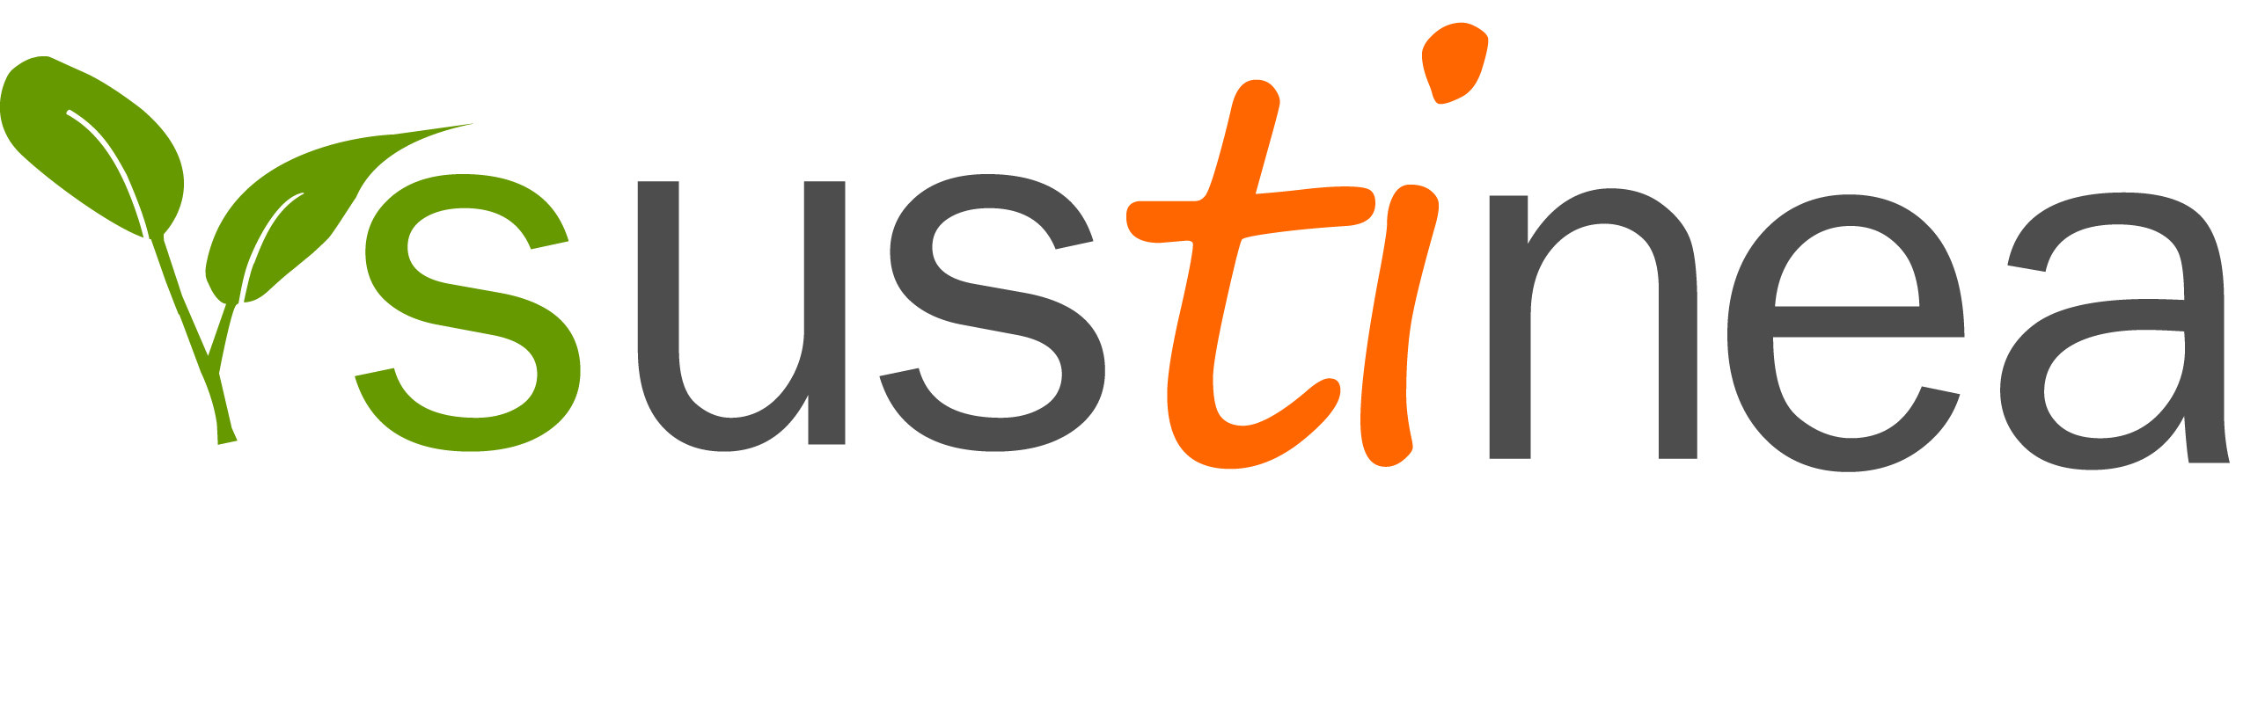
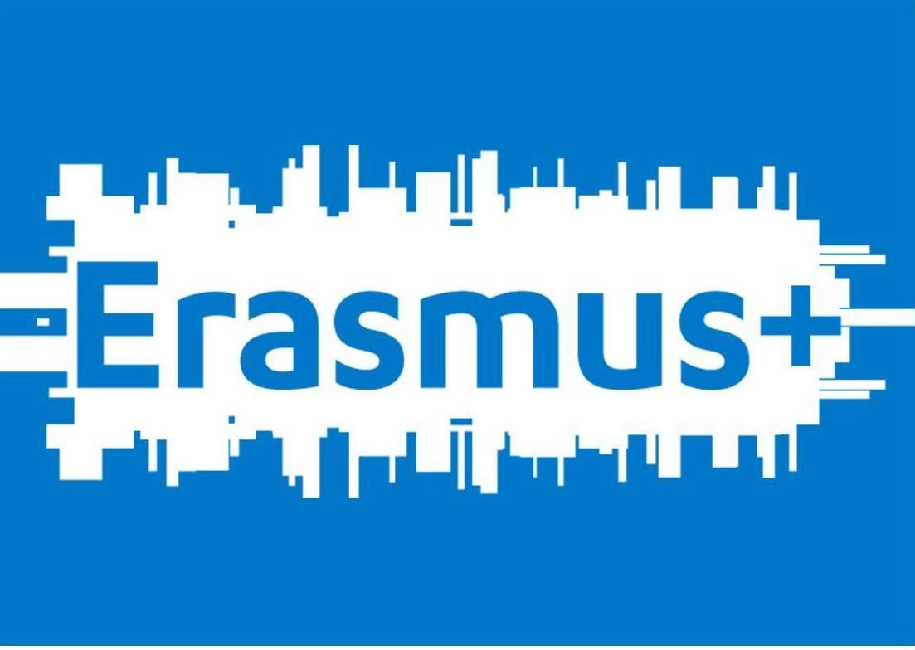

SUSTINEA - EVS VOLUNTEER APPLICATION FORM
Networks for sustainability

First name:
Last name:
Date of birth: | Age: |  | Gender:
Nationality:
Field of studies:
Knowledge of the Spanish language (speaking and understanding):

Knowledge of other languages (specify which ones and what level: mother tongue, fluent, good, basic):

When would you like to start your placement:
How long would you like to volunteer:
Which sub-project(s) are you applying for:
Phone number(s): |  | E-mail:
Name and EI Ref. Number of Sending Organisation:
Contact details of Sending Organisation:

- Why would you want to be an EVS volunteer at SUSTINEA?

- Why did you choose this specific project?

- Have you ever worked on environmental projects?

- What do you expect from this experience? How will you reach your own goals in this experience? And what do you expect from the hosting organisation?

- Sustinea promotes Sustainable Development, conservation of the environment and Environmental Education. What is your opinion on this approach?

- How would you describe Sustainable Development?

- How would you describe Environmental Education?

- How would you describe volunteering?

- What motivates you the most about volunteering for 9 months in another country?

- What do you think your biggest challenge would be to volunteer for 9 months in another country?

- List 2 advantages and 2 difficulties that you might have in group work.

- Among the activities that you will participate during the project which ones motivate you the most and which ones motivate you the least; why?

- What tools would you use to solve a conflict in the work team?

- What are some of the skills/interest that would assist you in carrying out your project?

- Have you ever learned another language? How? How would you rate your language learning skills?

- What are your others skills/interests (volunteering, hobbies, artistic or IT skills)?

- What kind of competences and skills do you think you will be able to acquire during your experience at SUSTINEA?

- What would you like to do once the EVS experience is over?

- Do you have any special needs (mobility, health, learning related etc.)?

- What is your relationship with your Sending Organisations? How will they support you before, during and after your project?

- Do you have a driving licence and would you be willing to drive SUSTINEA’s cars and vans?

Thank you very much!

