Partner Request for International training

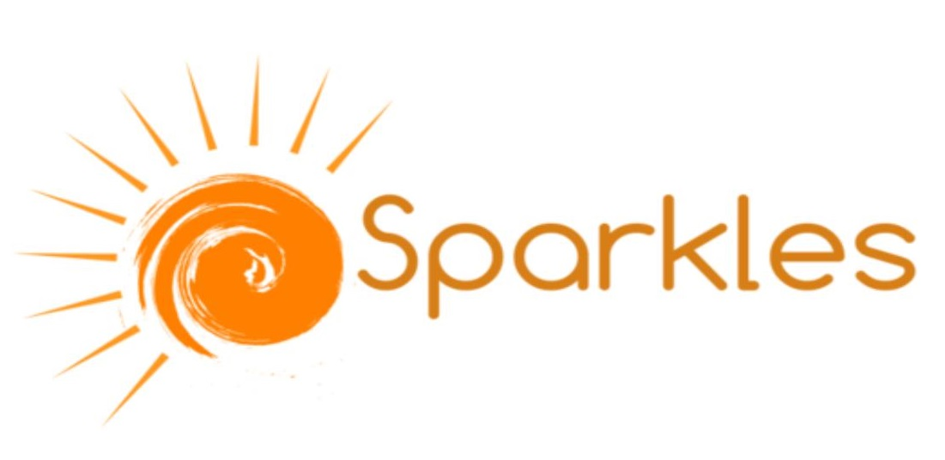

**Mentoring and coaching for diversity and inclusion**

*The greatest good you can do for another*

*is not just share your riches,*

*but reveal to him his own*

--- Benjamin Disraeli

Together with our partner organisation “Sparkles” from Italy we are preparing mentorship competencies development project. **We are looking for partner organisations, that work in the field of diversity, with minorities, migrants or other socially vulnerable groups of young people.** Thosethat are willing to improve their members work quality and include or strengthen mentorship processes within their organisations.

**Origins of the idea**

Having a lot of work experience with various organisations (those that focus their activities on human rights education, piece making, or work with marginalised groups, NEETs) we have understood that including mentoring and coaching practices in daily work of youth workers has a meaningful positive outcome.

Successful mentoring and coaching practices create opportunities for positive behavioural and attitude changes, help to enlighten core values, which is highly important when working with people from different backgrounds and young people inclusion.

Still we see that many youth workers lack these competencies, therefore, we do believe, that mentoring and coaching skills training would be very useful. We expect it would help professionals to improve their work quality, enrich their “tools baggage”. It will help to understand better their role, be aware about own work, personal and professional strengths.

Moreover, become more conscious about taken actions linkage with desired impact they want and can create through their work with young people.

**Goal**

Improve the level of key competencies and skills of youth workers in mentoring and coaching in order to work more efficiently with diverse and socially vulnerable groups.

**Specific objectives**

* Develop youth worker’s competencies in mentoring;
* Learn about the aspects of diversity mentoring;
* Equip participants with various tools and methods applicable in mentoring, including coaching;
* Exchange experiences, expertise and good practices on working with socially vulnerable groups;
* Develop further activities applicable in their work environment;
* Create environment for international networking and further cooperation.

**Methodological approach**

Training programme will be based on principles of non-formal education. You can expect learning sessions based on experiential learning, including practicing main skills of mentoring and coaching, group and individual work and focus on self-awareness and proactivity in learning.

**Partners’ Profile**

We are looking for **5** partner organizations in addition, which are:

* Working within youth sector, with young people (up to 29y/o);
* Work in the fields of diversity, Human Rights education or with other socially vulnerable groups;
* Willing to improve their members’ competencies in mentoring and coaching;
* Able to attract 4 participants per country which fit participants’ profile.

**Training place/ Venue**

Training will be held in Lithuania near Vilnius, for the duration of 10 days in the summer of 2017 (concrete dates will be specified later).

**Deadlines and costs**

We are ready to apply for the **2nd of February** deadline to get funding from *Erasmus + programme*. Costs of board and logging will be covered by the organisers. Travel costs will be reimbursed according to Erasmus+ regulations.

**How to apply**

If you are interested in partnership, please fill in and send us back the partner identification form (form below).

We will be waiting definite confirmation **from the partners until 22nd of January, 2017.**

We will contact each partner individually in order to get more details and start our cooperation.

**Contacts**

If you have further questions please do not hesitate contacting **Migle (email: migle.petkauskiene@gmail.com, Mob.ph: +370 685 06547, skype: miglosse).**

|  |
| --- |
| **PARTNER PROFILE** |

**Your organisation PIC number:**

|  |
| --- |
| **ACCREDITATION** |

**Have you received any type of accreditation ? If yes, mark it.**

☐ Accreditation of Youth Volunteering Organisations (ERAPLUS-EVS)

☐ EVS Charter (LLP-EVS-CHARTER)

|  |
| --- |
| **BACKGROUND AND EXPERIENCE** |

**Please briefly present your organization.**

|  |
| --- |
|  |

**Please describe what are the activities and experience of your organization in the areas relevant to this project.**

|  |
| --- |
|  |

**Please describe what are the skills and expertise of key staff/ persons from your organization, who will be involved in this project.**

|  |
| --- |
|  |

**Please also describe briefly how the project meets the needs and objectives of your organisation**

|  |
| --- |
|  |

|  |
| --- |
| **LEGAL REPRESENTATIVE** |

|  |  |
| --- | --- |
| Title |  |

|  |  |
| --- | --- |
| Gender |  |

|  |  |
| --- | --- |
| First name |  |

|  |  |
| --- | --- |
| Family name |  |

|  |  |
| --- | --- |
| Department |  |

|  |  |
| --- | --- |
| Position |  |

|  |  |
| --- | --- |
| Email |  |

|  |  |
| --- | --- |
| Telephone |  |

☐ Same address as the organisation

|  |
| --- |
| **CONTACT PERSON (Person responsible for the implementation of the action)** |

|  |  |
| --- | --- |
| Title |  |

|  |  |
| --- | --- |
| Gender |  |

|  |  |
| --- | --- |
| First name |  |

|  |  |
| --- | --- |
| Family name |  |

|  |  |
| --- | --- |
| Department |  |

|  |  |
| --- | --- |
| Position |  |

|  |  |
| --- | --- |
| Email |  |

|  |  |
| --- | --- |
| Telephone |  |

☐ Same address as the organisation