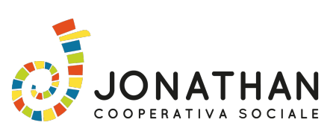

**IN CHILDOOD WE BELIEVE!**

**EVS PROJECT INFOS**

2 VOLUNTEERS

1 SEPTEMBER 2017 – 31 JANUARY 2018 (5 MONTH)

and

2 VOLUNTEERS

1 MARCH 2018 – 30 JULY 2018 (5 MONTH)

Piazzola sul Brenta, Padova, Italy

**IN CHILDHOOD WE BELIEVE!**

is a 5+5 month long-term EVS project that will take place in Piazzola sul Brenta near Padova (50 km from Venice). It will be hosted by JONATHAN COOPERATIVA SOCIALE (a no-profit organization) and the whole EVS project will last from 1st September 2017 to 30th July 2018, a period in which 4 volunteers from 4 European countries (2 for 5 months and 2 for the other 5 months) can experience the field of education and animation with teens and children. The project aim at developing volunteers skills in the field of education and entertainment, by experiencing in first person how informal and non-formal education can really empower and improve children and young people social and life skills.

In the project volunteers concretely will support Jonathan staff and working teams in their activities, including planning and operating into the field in order to carry out different activities.

On the base of their attitude, competences and expectation they may be selected for the first or for the second volunteering period as in the first period the activities will be focused mainly on the educational field while in the second period will be focused mainly on the entertainment field

**

**Project objectives:**

* To raise participants awareness about the role of informal education and promote the inclusion of children with fewer opportunities;
* To involve participants in education and entertainment planning and letting them operate into these fields;
* To improve participants skills in education and animation and intercultural dialog by acquiring new methodologies;
* To develop participants competences in education and animation fields and about human rights promotio;
* To improve participants competences in organizing cultural public event addressed to children and their families;
* To develop their foreign language skills, cultural awareness and civic competences as well as different social skills;

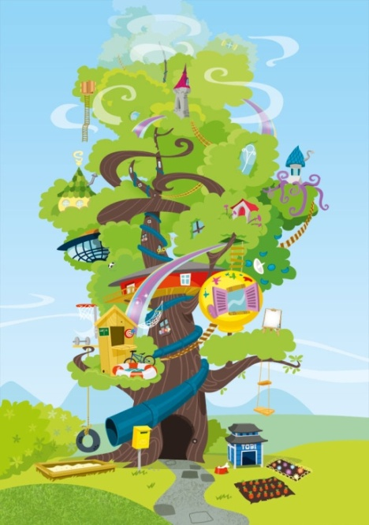

* To motivate young people to tell others about them, create their own projects, participate in other kinds of volunteering and use all this in their future;
* Promote EVS and Erasmus+ programme among local citizenship and among our networks (schools, public entities etc.).

**In this EVS project volunteers can:**

* Give support in planning and doing activities to entertain children and young people before and after school time with games, homework support, creativity/handicraft workshops, outdoor activities, etc., in early childhood schools, primary schools and lower secondary schools;
* Give support to the supervisory group at schools by entertaining pupils and students;
* Organize non-formal intercultural events (open to the citizenship) and language courses for children, young people and seniors;
* Give support to the different educational teams in planning educational paths about human rights, inclusion, environment protection, etc., filling reports and data, and especially acting in the field;
* Give support to animation team in planning and doing activities in public events, celebrations and parties or during animated reading or puppetry exhibitions;
* Give support to summer and winter camps teams, during the planning process of the activities and in the field;
* Give support to the staff on planning fundraising strategies, on organizing events and for other secretaryship activities related to ordinary youth and children activities;
* Give support to organize MAPU – Marvellous Puppetry Festivals (International Festival of Puppetry, 2°ed) on 19th-20th-21th of May 2018.

**Profile of volunteers**

 Must be between18-30 years old;

 Be willing to be part of the team and be part of the daily activities with positive and open mind;

 Be able to communicate in English;

 Be willing to enjoy time and having fun with children and young people and learn new educational methodologies;

 She/he likes art and creative activities, open-door activities and learn more about organizing entertainment opportunities for young people;

 Be ready to share accommodation with other volunteers from different countries and cultures;

 Be interested in children and youth education issues and artistic-cultural topic;

 Ready to work with younger and senior local people;

 To have ICT basic skills;

 Be ready to get actively involved in project activities and share his/her point of view at all levels.

**Volunteering & Free time activities**

Participants will do UP TO 7 hours of volunteer work 5 days per week and the rest of the time they will spend as they decide. Volunteers are free to organize their free time and days off as their want to. They may have some of their free days united if they decide to travel around the country. If they need we can help them to organize their free time suggesting some visit or activities (hiking, museum, trip, etc.) and/or we will be glad to involve them in our leisure time as much as possible.

**Practical info & money reimbursement**

 Volunteers will be accommodated in an equipped shared accommodation in Piazzola sul Brenta easily reachable from the working places.

 Volunteers will sleep in shared or single rooms with separate beds.

 There will be wi-fi access in the office (we are trying to provide wi-fi in the accommodation too).

 Volunteers will have to cook their own meals in the apartment kitchen. Each volunteer will get an ammount per month for food.

 Travelling costs will be reimbursed on the base of the EU distance calculator per each participant. They will be transferred to the sending organizations after presenting all original travel documents.

 Volunteers will also receive a pocket money per months during the volunteering period in Italy, calculated on the base of the Erasmus+ program guide.

**THE HOSTING ORGANISATION - Jonathan** is a non-profit organization born in 2009 in Piazzola sul Brenta, province of Padua (Italy). Our goal is to promote the society well-being through people's self-empowerment and self-development with an important role of active citizenship and intercultural dialogue. In our vision any individual and any group can contribute to the community development and growth, in a sustainable and human rights oriented way.

Thanks to the variety and interdependency of our human and professional resources, our activities range touches different areas: education, training, social inclusion, cultural and intercultural promotion, environmental protection, human rights, Italian language courses to immigrant and foreign people, gender studies and equal opportunities.

Jonathan has built over time a reliable and solid social network, so we work alongside families, schools, universities, local health authorities, social services, associations and local governments, providing our expertise and passion, promoting children and community welfare, trying to get closer to the territory and its actors, and to better meet community’s needs and interests. We promote inclusion and friendly way of life in all of our activities as principles of social equality and responsibility and active citizenship.

Our organization is settled in the Po valley, near Padua (15 km far). Our city is furnished of the main services and it is settled in the middle of important tourist sites, like Venice, the sea, the Alpes. Here we have a wide nature environment to enjoy and several bicycle paths. Our community is welcoming ad friendly and really active in the field of citizens welfare and entertainment, actually there are a lot of cultural and social associations well coordinated and collaborative to each other.

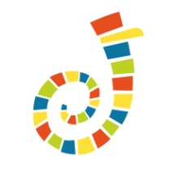

Our website: [www.jonathancoop.com](http://www.jonathancoop.com)

Facebook: cooperativa sociale jonathan