CALL FOR PARTNERS
“The hero’s journey – a new path for youth”
Training course
Italy – August 2017

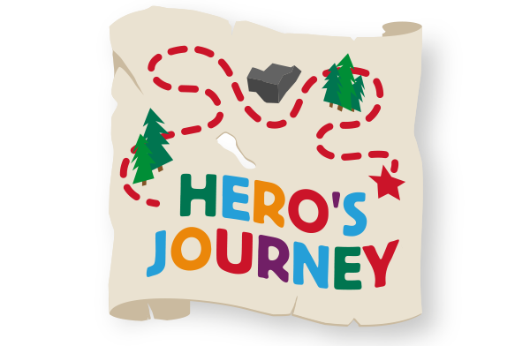

Background and theme of the project:
Young people are facing a time where adolescence is prolonging more and more due to lack of work and money to be self-sufficient and leave their homes.
It is now important to support the passage from childhood to adulthood in order to accompany young people through their own growing, enabling them to take their own responsibilities and decision for their life.
To give them the right tools is the base to support their passage to adulthood.

Main aim:
To give instruments to youth workers and educators to support young people in the passage from adolescence to adulthood.

Objectives:
- Learning how to stay with young people, listen to them and to their needs;
- Giving youth workers instruments )Hero’s journey) to work with young people in the age of passage from childhood to adulthood;
- Targeting the hero’s journey work on different target groups with different backgrounds;
- Sharing new techniques on rites of passages used in different cultures and environments.

Target group:
Youth workers, youth leaders, project managers, trainers, facilitators, coaches, mentors who can either bring a lot of knowledge and experience to the project or who are eager to attend because of what they can benefit from the knowledge and experience of their peers. Those who have strong personal and organizational commitment, who are capable or responsible of coordinating the projects in their organizations, because our intention is to develop sustainable network. With this experience or without, each national team should consist of language skilled people because for all activities, it is necessary to be able to communicate in English but we can offer help to those with lower level of language skills.

Trainers team:
Bret Stephenson M.A. – the author of „From Boys to Men: Spiritual Rites of Passage in an
Indulgent Age“. He has been a counselor of at-risk and high-risk adolescents for twenty-six
years. Bret has worked in residential treatment, clinical counseling agencies, group homes,
priváte counseling, foster parent training, Independent Living Program, and managed mentoring and tutoring programs. He has worked with teens from more than 100 countries.
http://www.adolescentmind.com/

Assisting:
Monica Mano, Helena Kosková

Program:
Experimental part (day 1-4)
Participants personally experience and reflect on different creative techniques of rites of passage an d The Hero's Journey model in order to have deeper understanding of what their youth will be experiencing and also how to use these activities and approaches in working with them. Examples of methods used: guided imageries, mask making, exercises on change, exercises on essences, sacred fire area, storytelling, personal mythologies,...
Metta level and educational part (day 5-7)
Time will be provided to conclude the experience, deepen the theorethical background and focus on how to use these approaches back home, with young people in our communities. Examples of discussion topics: archetypal adolescent development, risk taking behaviour, heal
thy adulthood, ability to function well in contemporary society, stages and dynamics of rites of passage, how to create your own rites for young people in our communities,...

Financial conditions:
The food and accommodation provided and paid by the organizers. Travels costs will be counted by distance calculator provided by European Commission and reimbursed by bank transfer after the course.
Participation fee: we will ask a contribution from 100 to 150 euro per person (it will cover the travel costs for American trainer)

Participants
3 participants per nations, 10 nations, will be involved. Aged 18 and over, able to communicate in English and willing to develop future projects and network.

When and where
The TC will be organized in Italy, in a venue close to woods where to experience outdoor activities. The TC will be organized in August

If you are interesting in being partner in this Training Course …
Fill the questionnaire…https://goo.gl/forms/0I49qp7stI4nJSIz1

If you have, any questions do not hesitate to contact!
info@youth4youth.it
