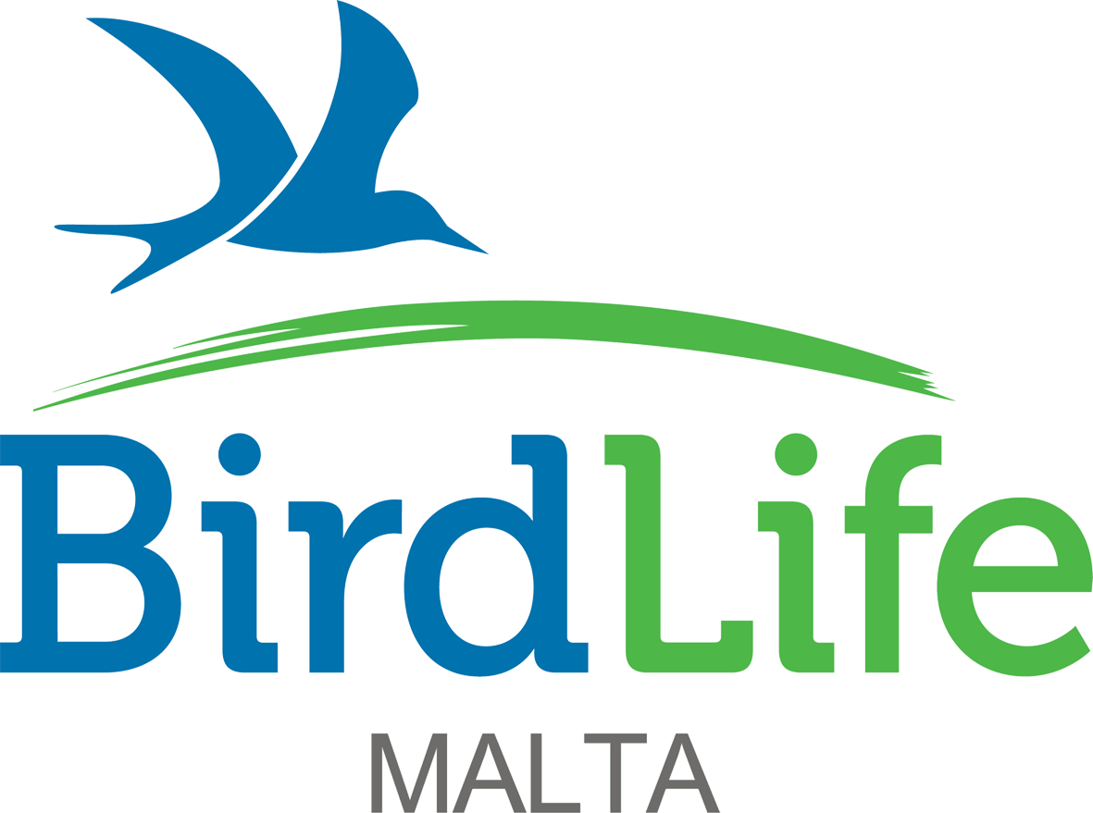
FOR BIRDLIFE MALTA
USE ONLY
ACKNOWLEDGE

57/28, Abate Rigord Street, Ta’ Xbiex XBX1120, Malta
info@birdlifemalta.org , www.birdlifemalta.org

APPLICATION FOR EVS VOLUNTEER ASSISTANTS

Closing date Sunday 27th November 2016

STRICTLY CONFIDENTIAL
THE INFORMATION CONTAINED IN THIS APPLICATION FORM WILL BE USED SOLELY FOR THE PURPOSE OF THE EMPLOYMENT OF THE ABOVE MENTIONED POST AND UNLESS OTHERWISE REQUESTED BY THE APPLICANT, WILL BE RETAINED BY BIRDLIFE MALTA FOR STAFF RECRUITMENT PURPOSES IN THE EVENT OF ANY ADDITIONAL FUTURE VACANCIES.

This application form is to be returned to BirdLife Malta at the above-mentioned mail address. CVs will not be considered.

How did you learn of this vacancy?

Personal details
(Boxes expand automatically as you type.)
Surname |  | Dr/Mr/Mrs/Miss/Ms/Other

Forename(s)

Address

Postcode

Home Tel no |  | Business Tel no

Mobile Tel no |  | Other Tel no

May we, with discretion, phone you at work? Yes No
Do you hold a full driving licence? Yes No
If yes, do you have any current endorsements? Yes No

If yes, please give details below.

Meeting EVS criteria
EVS volunteers must be aged between 18-30 and living in one of the programme or partner countries listed on www.erasmusplus.org.uk/participating-countries. Please confirm the following details about yourself below.

I confirm that I will be aged between 18-30 on February 1st 2017 Yes
I confirm that I live in one of the Erasmus+ programme or partner countries. Yes

Qualifications
List the qualifications you have taken or are about to take (eg Matsec ‘O’, ‘Int’, ‘A’ Level, GCE, Degree, Masters Degree, PhD, or other) – please indicate failures.

Type of qualification | Subject | Result/date | Type of qualification | Subject | Result/date

Language skills

Language:

Mother tongue | Fluent | Intermediate | Basic

Language:

Mother tongue | Fluent | Intermediate | Basic

Language:

Mother tongue | Fluent | Intermediate | Basic

Language:

Mother tongue | Fluent | Intermediate | Basic

Past employment details (Excluding your present or last employment)

Employer’s name & address | Job title | Date |  | Salary | Reasons for leaving
 |  | From | To

Present or last employer/volunteer role details
Company name and address

Postcode

Position held

Dates from |  | To

Final or most recent salary and benefits

Outline present duties

Reasons for wishing to leave

Which role are you most interested in applying for and why are you interested in this role?

Relevant experience

Please use the short role descriptions to indicate where you have relevant skills and experience to the internships you are especially interested in.
(Please draw from past employment and/or voluntary activities. Please give details of any scientific papers you have had published.) Indicate the number of years you have been involved in the duties mentioned and relevant job or volunteer role titles.

Training courses
Detail below any specialised training you have received or any relevant short courses attended.

Spare time interests and vocational activities

Criminal record
Have you ever been prosecuted or convicted in connection with any offence and is there any pending prosecution? Please give details.

Length of notice

Declaration
I confirm that the information contained in this application form is correct.

Signature

Date

