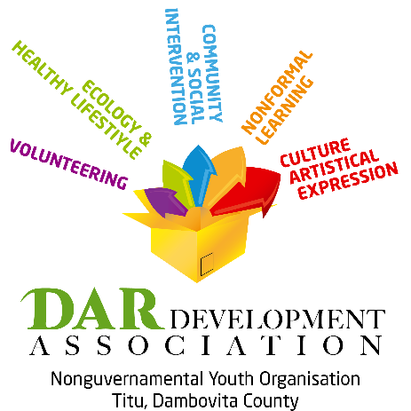


Exchange : ZOOM on Youth

Participating countries: 5 countries: Romania, Bulgaria, Italy, two other countries to be determined

Number of participants: 6participants + 1leader

Age of the participants: 16- 25 years old

Young people with fewer opportunities

Place: Titu, county Dambovita (at 50 km from Bucharest the capital of Romania /airport)

Period: 20.08.-30.08.2017 ten days of activities + other 2 travel (to be established exactly after approval)

Travel expenses covered according to Erasmus Plus distance calculator

Project Subject: Our organisation aims through this project to improve young people awareness over the following issues identity, employability, life style and active citizenship with focus on rural and peri-rural (small towns) areas.

Photography will play a key role as method for the young people to express themselves, the project will be a combination of group work sessions development workshops, outdoor activities and educational visits.

The project will encourage participants to be more active, healthier and respectful citizens and to develop personal skills, confidence levels and social input, bringing a positive impact on their communities.

