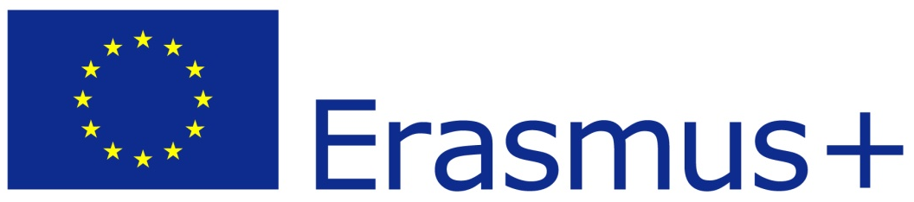

946428031

Full legal name | Youth of Europe
Full legal name (English) | Youth of Europe
Acronym | YoE
Address | Topolowa 1/29
City | Bydgoszcz
Country | Poland
National Identification Number | KRS 0000546802
Region | Kujawsko-Pomorskie
Email | sending@youthofeurope.pl
Web site | www.youthofeurope.pl
Otlas | https://www.salto-youth.net/tools/otlas-partner-finding/organisation/youth-of-europe.9042/

Type of Organization | Non Governmental Organisation
Is the partner org. a public body? | No
Is the partner org. a non-profit? | Yes
Activity level | Regional
Has the organization received any type of accreditation before submitting this application?
Description of the organization | Youth of Europe is a young foundation working on youth engagement in the local and international level. This includes civic, social and ecological actions. We have broad experience in design and implementation of EVS projects as well as other types of youth projects realized in the frames of the Youth in Action and Erasmus + programme. Among the foundation members are ex-EVS volunteers and experienced European projects coordinators. The NGO realizes its action across all of Europe, but its office is located in Gdańsk.  As a part of its activities foundation cooperates with University of Gdańsk and other expert institutions from the region.
Holders of projects  Projects financed from the  program "Youth in action"/Erasmus+ | Programme or initiative Identification/contract number Contracting promoter Title of the project  Erasmus+ 2015-2-RO01-KA105-015377 Babilon Travel Value the Difference  Erasmus+ 2015-2-SE02-KA105-001197 Carlstad Youth Association Life Optimizer  Erasmus+ 2016-2-SK02-KA105-000977 Liptiov Green Group Let’s Go Eco-Tourism!

Legal Representative | Vice-President
Title, Family Name | Mr Pronobis
First Name | Igor
Position | President
Email | info.projekty.miedzynarodowe@gmail.com
Telephone | 0048601822422

Contact Person
Title, Family Name | Mr Wilk
First Name | Piotr
Position | Project Coordinator
Email | sending@youthofeurope.pl
Telephone | 0048605573757

Please briefly present the partner organisation.

Youth of Europe is a young foundation working on youth engagement in the local and international level. This includes civic, social and ecological actions. We have broad experience in design and implementation of EVS projects as well as other types of youth projects realized in the frames of the Youth in Action and Erasmus + programme. Among the foundation members are ex-EVS volunteers and experienced European projects coordinators. The NGO realizes its action across all of Europe, but its office is located in Gdańsk.
As a part of its activities foundation cooperates with University of Gdańsk and other expert institutions from the region.

What are the activities and experience of the organisation in the areas relevant for this application?
Even though the foundation Youth of Europe ha officially existed for a short time, it is an experienced partner organisation in a number of different Youth in Action and Erasmus+ projects. Youth of Europe specializes in the field of sport and sustainable development. Other work focuses on young people from the region, to develop their social and leadership skills, to improve their interests in economics and democratic issues.
The organisation work focuses on the innovative use of sport as a method in non-formal education.
Notably, Youth of Europe has adopted water sports such as sailing, swimming and diving as a tool for integration and inclusion. Another branch of sport that is explored are winter sports. Organisation’s trainers acquired international ski instructor certificates, and ski rescuing permission.

Youth of Europe was a partner organizer of number Youth in Action/Erasmus+ inititives like Youth Exchanges: We play fair! in 2012, On the Amber Road in 2013, Youth in Democracy project: TrEND in 2012, and it is accredited EVS sending and coordinating organisation. Add to that YoE has developed number of projects in cooperation with foreign organisations like EuropAdo with Beligan partner AJMBO, activities will be hosted in Poland.
Witihin the Erasmus+ Youth of Europe was a host of a number of Youth Exchanges, in 2016 Life Optimizer and Value the Difference; in 2017 Be Involved, CultRural Lab; and in January 2018 winter sports project Cultural Inclusion Sports Club.
Youth of Europe has been partner also to KA2 projects: Strategic Partnership in the field of youth and Youth Alliance together with the Romanian and Belgium partners.
Currently Youth of Europe is a partner in a TEVIP KA2 Strategic Partnership together with Berlin organization Plan Politik.

What are the skills and expertise of key staff/persons involved in this application?
Youth of Europe was a part of a number of youth projects within Youth in Action and Erasmus+ programme. The members of the YoE are familiar with EU procedures, and are qualified to develop and implement youth projects, particularly youth exchanges, European voluntary service and youth democracy initiatives. The members of the association are trained instructors and medical rescuers.
Staff involved in the project:
Igor Pronobis - coordinator on the polish side of the project, experienced youth in action/erasmus+ trainer and coordinator, has conducted over 10 youth projects all around Europe, he is board member of ENGO MV International, for the Instytut Dziedzictwa Kruszwicy he works as International Projects Coordinator, he is certified First Aider, water rescuer, ski instructor, sport instructor and he is fluent in Polish, English, Spanish and French.
Ziemowit Pronobis, EVS coordinator at Instytut Dziedzictwa Kruszwicy, went for 5 months EVS to Dominican Republic, was coordinating number of projects around Europe, he attended over 30 YE and TC all around Europe. He is certified First Aider, water rescuer, ski instructor, sport instructor and he is fluent in Polish, English, Spanish and French.
Piotr Wilk - experienced youth leader at various youth projects around Europe. He is skilled in project management. Piotr holds a degree in tourism and did his EVS in Bulgaria. In Youth of Europe he is responsible for logistics and coordination of the events.
Katie Bak– Polish-American living permanently in Poland. In the organization he is in charge of delivering workshops, correspondence and the application writing. Katie hold a diploma in mediation and cultural studies. Shares his American perspective and innovative methods of non-formal education. She is native English speaker but fluent in Polish.

