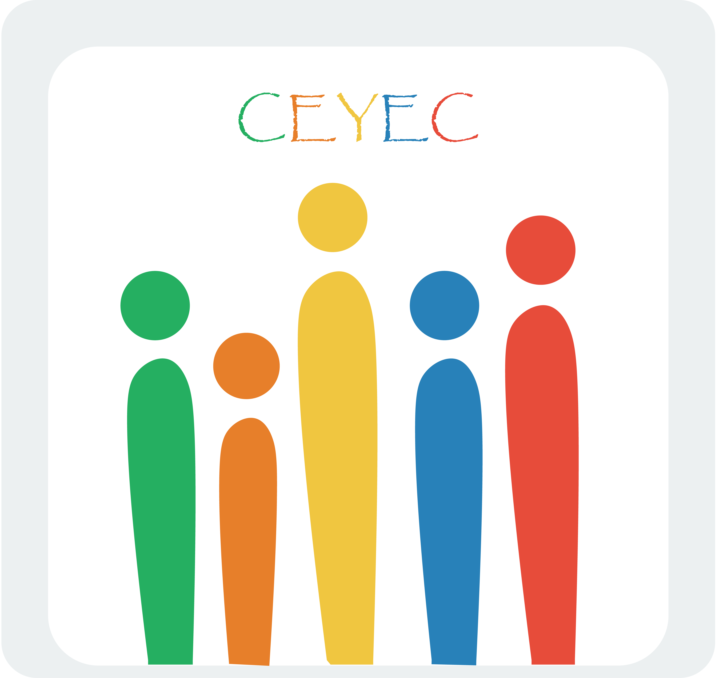

Partner Identification Form

A. PARTNER ORGANISATION
PIC |  |  | 922010609
Full legal name (National Language) |  |  | Civic Education and Youth Empowerment Center
Full legal name (Latin characters) |  |  | Civic Education and Youth Empowerment Center
Acronym |  |  | (CEYEC)
National ID (if applicable)
Department (if applicable)
Address (Street and number) |  |  | Nor Nork 8th Microdistrict, 4/26
Country |  |  | Armenia
Region |  |  | Yerevan
P.O. Box
Post Code |  |  | 0049
CEDEX
City |  |  | Yerevan
Website
Email |  |  | ceyecarmenia@gmail.com
Telephone 1 |  |  | +374 55 67 45 57
Telephone 2 |  |  | +374 93 55 30 45
Fax
B. PROFILE
Type of Organisation |  |  |  | YOUTH ORGANISATION
Is the partner organisation a public body? |  |  |  | No
Is the partner organisation a non-profit? |  |  |  | Yes
C. ACCREDITATION
Has the organisation received any type of accreditation before submitting this application? |  | - N/A
Has the organisation received/applied for any EU grants? |  | - Yes
D. BACKGROUND AND EXPERIENCE
Please briefly present the partner organisation. | Civic Education and Youth Empowerment Center (CEYEC) is a youth organisation, funded by young enthusiasts from all over Armenia, aiming at developing civil society in Armenia through civic education and youth empowerment.  Here are the objectives of the organisation:  - To promote human rights, democracy and equal rights among youth  - To foster conflict resolution and the establishment of peaceful environment  - To stimulate youngsters' active participation and involvement in society and decision making process  - To increase the political self-consciousness in society  - To support the promotion and development of self education and non formal education among youth  - To increase the participation and integration of youth with fewer opportunities in youth projects and life  - To promote intercultural dialogue  - To foster the dissemination of voluntary work  CEYEC is a founder member and the main organisation of international network “Peace and Development Youth Club”, which includes 6 countries – Armenia, FYR Macedonia, Belgium, Germany, Spain and Czech Republic. Network is established to address local and international challenges in European and Eastern Partnership states.
What are the activities and experience of the organisation in the areas relevant for this application? | Core members of CEYEC are working together for already 5 years originally being members of "Civic Education and Youth Empowerment" informal group. They have conducted Training courses related to Conflict management, Cultures, Peace-building, personal development, Civic activism and active citizenship.  They have cooperated individually and were involved in implementation of project financed by Erasmus+, Council of Europe, German office of Foreign Affairs, Konrad Adenauer Foundation, etc. They have more than 10 years personal experience working in Youth Sphere.
What are the skills and expertise of key staff/persons involved in this application? | Mkhitar Hayrapetyan, president: Mkhitar is the head of the NGO Civic Education and Youth Empowerment Center. He is actively participating in civic and political lives of Armenia since 2007. Mkhitar is holding a Master degree in Oriental studies. 2011-2015 he was a vice president at “Association of young politicians”. Mkhitar is one of founding members of “Civil Contract” political party. Mkhitar is responsible for coordination and work with local and international partners.  Grisha Edzgeridze, vice-president: Grisha is actively involved in civic activism of Armenia since 2011. He studies at Yerevan State University in faculty of Oriental Studies. During last 3 years Grisha has organised plenty of protest marches and demonstrations in support of educational system reforms.  Ruben Rubinyan, board member: Ruben is an International Relations specialist. He has earned a Bachelor's degree in International Relations at Yerevan State University, a Master's degree in Politics and Security at University College London and a Master's degree in European Studies at Jagiellonian University, Krakow. In 2015 Ruben has worked at UNHCR – the UN Refugee Agency, focusing on the problems faced by mainly Syrian, Ukrainian and African refugees in Armenia. He has also been involved in the sphere of civic activism in Armenia – from monitoring elections to taking part in environmental protection.  Gevorg Petrosyan, board member: Gevorg is a PhD Candidate in Turkish Studies. He is an expert on Middle East region, Conflict management. Gevorg has strong background both in academical and youth work spheres.  Lena Nazaryan, board member: Lena is a project coordinator with more than six years' experience in the sphere of civil activism. She has worked in Investigative Journalists and Region Research Center NGOs as a journalist. 2009 – 2015 has worked in Transparency International Anti-corruption Center NGO as a project specialist. Lena is currently working in The American University of Armenia Center for Responsible Mining as a mining community monitoring and outreach coordinator. She was a member of "Save Teghut Civic Initiative", observer in Election Observations Missions both in Armenia and in Georgia.  The team of CEYEC engages civic active youngsters, educational professionals with more than 15 years of experience in Non formal education and youth work both on local and international levels.  Besides the committed team within CEYEC, we are also working with external partners, good friends of the organisation which follow the same values as we are in CEYEC - Human Rights, active participation, inclusion, Democracy and Rule of Low.
E. LEGAL REPRESENTATIVE
Title | Mr
Gender | M
First Name | Mkhitar
Family Name | Hayrapetyan
Department
Position | President
Email | mkhitarhay@gmail.com
Telephone 1 | +374 93 67 45 57
Address | Nor Nork 8th Microdistrict, 4/26
Country | Armenia
Region | Yerevan
P.O. Box
Post Code | 0049
CEDEX
City | Yerevan

