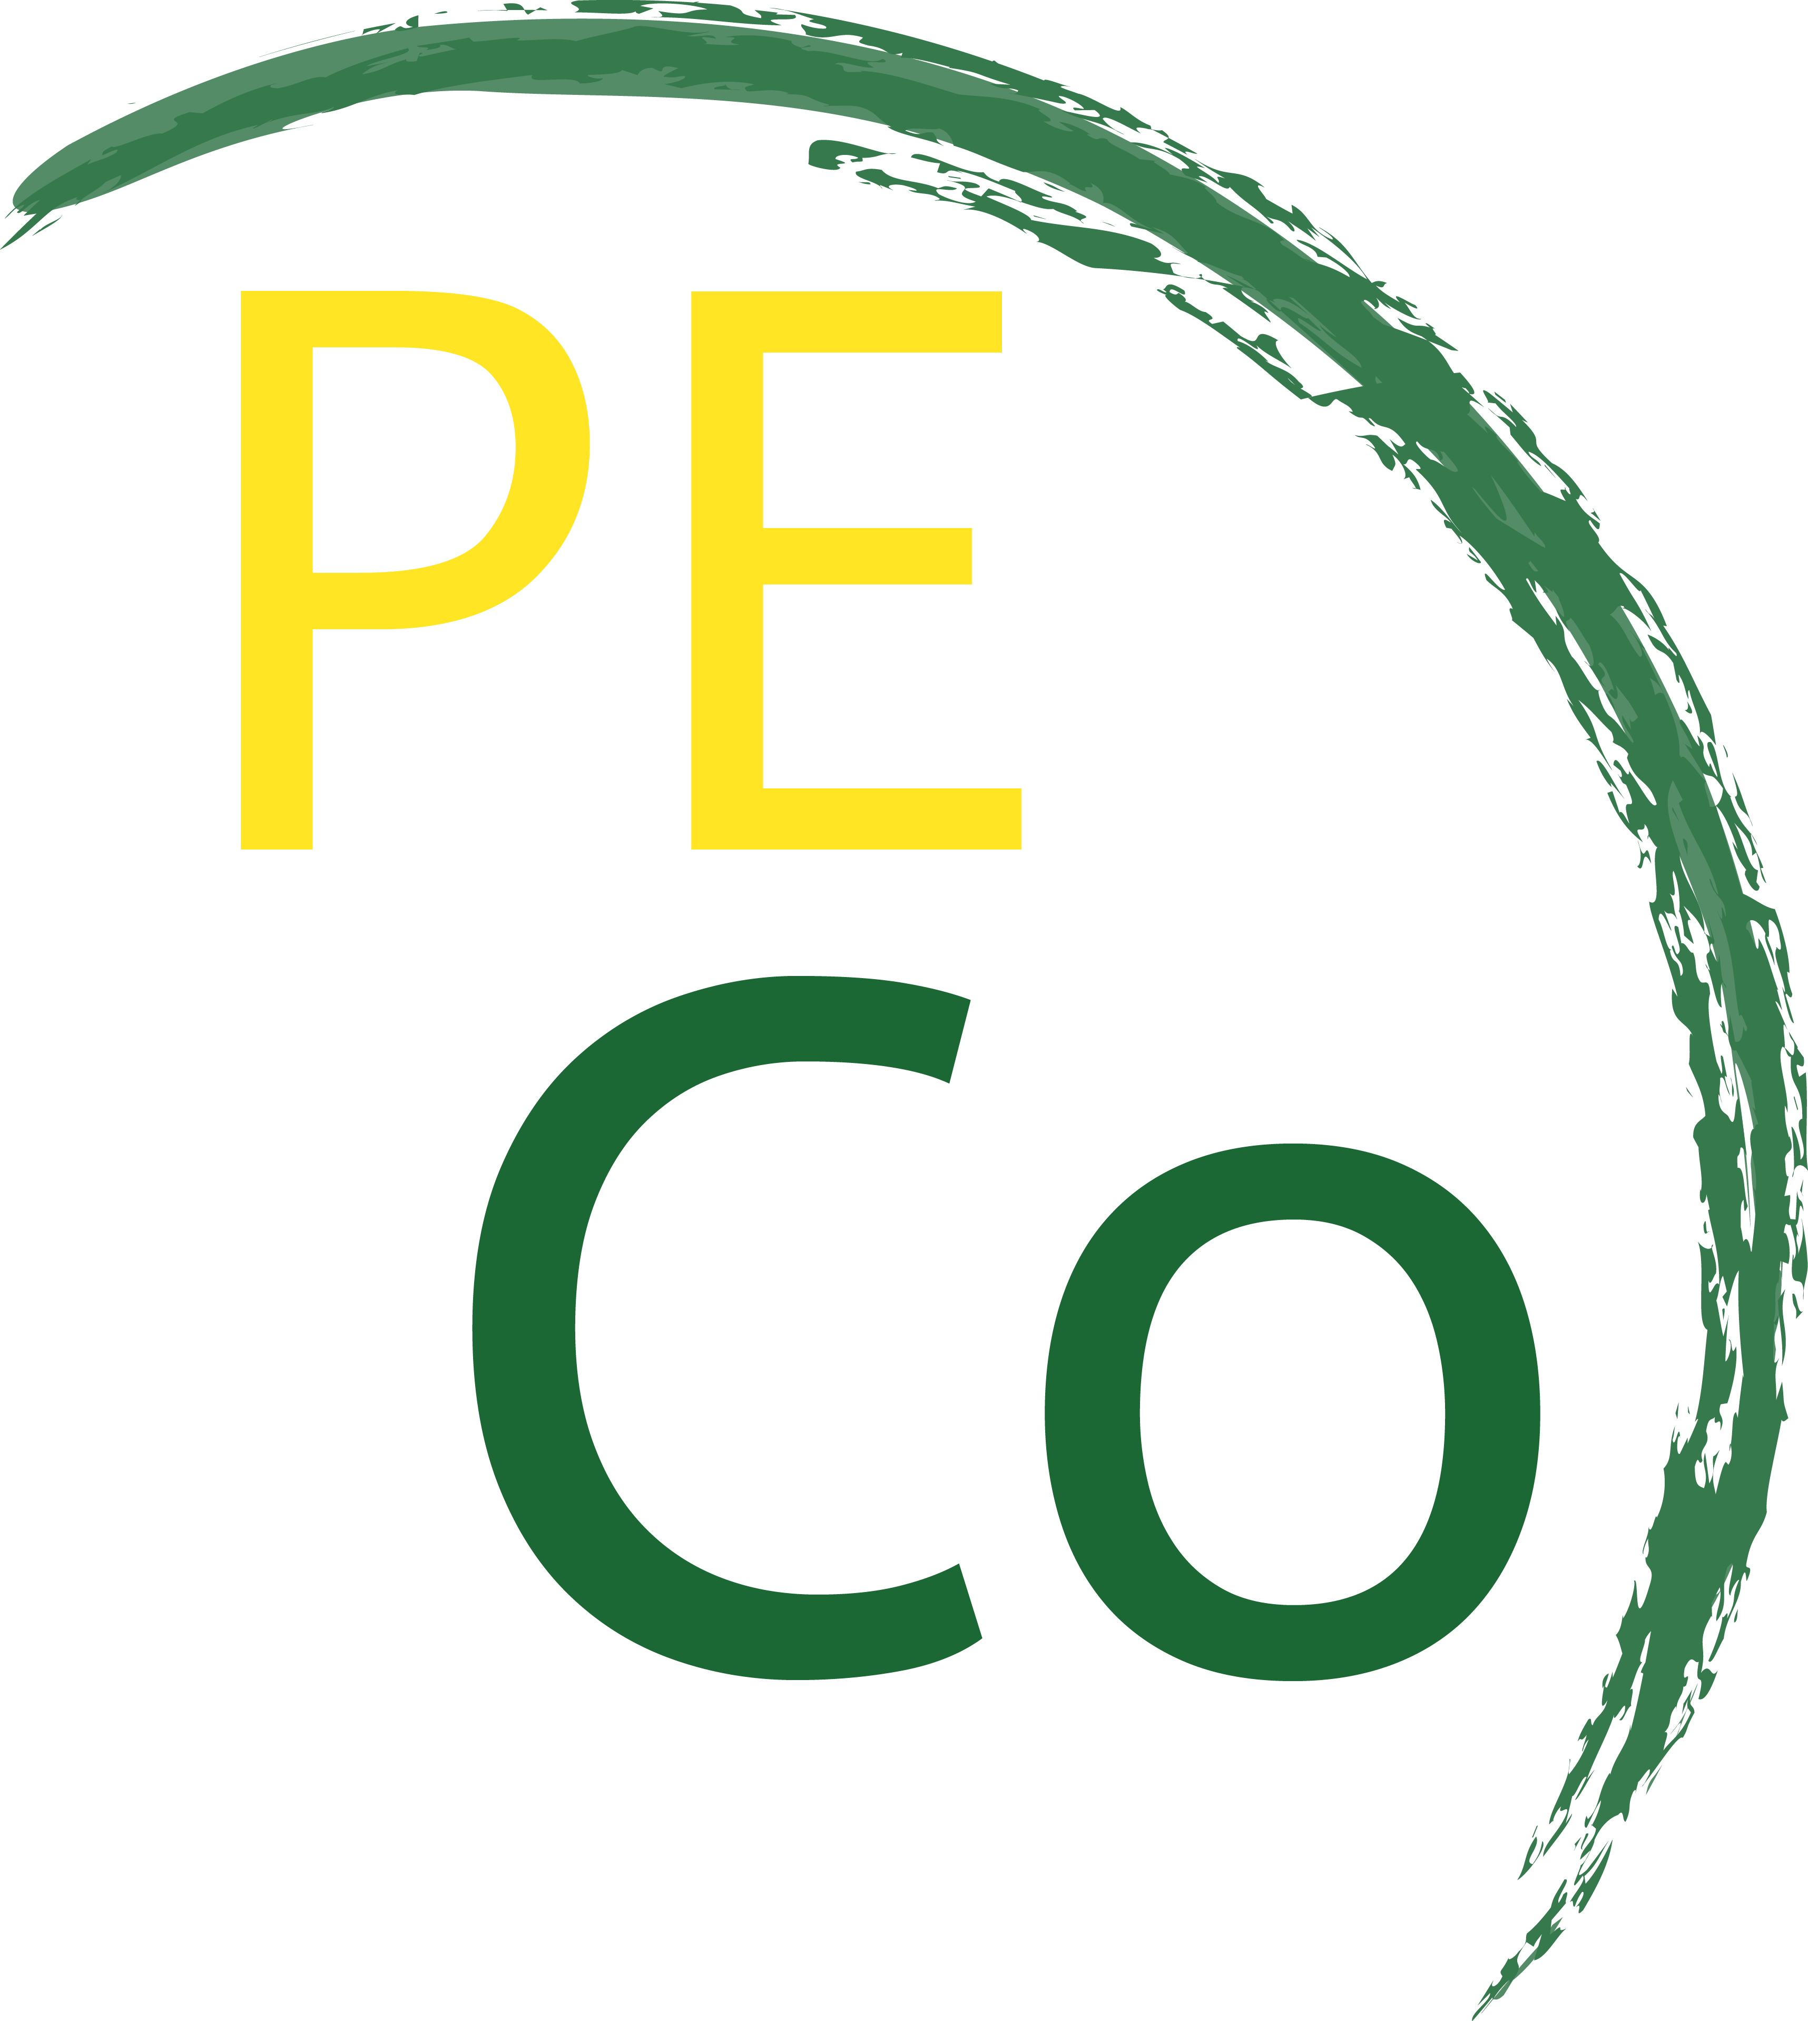

***Please return it together with your P.I.F at*** [exchanges@peco.genova.it](mailto:exchanges@peco.genova.it)

* HOW DO YOU THINK TO SHARE THIS PROJECT WITHIN YOUR LOCAL COMMUNITY?
* HOW THIS PROJECT CAN BE HELPFUL FOR YOUR ORGANIZATION AND FOR YOUR YOUNGSTERS?
* HOW DO YOU USUALLY FIND PARTICIPANTS?
* HOW DO YOU FIND PARTICIPANTS?
* WHY YOU ARE INTERESTED IN THIS PROJECT?
* HOW DO YOU FIND PARTICIPANTS?

**THANK YOU**

* DO YOU HAVE OR YOU COULD GET GOOD CONNECTIONS WITH LOCAL MEDIA ?
* DO YOU HAVE EXPERIENCE WITH THE TARGET GROUP OF THE PROJECT?

IF YES, TELL US MORE !

**Terrarum Orbis project**

**QUESTIONNAIRE**