Call for EVS
Youth center of Trbovlje is applying for a new EVS project on the second deadline for Erasmus + projects on 26th of April.
Project title: »Creative little feet«
Project duration: 1.9.2016 – 5.31.2017
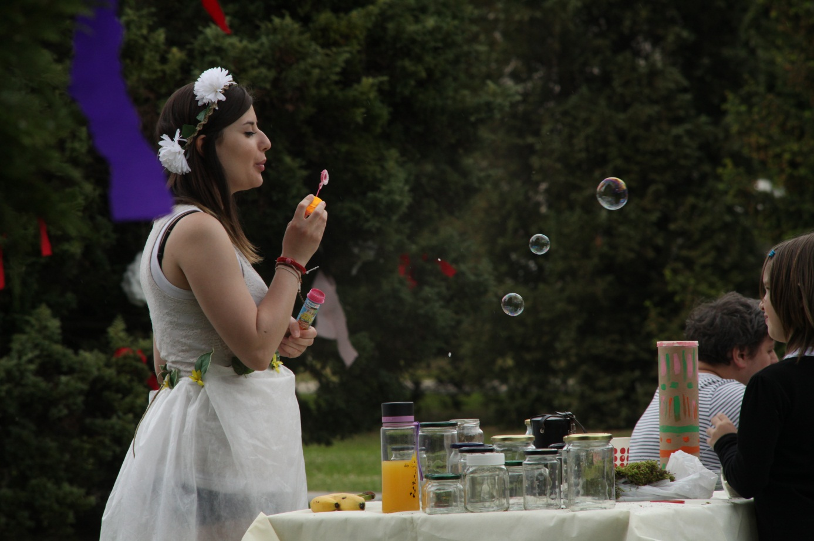
Aims of the project
- Encouraging creative way of learning, by building a better connection between formal and informal learning. Bringing non-formal methods of learning in school subjects such as arts, music,sports and languages.
- Building common grounds between youth organizations and schools trough the support of EVS volunteers that enrich the organizations work.

WHO?
What kind of a participant are we looking for? A young person, who dose't have a problem working with children, since more than half of the project time will be spent in a primary school. Person who is flexible, open-minded, has a self-motivation and proactive. Who has highly developed cultural awareness and is socially responsible, who knows how to express himself/herself and is familiar with communication in a foreign language. Someone who likes creative methods of learning and enjoys working with children. Creativity is always welcome and will come in handy for school subjects such as art,music,sports, and languages.
WHERE?
Volunteer will be active in 2 organizations in Zasavje region, smallest region in Slovenia (http://en.v3krasne.si/). Volunteer will spend 4 days/week working in the primary school Ivana Cankara Trbovlje (http://www.osic.si/ )
and 1 day/week in youth centre Trbovlje (http://www.mct.si/ and https://www.facebook.com/mct.mladinskicentertrbovlje).
The volunteer will have the support from both organizations during the whole project. Mentors will be provided for the volunteer.

WHEN ?
1.9.2016  31.5.2017

WHAT?
The volunteer's tasks at the school will be to spend quality time with children and implement informal methods of learning trough games, songs, art and sports . Volunteer will enrich the school enviroment with individual support and group dynamics trough variety of non formal methods. Volunteer will participate in sport, cultural and creative activities which are preformed daily and carried out a language course in his/her native language. The volunteer will have a chance to creatively show his or hers culture trough different lessons in school.
At Trbovlje Youth centre the volunteer will be part of the team together with other international volunteers. The volunteer will have a chance to create different after school workshops for kids and other youth. The volunteer will also help with the realization of the program in the youth center, such programs as youth exchanges, concerts, free time activities.
The volunteer can be a link between the formal and informal learning by implementing their culture and methods in to both organizations.

