______________________________________________________________________________

About us

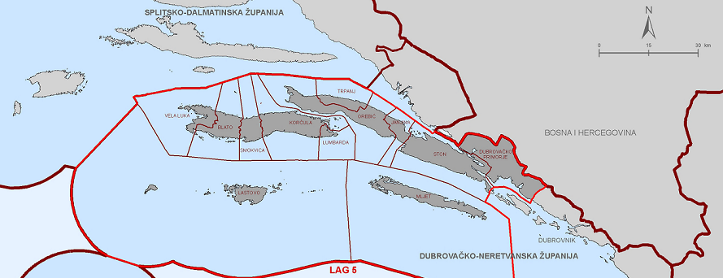

LAG 5 is an NGO founded with the purpose to implement the LEADER approach in south Croatia. LEADER (Acronym derived from French: "Liaison Entre Actions de Développement de l'Économie Rurale") is an acronym that stands for "links between actions for the development of the rural economy".
Our mission is to create a LAG 5 community with a competitive economy, high quality of life and attractive preserved cultural heritage whose development is based on traditional values and sustainable development.
LAG 5 stretches on 5,166 km2 of land area in the Dubrovnik-Neretva County. It covers five areas: Dubrovnik West Coast, peninsula of Pelješac, islands of Mljet, Korčula and Lastovo comprising the territory of 12 local authorities: Municipality of Dubrovnik West Coast, Ston, Janjina, Trpanj, Orebić, Mljet, Lumbarda, Smokvica, Blato,Vela Luka, Lastovo and Town of Korčula. Our administrative structure is formed from the following bodies: the President and Vice President, Steering Committee and the Supervisory Board. They are chosen according to the LEADER principles by the LAG 5 General Assembly for the period of two years and can be re-elected. They participate as volunteers. Manager that is chosen by the Steering Committee for the period of four years and can be re-elected. Manager is employed in the organisation.
LAG 5 is an accredited body to implement LEADER approach in Croatia and is therefore establishment of of local partnerships (local action groups - LAGs) who link local stakeholders from all three sectors. Our task is creating and implementing local development strategies, making decisions on the allocation of available funds and management of the funds.
We produce effects in encouraging local sustainable development:
- we pool and combine existing human and financial resources in the public, private and civil sectors, and volunteers,
- we bring local stakeholders together in order to launch joint projects and cross-sectoral actions in order to achieve synergy, a sense of common ownership and critical mass needed for improving the competitiveness of the area,
- we strengthen dialogue and cooperation between different rural stakeholders who often do not have joint work experience, thus reducing potential for conflicts and moderating situations in which solutions are reached through consultation and discussion,
- as an organisation that is immersed in interaction between different partners, we moderate the process of adaptation and change, whilst taking account of the environment, diversification of the rural economy and quality of life.
Our stakeholders include:
- representatives of local self-government and public institutions,
- trade/professional organisations and unions (agriculturists, small enterprises and other activities),
- associations (environmental protection, cultural service provision, community development, women, youth etc.)
- local development agencies,
- business sector,
- media,
- high-profile individuals.

