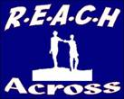  REACH ACROSS PROFILE INFORMATION  PIC number: 945650188 | R.E.A.C.H ACROSS  Residentials, Educational Activities, Community Holidays  10-14 Bishop Street, L’Derry, BT48 6PW  Tel.No. (028) 71 280048 Mobile No. 07854833371  www.reach-across.co.uk reach_across@hotmail.com  Registered Charity No. XR 11455

1) | Name of Partner Organisation and Main Contact for Exchange
- REACH Across
- Barney Mc Guigan ( Project Co-ordinator)
2) | Address of Organisation, Telephone, E-Mail and Website
- REACH Across, 10-14 Bishop Street, Derry, Northern Ireland BT48 6PW

- Tel: 0044 28 71 280048 Mobile: 07854833371

- E-Mail: reach_across@hotmail.comWebsite: www.reach-across.co.uk
3) | Age Group, Gender and Social Background of Group Members
- Project Age Group: 15 – 17 years Gender: Male and Female
- 12 young people per group. 6 male and 6 female if possible.
- 1 male and 1 female leader for each group.
- REACH Across Members are from towns in the North-West region of N. Ireland. Some members are from areas of low income and high unemployment.
4) | 3 Main Aims of REACH Across
- To create friendships between young Catholics and Protestants
- To provide opportunities for young people to gain new qualifications and
take part intraining courses that will benefit their futures
- To provide international opportunities for young people that will increase
awareness of cultures, social conditions, youth matters etcin Europe
5) | a) Preferred Dates and Number of Days for Exchange  b) Possible Dates for Advance Visit
- Exchange–Stage 1 -Derry, N. Ireland (July) Stage 2-Partner Country (Aug)
Each stage should have at least a 4 day programme
- Advance Visits- Advance Visits in May or June
6) | Accommodation and Facilities To Be Used During Hosting Stage of Exchange
 | Our Partner Group will stay in fully-equipped apartments at our local University and the facilities will include a gymnasium, sports areas, laundry etc
7) | List of Activities, Workshops, Visits etc Proposed For Exchange
 | a) Drama b) Art & Craft session c) Water Activities/Swimming d) Various Sports e) Cultural Learning f) Laser Quest g) Historical Visits h) Ice Skating i) Visit N. Ireland Parliament j) Meet the Mayor of Derry k) Mini Olympics

8 | Currency And Additional Money Advice
- N. Ireland uses British Pounds. The Republic of Ireland uses the Euro.
- There are many banks and ATMs
- REACH Across will cover costs of food, accommodation, transport and activities during the local stage.
In N. Ireland, REACH Across will be responsible for all costs relating to accommodation, activities, food and transport
9) | Types of Transport To Be Used During Exchange
 | - REACH Across will collect the partner group from the airport. During your visit we will use a minibus and large buses.
10) | Preferred Food Types of REACH Across Group
 | REACH Across members like pizza, curry, pasta, burgers, potatoes, chips, sandwiches (tuna, ham, salad etc), chicken, lasagna
 | Any Other Helpful Information
11) | - During the Advance Visits, representatives should visit the planned accommodation, meet selected young people and discuss food, activities, transport and workshops  - When participants are selected we can start a Facebook page to help with planning and group introductions  - During the exchange we will make a DVD of the activities  - Your group will have one free day so that you can relax at the accommodation,  go shopping, go on a tour of Derry or play sports
DERRY CITY, N. IRELAND

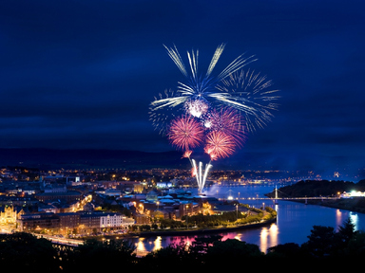
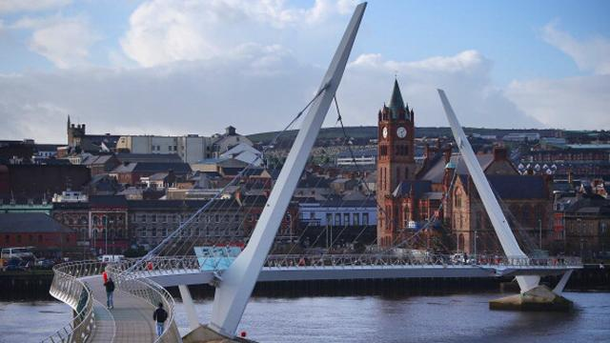
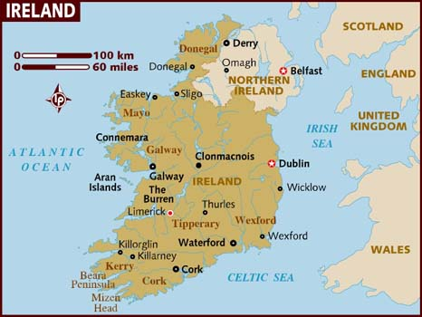

MAGEE UNIVERSITY STUDENT VILLAGE
SPORTS AREA AND ACCOMMODATION

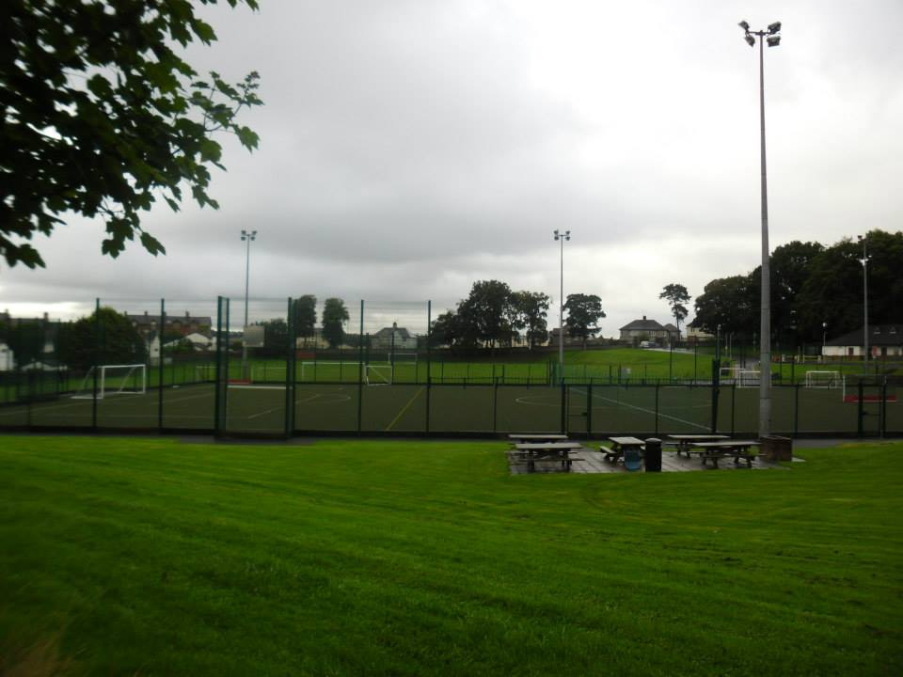
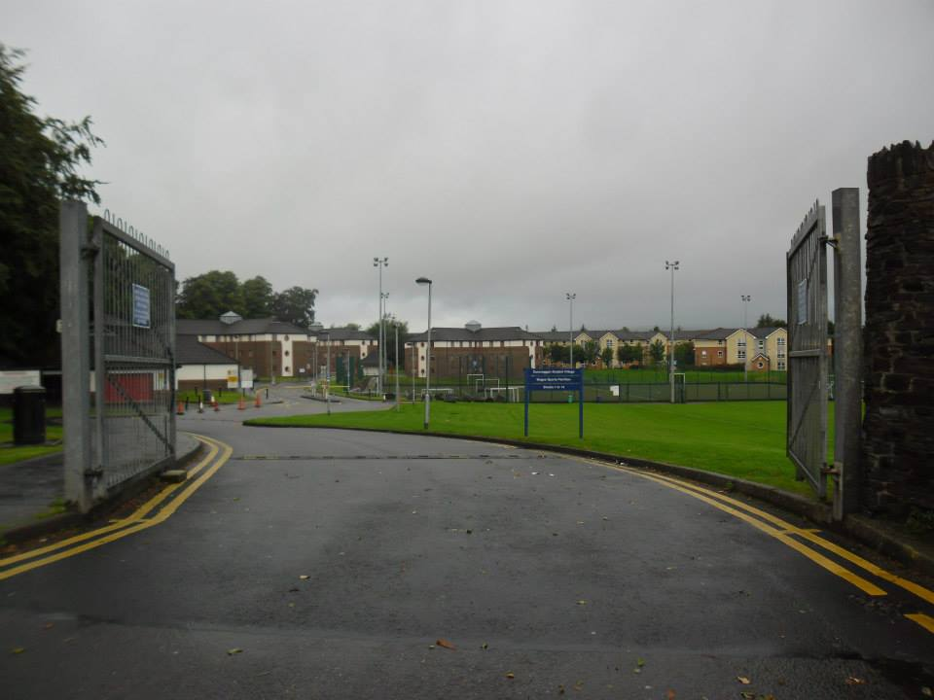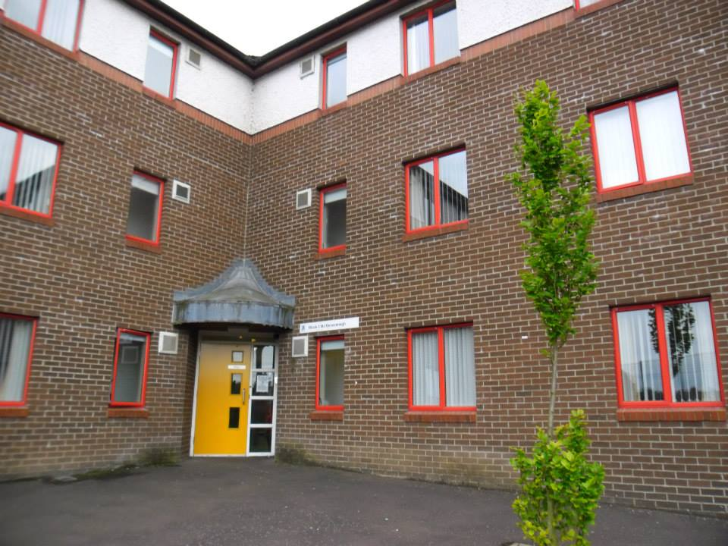

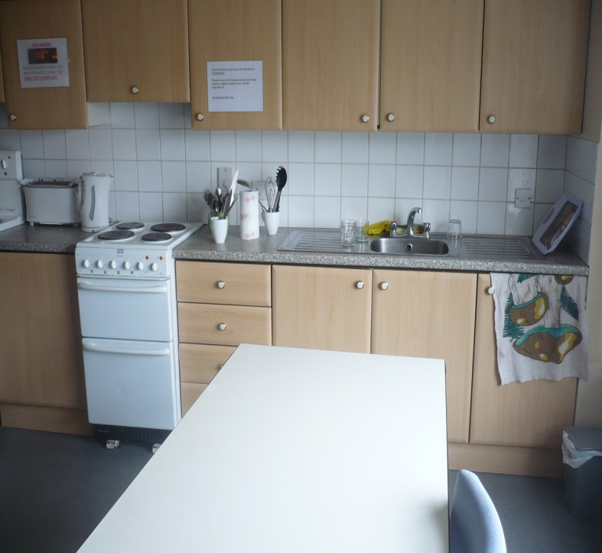
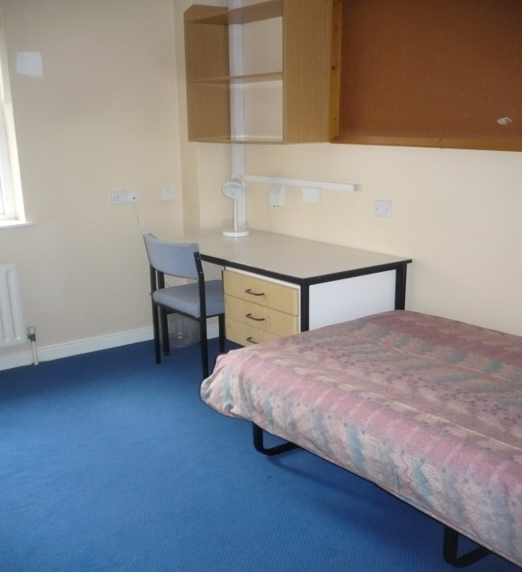

INTERNATIONAL EXCHANGE (CYPRUS & HUNGARY 2019) - N. IRELAND SCHEDULE
Timetable | Activities |  |  |  | Non-formal and informal learning methods used
SCHEDULE DAY 1 DESCRIPTION
AM | Cypriot Group Arrive
 | Group Introductions & Organisation Profiles |  |  |  | Ice-Breaker Games, Powerpoint& DVD Presentaions
PM | Team-Building Session |  |  |  | Interactive Workshop To Help Confidence Of Participants
SCHEDULE DAY 2 DESCRIPTION
AM | Visit Tower Museum - Story Of Derry Exhibition |  |  |  | Learn of the traditions and historical events of Derry
 | Basic Language Skills |  |  |  | Basic Greek Words & Phrases To Assist Communication and Learning
PM | Cultural Treasure Quiz |  |  |  | Groupwork Session To Familiarise Participants With Local Environment and Cultural Landmarks
 | Trampolining Games & Exercises |  |  |  | Informal Activity To Enable Integration
SCHEDULE DAY 3 DESCRIPTION
AM | Visit Giant's Causeway And Famous Rope Bridge |  |  |  | Learn about historical and cultural landmarks in N. Ireland
 | Visit Historical Sites and Film Locations |  |  |  | Visit Medieval Landmarks & Locations In Game of Thrones
PM | International BBQ |  |  |  | Groups prepare and present traditional meals and develop catering skills
SCHEDULE DAY 4 DESCRIPTION
AM | Cultural & Social Workshop |  |  |  | Discuss Cultural and Social Traditions In Partner Countries & Europe
 | Raft-Building |  |  |  | Informal Activity To Build Integration, Teamwork & Confidence
PM | Music & Dance |  |  |  | Cultural Dance & Music of Respective Countries
SCHEDULE DAY 5 DESCRIPTION
AM | Self Programme Day |  |  |  | An Informal Day of Education Visits or Cultural Entertainment
 | Laser Quest |  |  |  | Team-Building and Social Activity
PM | Drama Workshop |  |  |  | Develop drama skills including script writing and performance
SCHEDULE DAY 6 DESCRIPTION
AM | Tour of N. Ireland Parliament and Meet Politicians |  |  |  | Learn of Political Structures and Ask Politicians About Social Issues
 | Visit Belfast PeaceLines& Post-Conflict Locations |  |  |  | Visit Landmarks of Division & Tragedy Related To Our Conflict
PM | Ice-Skating Activity |  |  |  | Informal Activity To Enable Integration & Confidence Building
SCHEDULE DAY 7 DESCRIPTION
AM | Art & Craft Workshop (FABLAB) |  |  |  | Promote creativity and design skills by producing items of art or craft
 | Indoor Sports |  |  |  | Promote healthy living and develop sporting skills
PM | Visit Foyle Search & Rescue |  |  |  | Visit a community project to learn of procedures and methods used to prevent suicide
 | N. Ireland & Europe Now |  |  |  | Discuss Brexit, Refugee Crisis, Global Youth Issues, New Cold War
SCHEDULE DAY 8 DESCRIPTION
AM | European Union & Division Workshop |  |  |  | Groupwork Exercises & Debates re European Benefits & Divisions
 | Watersports Activity |  |  |  | Informal activity to cement integration and develop water confidence
PM | Digital Skills |  |  |  | Production of a Finale DVD from Project Footage
SCHEDULE DAY 9 DESCRIPTION
AM | Visit Bloody Sunday Centre & Apprentice Boys Museum |  |  |  | Visit Centres Dedicated To Major Historical Events Associated With This City
 | Meet The City Mayor |  |  |  | Learn About Local Government And interview Councillors
PM | Project Evaluation & Farewell DVD |  |  |  | Evaluation Session - Participants Individually Review Project
SCHEDULE DAY 10 DESCRIPTION
AM | Cypriot Group Depart
PM

