Be Practical, Stay Healthy-BPSH
Erasmus+ KA1-Youth Exchange Project
BPSH is a youth exchange project within the Erasmus Plus Program. The Project aims to examine the ways of healthy nutrition, find out some better ways to have a healthy life and minimize the problems stems from a bad nutritional habit. 48 young people will be together to share their best practices about this subject. We will have chance to be informed by experts on nutritions. To find and eliminate the wrong and harmful facts and habits known as true.
Project will be held in Mengen, BOLU. A city aproximately 3 hours far from Istanbul with amazing natural beauties.
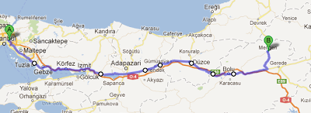
Within the program, we will have to chance to see some of the natural places in BOLU as well.
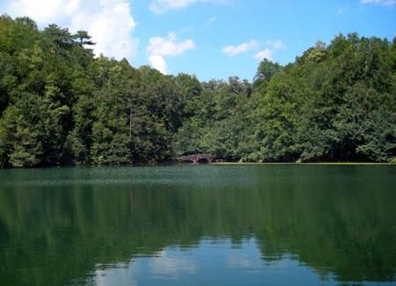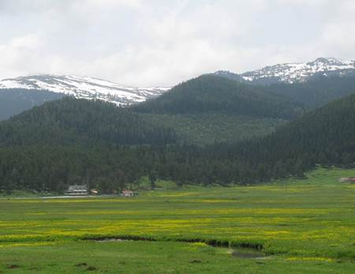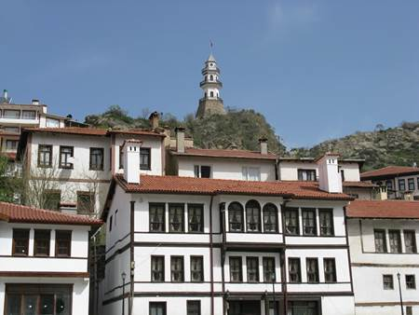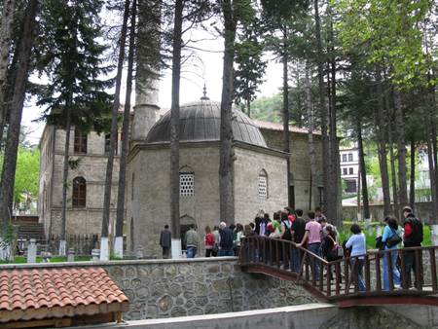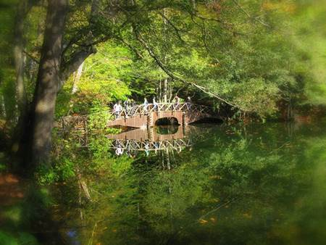
The project take place between 20-28 August 2016.
Please do not hesitate to asking any question. You can reach us, gunayyusuf@windowslive.com
Active EuroYouth Team
Sincerely
Yusuf GÜNAY-President

