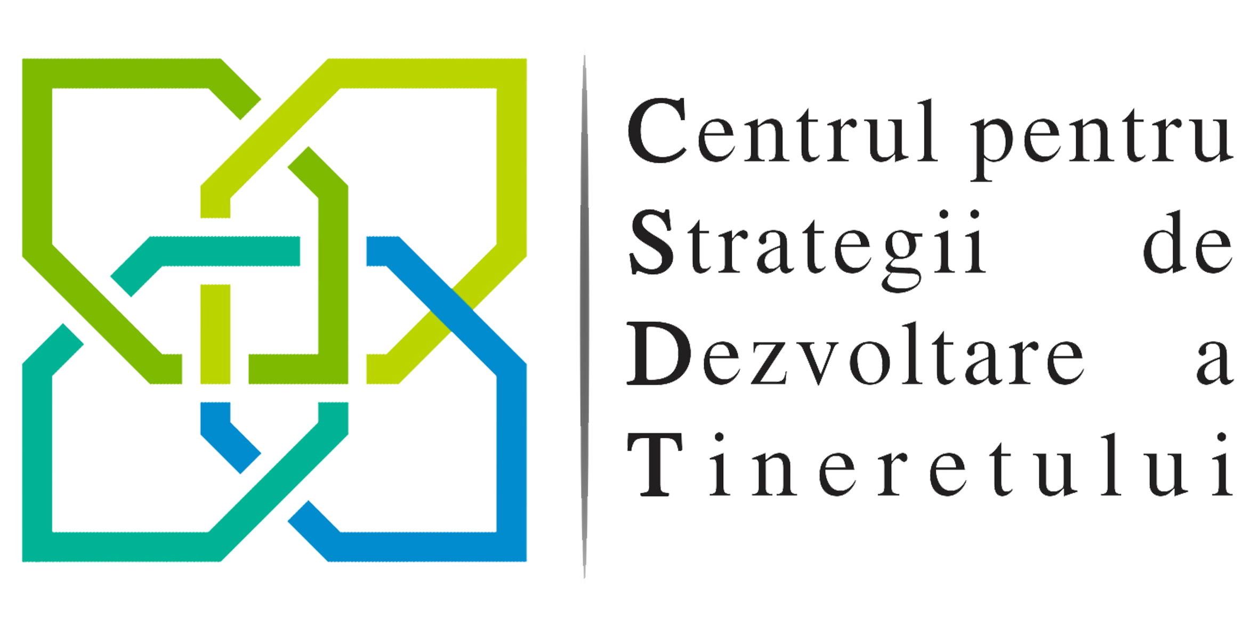

Organization Description

Motto: “Education is the most powerful weapon.”

Short description:

We're an organization that is actively involved in project development and implementation in the local, national and international non-formal education sphere, that directly aims at personal and professional youth development.

Values, vision, mission, goal, objectives:

The vision and the mission draw the main axis for the entire Center of Strategies for Youth Development’s (CSYD) activity, which convey what we wish to realize and what paths we have to take.
The values establish the main coordinates for the youth strategies' which we wish to implement with their help.

The values which underline the Center of Strategies for Youth Development are:

- charitable activities;
- cultural and artistic events;
- entrepreneurship;
- non-formal education;
- civic responsibility;
- volunteering;

The Center of Strategies for Youth Development’s vision is of a world in which formal education additionally soaks with the non-formal and informal education methods to contribute to the development and accountability processes of the youth. We believe that the vision is achievable only through designing and implementing strategies meant to develop the personal and professional abilities of the youth, both in a formal, academic environment and in a non-formal one..

Our mission is to continuously transform the community through the development of young, responsible leaders and a mentality oriented towards proactivity, involvement and action.

The Center of Strategies for Youth Development has the main goal of developing and implementing youth strategies under the form of projects that target youth personal and professional development through their active involvement in the educational process.

In order to achieve the Center of Strategies for Youth Development’s goal, we will hold direct economical and charitable activities:

- organizing youth camps;
- organizing training lectures;
- providing individuals and legal entities with consultancy on project organizing, implementing or writing;

In order to achieve the Center of Strategies for Youth Development’s goal, we propose a series of activities and objectives:

- implementing educational programs for youths;
- developing volunteering projects for youths;
- forming local, national and international partnerships meant to cooperate to achieve experience exchanges meant to contribute to the personal and professional development of the youths involved;
- holding international exchanges of youths;
- providing consultancy to the youths which wish to conceive projects which have common goals with CSYD;
- organizing both national and international youth camps;
- developing educational resources which can be used as teaching materials in youth development processes;
- organizing activities which aim to increase youth chances of being employed;
- implementing projects which aim to educate and train adults;
- promoting and involving in cultural activities which aim to promote local, national and European patrimony;
- organizing cultural and artistic events;
- supporting intercultural events through youth involvement in such initiatives;
- organizing projects and lectures which aim to develop organizational capacities of youth associations;
- holding charitable events;
- involvement in volunteering activities with social purposes;

About us:

The CSYD association was born in January 2014, being active for almost two years as an informal group of youths with initiative. Due to growing involvement in various local and international projects, it was decided that it is time to move onto the next phase. Thus, by the end of 2015 the initiative group has gained its legal personality of a nongovernmental association named "Centrul pentru Strategii de Dezvoltare a Tineretului" (Center of Strategies for Youth Development).
The main strong points of the CSYD are the multisectoral experience of the team as well as expertise in consultancy processes and organizational management training.
We plan on creating further youth programs meant to develop the leadership potential of each participant as well as other personal and professional abilities, based on the sharing of knowledge, experience and ideas using non-formal education methods. The youth development strategies which we implement as projects in which youths are actively involved in are adapted to all that wish to develop, regardless of age or level of experience, are innovative from a methodological and thematic point of view, are flexible, also including short term modules and long term sessions.

Legal form:

The Center of Strategies for Youth Development is a private law association, legal entity without patrimonial purpose, nonprofit, nongovernmental, apolitical, independent, with public benefit, of which activity will undergo according to the law O.G. no. 26/2000, Law no. 246/2005 and of other legal regulations of the Romanian State.
Founding members:
Vîlceanu Tudor Andrei – president
Leschian Rareș - vicepresident
Doroghi Dan - secretary
Silaghi Sorin - censor

Billing Data:

ASOCIAȚIA CENTRUL PENTRU STRATEGII DE DEZVOLTARE A TINERETULUI, headquarters located in Timişoara, Arieş str., no. 19, room 004b-006/4, Timişoara, Timiş County, Romania, Fiscal Unique Registration Number (U.R.N.) 35320660, banking account IBAN RO29BTRLRONCRT0325849101, open at Banca Transilvania Timişoara – Bega Agency, represented by Vîlceanu Tudor Andrei as president.

VÎLCEANU TUDOR ANDREI, president of the Center of Strategies for Youth Development association residing on General Gheorghe Magheru str., no. 5, building BM1, staircase B, 5th floor, ap. 53, Oradea, Bihor County, Romania, identified by ID XH series no. 984753 released by SPCLEP Oradea on 14.01.2015, PIN 1930515055082.
