**A   
DIARY   
OF   
AN OBESE**

**From 30.09.2016**

**To 07.10.2016**

ALGERIA-EGYPT-FRANCE MACEDONIA-POLAND-SPAIN SERBIA-TUNISIA-TURKEY

DIARY OF AN OBESE

***On this page there is some basic information about the project, partners, useful websites and etc. On the next page; you will find the provisional activity program and a list of things you should do before the training course. On the last page you will see a map of Izmir, travel details and a short description of the venue where the training course will take place.***

***Who? When? Where? What?***

As Turkish Red Crescent Izmir Branch, we’re planning to make a youth exchange project about OBESITY. This project will take place in the center of Izmir. There will be 9 countries including Turkey. There will be workshops, brainstorming about OBESITY, food habits, healty diet etc. And also we plan to put some sport activities. This project also will include work with visually impaired students.

That’s why; we kindly ask you to find 4 participants + 1 leader, **5 participants** in total. (2 participants must be Obese), aged between 18 and 30. Gender equality is important.

**Countries**: ALGERIA-EGYPT-FRANCE-MACEDONIA-POLAND-SPAIN-SERBIA-TUNISIA-TURKEY

**Date**: Between **30th** of SEPTEMBER and **7th** of OCTOBER 2016 (6 Days are for activities, 2 for travel) (Dates are to be made certain later)

|  |
| --- |
| For travel distances between 100 and 499 KM: 180 EUR per participant |
| For travel distances between 500 and 1999 KM: 275 EUR per participant |
| For travel distances between 2000 and 2999 KM: 360 EUR per participant |
| For travel distances between 3000 and 3999 KM: 530 EUR per participant |
| For travel distances between 4000 and 7999 KM: 820 EUR per participant |
| For travel distances between 8000 KM or more: 11000 EUR per participant |

**Expences**:

We will calculate your distance with   
<http://ec.europa.eu/programmes/erasmus-plus/tools/distance_en.htm>

*We will cover all local transportations and accommodations.



**We kindly ask participants:**

to do research about the rate of *obesity* in their countries and gather information about its reasons

to be able to present *food habits* in their countries

to be prepared to present their *food culture* in the intercultural evenings

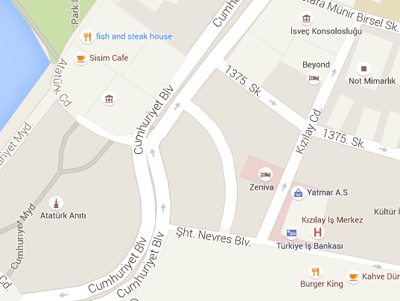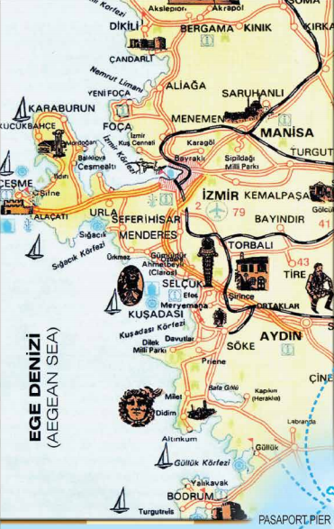Accommodation: [***Zeniva Hotel***](http://www.zenivahotels.com/)

Red Crescent

Hotel

(**Note**: The hotel may be changed but it will be equal in terms of facilities and services)

***How to Get Here?***

You should look for flights to the airport of Izmir, Adnan Menderes International Airport. We will set up somebody to wait for you and pick you up from the airport and take you to the hotel. So you won`t have any stress about how you will manage to arrive in city center. Please keep contact with project coordinator before buying tickets.

**Contact:**

Gökhan Günpay

gkhangnpay@gmail.com