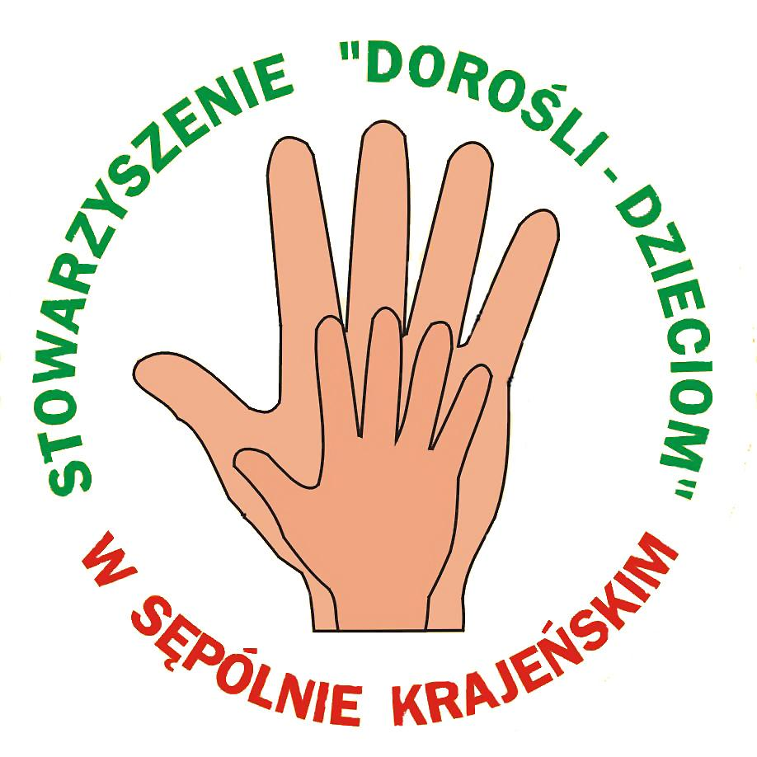
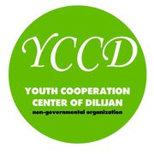

Training Course on Gender Issues in Youthwork
“Gender Equality – Make It Reality!”
Armenia, 7-14 July 2012

General idea
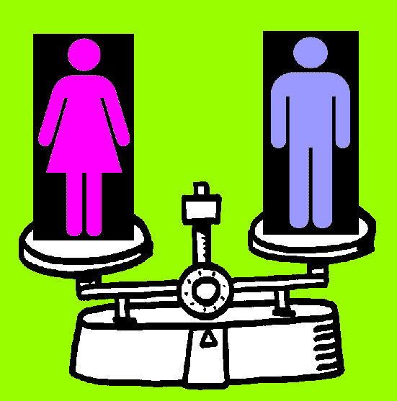
Equality between men and women is one of the important features of the “Youth in Action” programme. Nevertheless, gender issues are very often ignored in the projects and youth work in general. Many forms of gender discrimination and sexisim still exist in society and are “silently accepted”. To promote the gender equality it is highly important for youth workers to be aware about such concepts as gender/sex, gender roles, gender stereotypes, gender mainstreaming and gender education. If youngsters are aware about gender equality already during the period when they are growing up, it is later on easier for them to require respect for gender equality also during employment and in relationship with others in the society.

The main aim of the training is to increase the awareness of gender issues in youth work by providing youth workers and youth leaders with competencies in planning, facilitation and evaluation of non-formal learning processes during their daily work with youngsters, where gender issues ARE respected and by planning gender mainstreaming in their work.

Objectives
- To develop and/or improve participants’ knowledge and understanding on various concepts related to gender issues and to reflect how gender equality relates to youthwork.
- To analyze the traditions, roles and perception of gender in different countries (we expect big differences in this regard between Programme and EECA countries) and on policy level at the European stage (for example, gender mainstreaming and gender equality at employment as EU policy).
- To enable the participants to feel and reflect about the power of gender (and gender roles) by giving them the chance to experience different kind of gender inequality situations/contexts (also practical field-work tasks in Armenia).
- To identify areas in the youthwork that suffer from gender inequality and discuss startegies and methodologies to overcome them.
- To discuss the application of various non-formal learning methods and approaches to participants’ daily work for gender mainstreaming.
- To practice newly gained knowledge by planning concrete non-formal learning activities for concrete target groups (school leaders, youth with disabilities, early-school leavers, etc.) and aims (inclusion, increased employability, etc.) that can be later implemented.
- To provide the participants with skills to develop good quality projects within “Youth in Action” programme that would focus on the topic of equality between men and women and/or mainstreaming.
- To build partnerships for future projects.

Approach and methodology
To make sure that the training has a real impact on the participants, it would include wide spectrum of methods and approaches. Before the training participants will be asked to do a small research on situation of gender issues in their countries (“a homework”). During the training the participants will have a chance to increase knowledge, exchange experience, as well as to develop concrete skills and change attitudes regarding gender issues. Apart from traditional NFE methods such as group work, discussions, simulation games, etc., we will also make sure that we fully use the potential that we are in Armenia (a country where gender role are very strong and traditional) and make field visits to organizations and interviews with people. Big emphasis will be put on reflection to make sure that participants have enough ability later to apply the experience and gained knowledge in practice in their realities.

Participants
27 participants from Programme Countries (EU, Turkey, Norway, Lichtenstein, Croatia and Swissland) and Eastern Europe and Caucasus (Armenia, Azerbaijan, Georgia, Moldova, Ukraine and Russia) – 3 representatives from each country.
The course is designed for youth leaders, educators and youth workers, who work represent some institution or organization and work on daily basis with youth. Participants should already have some experience in non-formal education, but not necessary dealing with gender issues. They should be ready for an intercultural experience and interested in developing strategies and projects around gender and act as multiplier agents in their region or/and internationally.
As the training course will be carried out in English, participants must have a good command of English.

Dates and location
The training will take place 7-14 July 2012. Concrete location will be determined at a latter phase, but it will be outside the capital – Yerevan.

Financial conditions
The training course will be implemented in the framework of EU “Youth in Action” Programme. The accommodation, food and visa fees will be covered fully. Travel expenses will be reimbursed at 70% of the real cost (with cheapest mean of transportation) in return of original tickets/invoices. Insurance should be arranged and covered by each participant.

Organizers and trainers
Project will be implemented by Association “Adults for the Children” (Poland) – main coordinator – responsible for application and administration of project and Youth Cooperation Centre of Dilijan (Armenia) – responsible for organization and logistics of the training.
The training will be facilitated by two experienced trainers:
Giorgi Kakulia (http://youthforum.partners.salto-youth.net/tools/toy/giorgi-kakulia.1234/)
Ieva Grundsteine (http://youthforum.partners.salto-youth.net/tools/toy/ieva-grundsteine.1858/)

Application procedure
If you are interested participate in this project, please do the following by Friday, 21-st of October:

- Send e-mail to daniello13@wp.pl, where you state the name of your organization and answer the following questions:
  - What is your organizations motivation to participate in the training course?
  - Have you faced any situation in your (youth) work where you have noticed the gender in-equality? Please describe.
  - Who would be the 2-3 participants representing your organization (please mention their genders and their function/role in the organization)?
- Send PART III with signature, stamp and indication of the project title "Gender Equality – Make it Reality!” (please make sure that you use the correct form of PART III – see it below) by fax to number +48 52 3882597 (the Polish NA requires PART III to be sent by fax, so, scanned version will not be sufficient!).

- When you receive confirmation that your organization has been selected as a parter, you will be kindly asked to send us immediately the original of PART III by regular mail to the address:

Stowarzyszenie "Dorośli-Dzieciom"
Daniel Wargin
ul. Szkolna 8/7
89-400 Sępólno Krajeńskie
Poland

Should you have any questions, please do not hesitate to contact us:
daniello13@wp.pl or ieva.grundsteine@gmail.com!

Part III. Partner promoter(s)
A. Details of the partner
Name
Street address
Postcode |  |  |  |  |  | City
Region |  |  |  |  |  | Country
Email |  |  |  |  |  | Website
Telephone |  |  |  |  |  | Telefax
Person in charge of the project (contact person)
Family name (Ms/Mr) |  |  |  |  |  | First name
Position/function
Email
Telephone |  |  |  |  |  | Telefax
B. Profile of the partner
Type and status | Non profit/non governmental organisation |  |  | Public body Informal group of young people
 | Body active at European level in the youth field (ENGO) |  |  | Other – please specify:
Activity level | Local |  | Regional |  | National |  |  | European/International
 | Member organisation of the applicant
Please give a short description of your organisation/group (regular activities, member of, etc.) :

C. Preliminary agreement of the partner
I, the undersigned, on behalf of (repeat the name of the partner)
confirm our participation in each stage of the project (repeat the title of the project as stated in Part I):
"Gender Equality – Make it Reality!”
I declare having reached an agreement with all the promoters involved in the project with regard to the share of EU grant my organisation/group is entitled to receive in order to implement the project.
I confirm that my organisation/group has not applied for funding for this project to another National Agency or to the Executive Agency.
Furthermore, I confirm my undertaking to ensure visibility of the European Union support for the project and to ensure dissemination and exploitation of its results.
Name in capital letters:
Place: |  | Signature:
Date: |  | Signature:

