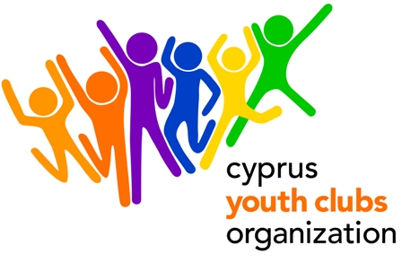
Youth in Action, 4.3, Cyprus
Disabilities or Different Abilities ?
A European training course with the support of the EU Youth in Action Programme

PROJECT OUTLINE
- Project title: Disabilities or Different Abilities?
- Organization: Cyprus Youth Clubs Organization (CYCO)
- Main theme for the project: Development of the skills and tools needed to involve people with disabilities (different abilities) in Youth activities. Participants should be Youth Workers, Youth Leaders or just members that are interested in this field.
We encourage organizations to participate with 2-3 people each.
- Project type: Youth in Action (Action 4 - Youth Support Systems/ Sub-Action 4.3 – Training and networking of those active in youth work and youth organizations). Training Course.
- Organizations’ Country: Cyprus
- Place: Cyprus
- The project starts: Sunday 01/07/2012 (arrival day)
- The project ends: Sunday 08/07/2012 (departure day)
- Deadline for applications: Friday 24/10/2011
- Duration: 6 days (excluding arrival day and departure day)
- Group age (average): none
- Contact person: Giorgos Kafkalias
- E-mail: giorgos.kafkalias@cyco.org.cy
- Tel.: +35722323260
- Fax: +35722321979
- Summary of the project: The project will bring together a maximum of 20 participants in order to explore ways to involve people with different abilities (disabilities) in youth activities. Stereotypes, challenges, Social inclusion, Active Participation and citizenship, prejudices are only some of the subjects that are going to be analyzed. The participants will enhance their skills and their tools in order to support their own target groups, in particular young people with fewer opportunities inclusion (people with all kind of disabilities). The project is going to use new activities to show new ways on how to involve everybody. The project will also highlight the significance of the activation of immobile volunteers in the participants’ organisations.The outcome of the training is expected to have a multiplication effect: from the individual participant to the organization he/ she represents.
- Financial aspects: participants will be reimbursed for the 70% of the travel cost on display of their boarding passes. Food and accommodation is paid. Participants will be required to pay a participation fee of €30.
- Safety & Insurance: We will require copies of the travel insurances before travelling to Cyprus.
- How to participate: Send us a short description of your organization and the link to the website (if you have one). Please send us the names, gender and role (Youth Leader, Social Worker, Youth Worker) of the participants. After you fill in the Part 3, send the scanned version to Giorgos Kafkalias giorgos.kafkalias@cyco.org.cy and mail the original to
GIORGOS KAFKALIAS
CYPRUS YOUTH CLUBS ORGANIZATION
P.O. Box 12106 CY 2341 NICOSIA
CYPRUS

