ARTICLE 8 – ROLES AND TASKS OF THE PARTICIPANT

8.1 Role and task of the participant in host association

This project offers non-formal forms of education, especially in the area of language and presentation of the wealth of languages in Europe. Our target group are children, adolescents and young adults. The main actions of the volunteers will be helping the organization and realization of creative workshops in the French language by non-formal education methods with other volunteers, but will also represent a regullar help to the teacher in the kindergarten who organize and conduct those workshops.

For the volunteers who are not speaking French we are proposing others creative activities. The goal of this project is to develop intercultural awareness of the volunteer and the public directly affected, through the organization of the educational and artistic activities, offered during the year, as well as through the organization of exchange youth camps.

The second objective of this project is to organize activities around the promotion of volunteerism and the program Erasmus+ as opportunities for non-formal education for young people from Novi Sad and as one of the possibilities of development of their creativity and initiative, as well as track skills development in the fight against unemployment. For our association it would be a very important activity – the Serbia’s youth is not informed enough about these possibilities and they don’t know how to find the information.

Tasks of international volunteers in the host organization

The main theme of this program is the organization and realization of linguistic, creative or artistic workshops for children, youngsters and young adults.
The volunteer will have the full support of the staff in the host organization in expressing his/her ideas and initiatives in designing workshops for children and will be able to present the French culture and language to them in an interesting and creative way.
Volunteer will participate in:
- activities in the kindergarten – playing with children, organizing some games, communicative situations, telling stories, music activities, sports activities outside in the school yard, helping the teachers to organize activities about storytelling and organizing them by themselves
- organizing French lessons for children, with the help and support of an experienced French teacher. Volunteers can take part in French lessons through games, communicative situations, explanation of vocabulary, reading different texts, listening to music, explanation of cultural point of view, collaboration with others schools, with direct contact with the children from different countries using internet possibilities, cooking with them, etc and will always be helped by an experienced teacher who will be with the volunteer at all time. The independence of the volunteer during the activities will be stimulated, especially with the idea to develop the capacities for the employability, but the responsibility for the quality and the realization of the classes is always a teacher’s responsibility, and though the volunteer is not a substitute to the professional teacher, he/she will have his/her own responsibilities to be kind and patient with the children and interesting for teenagers. It’s not a problem if the volunteer is not experienced in working with children, he/she will receive necessary help and support. The teachers will be constantly present during all activities of the volunteer and the non presence of volunteers will not disturb in any way the normal functioning of the association. The kindergarten and its extra activities have been verified by the Secretary of education of the region of Vojvodina and the number of personnel is more than enough for the normal functioning of the association.
- helping the teachers in the realization of stage presentations, helping the teachers in preparations of the activities – creating games, preparing drawings for activities, finding traditional songs…
- organization and realization of different activities in art, theatre, music, telling tales, etc ;
- participation in organization of the artistic festival “The Jules Verne’s illumination” (held in Novi Sad at the end of September)

The volunteer who doesn’t speak French could take part in (those activities are proposed also to volunteers who are not very interested in educational activities or to those who would like to do them)
  - theatre and musical activities
  - video and photo projects
  - working on the website, Facebook and Twitter of the association and work at the library
  - helping the teachers in the realization of stage presentations, searching for music, creating decorations, costumes, preparing the light for the plays
  - helping the teachers in preparations of the activities – creating games, preparing drawings for activities, finding traditional songs…
  - arrangement of the expositions of the volunteers work (photos, creative work, posters) inside the Centre Jules Verne
  - activities concerning the presentation and promotion of the volunteering program and programs for youth Mobility at the Jules Verne Association and the University of Novi Sad and visiting the office of local community and promoting the projects of ERASMUS +
  - promotion of EVS – organization of promotion of the projects of EVS
  - discussion with students – presentation of their country and regions
  - organization of intercultural activities
  - looking for new partners in other countries to make possible new exchange projects. The centre is planning to foster the international cooperation with other similar organizations in Europe. For centre Jules Verne it would be very interesting if a volunteer could find a school or an association in his own country where children are learning French and make contacts and take a part in completing an exchange with three or more associations or schools.
  - participation in some of the activities related to the sending activities for EVS of youngsters from Serbia in order to give their own opinions and experience on intercultural learning, intercultural differences etc. to future volunteers.
  - preparation and organization of the festival “Jules Vern’s illuminations”, management of the project, coordination with the local and EVS volunteers, realization of the creative activities, looking for the partners for the project with the local volunteers, looking for partners, artists, maintaining the website and Facebook of the festival
Apart from all these regular activities, volunteers can create their own project in collaboration with teachers or by themselves. According to the interest developed by the young EVS during their project EVS, they will have the possibility to continue a personal project.
Each initiative and innovative idea will be welcome in the course of regular activities. The role of the volunteer will be adapted to the affinity, voluntary skills and expectations. According to interests developed by the young EVS during the EVS project, she / he will have the opportunity to pursue a personal project (testimony, documentary, animation, magazine, newspaper article, story or video pictures...) and then install an educational project based on their choice (an exchange project, art project, theater, presenting his/her region), they may present it to their country of residence, after the period of EVS (either his/her ohn cuntry or in the host country). The center wants to stimulate international cooperation with similar organizations in Europe (particularly in Francophone countries) and the volunteer could help find new partners abroad to establish cooperation and join in activities in this sense.
The volunteer will have a two day trenning about the personal project, will recive two documents about the and also be motivated bay host organisation to present it to others volunteers in the association but also to other local organisation.
In the Centre Jules Verne, the volunteer will have access to the Internet, video, DVD, video projector, computer, printer, he/she will be able to record or film the children. There is a fairly large collection of audio and video equipment as well as games created by the teachers, especially for children and teens.
The volunteer will have independence in work but will always (daily) be supervised by an experienced teacher and a teacher from kindergarten regarding assistance for the preparation and explanations of activities, support for research equipment, presentation sites and software necessary for the work, advice for managing groups and individual etc. The responsibility for the quality and the successful completion of classes will always be the responsibility of teachers and the volunteer will in no way substitute professional teacher, but she / he will always have a responsibility to come on time, to be prepared to assist in the regular work with children, to demonstrate a motivation to work with children, to present the kindness and patience with children, to try to offer innovative and motivating activities for young and to be open minded with all children and young people from different social and cultural backgrounds.

The teachers will be constantly present during all activities of the volunteer and the non presence of volunteers will not at all disturb in any way the normal functioning of the association. The kindergarten and its extra activities have been verified by the Ministry of education and the number of personnel is more than enough for the normal functioning of the association.

A major theme of this project is the promotion of intercultural education. On the one hand, it is to organize and carry out exchange camps (search for partners, communication, preparation of intercultural activities and the activites against xenophobia for the youth exchange projects). On the other hand, during the school year, intercultural education will be offered to children through activities leading to a reflection on their own identity (cultural, family, personal) and their relation to the difference. The volunteer will be able to build his own activities based on the activities proposed in the educational kit "All different, all equal" of the Council of Europe (Directorate General of Human Rights) and KITs offered by various NGOs (e.g. "educational activities: discover the theme of discrimination to young people" Amnesty International) and by using the ideas presented in the icebraker Kit on the web page of the Council of Europe. Discrimination issues can also be analised through interactive theater especially Forume theatre. On this occasion we will develop further partnerships with local organizations.

A major theme of this project is to work towards a better understanding between young people from different participating countries, by promoting tolerance, awakening them to the issues of prejudice and stereotypes and fighting against xenophobia. We would also deepen and go a step further by encouraging participants to continue to promote these values and to fight against the problems in their own communities.

Various workshops, especially with preadolescents, adolescents and young adults, will be organized around key themes: Understanding Youth in different cultures, and the fight against xenophobia, racism, prejudice and stereotypes. The methods used will be the non-formal education types: different types of games, theater, literature, psychological operations, of writing workshops, simulations, group discussions, role plays, etc. To carry out the planned activities the volunteer will handle the search for partners and correspondence with them, research activities, their preparation and at the end their organization with children.
The personal project should be part of activities planned by the status of the host organization. The project can be linked with the host association or in connection with local structures with which the host association works. If the volunteer would like to propose a new idea or new collaboration for the realization of his personal project should agree with the supervisor, respect the basic ideas of status of the host organization and not to top organizational resources.

The volunteer undertakes to respect the strict rules of hygiene in our structure, especially in the work in the kindergarten as well as to respect the strict rules to not provoke situations that can put children danger or risk. He/she undertakes not to enter criminal activities during his EVS project, if not, the host association could stop the project. It is also forbidden to, during his/her work with children and young people do any kind of promotion of any political party or any religion or style of living. This is strictly forbidden by law in Serbia and could also cause the decision of the host organization to stop the project.

The volunteer absolutely must possess a medical certificate for working with young children attesting that he/she does not have any diseases that could be transmitted to children, and not to have a psychiatric or psychological record or problems that may put children in danger or cause the situations of serious conflict. The volunteer is obliged to submit a medical certificate before coming to realize his/her EVS in Serbia as well to present the extract of his criminal record (criminal record bureau (CRB) denying lawsuits and criminal activities) and to obey the rules and visa legal issues of stay of a foreigner in Serbia. The information on the issue and visa regulations and all information about medical tests will be in the info pack EVS Jules Verne in attachment of this document. To make the visa application to the police in Serbia, volunteer undertakes to come in Serbia with the passport.

8.5 Working hours, days off per week, holidays

The volunteer will not work for more than 35 hours per week; language lessons, reunions, preparation for activities, activities and personal project are included. Her/his activities will include mostly creative workshops with children, teenagers or students and only a few administrative tasks. Volunteers will have free weekends and also free time during the national holidays in Serbia. The volunteer will also have two free days per month during the EVS; which is 24 days maximum during his/her EVS project if it’s 12 months long. The volunteer will be able to use his/her holidays during the winter (from the 20th of December until the 15th of January) or summer school’s holiday (June, July, August). The best period to take the holiday is the last month of their project. During other periods the volunteer can take the holiday according to his/her wishes or needs but in the agreement with the host organization.

During the first phase (two months) the volunteer will spend 33 hours in organization + 2h of the Serbian classes. In this period the volunteers need more time to adapt themselves for - working methods, groups, staff, books, local partners, apartment, local community, cultural differences. In this period the process of learning is very fast in different ways...and in order to provide good education and help to the volunteers he/she is supposed to stay little bit longer in the association. When the volunteer is "stabilized" in learning related to the working tasks, host organization and the local community and he/she has succeeded to adapt himself/herself, he/she can start to commit to their personal project. With the start of the third month (depending of the volunteers needs) the volunteer will start spending 28,5h in the organization Jules Verne and will have 1,5h for the Serbian classes and 5 - 5,5 h for his/her personal project (the volunteer is not obligated to spend those 5 - 5,5h in the organization; he/she can spend them where he/she wishes but he/she has to adapt his/her personal project to the capacities of the host organization and the realization of the activities in the host association in order to not disturb to mach other volunteers or employees in the host organization ).

During this 28,5h in the organization the volunteer will have maximum 13h of concrete activities with the public, 13h for the preparation for the activities, an hour for the reunion with the supervisor and one hour for the reunion with the internal mentor.

If the volunteer doesn't propose a concrete personal project, the host association will make suggestions in order to motivate him/her. And if he/she does not use the 5 -5,5 hours for the personal project, he/she can come in the organization and organize some interesting activities for his/her colleagues such as dinners, evenings, movies etc. or whatever he/she likes.

In our association, various activities will follow throughout the year.

- The month of September is dedicated to the re-entry but also creative workshops with lanterns. The end of September was chosen for the realization of the local festival "The Jules Vern's Illuminations" with the duration of three days, where we present our beautiful lanterns in a parade and in one big exposition of the big lanterns created by the artists.
- During the month of September, October and November we perform French classes with young people, children and adults (working with the French learning methods and different learning activities of French in kindergarten and through the creative and artistic activities)
- In December we realize many projects or artistic workshops (manual activities, traditional storytelling workshops, drawings and cooking workshops)
- In January young people begin preparations for theater performances (work on the texts, reading, vocabulary, body language, theater exercises, exercises of group creation and confidence, rehearsals, choosing music etc ...) The presentation of these events is happening towards the end of March, the month of Francophone during "The day of the French theater".
- Young people return to work with the manual until mid-June.
- Then during the summer months, July and August, we organize youth exchanges with young Francophone’s from different countries, aiming at intercultural learning, and we also organize workshops for our youth. Volunteers make more trips in Serbia during the summer months and take their holidays too.

Working hours:

French volunteer Weak A

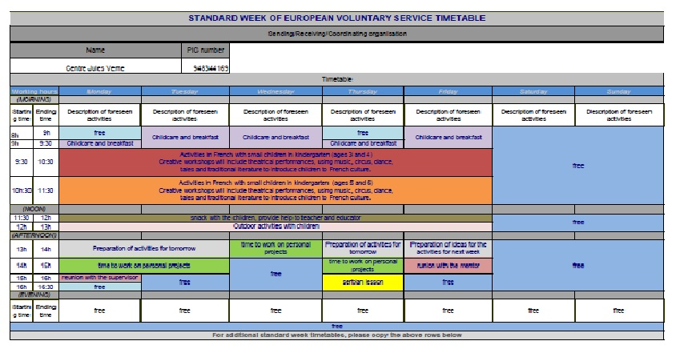

French volunteer Weak B
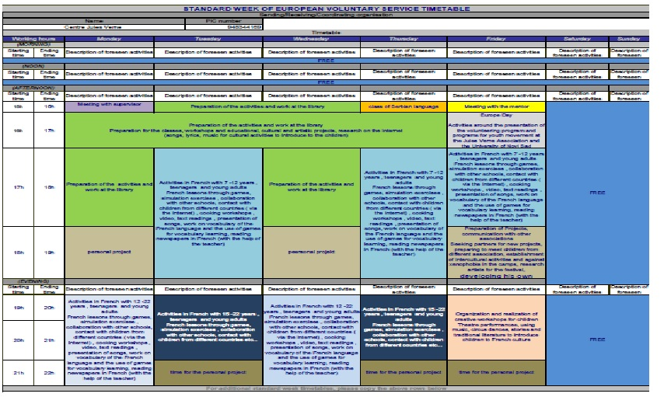

volunteer non speaking French weak A
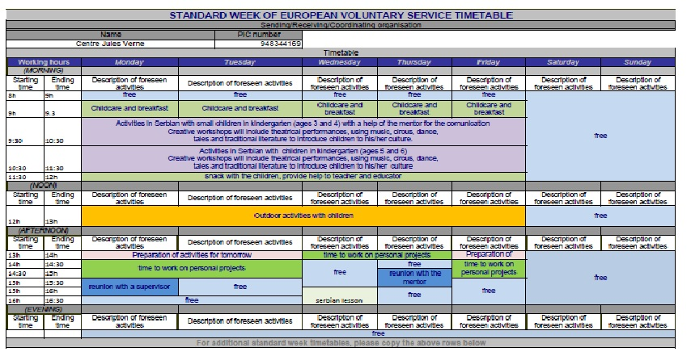

volunteer non speaking French weak A

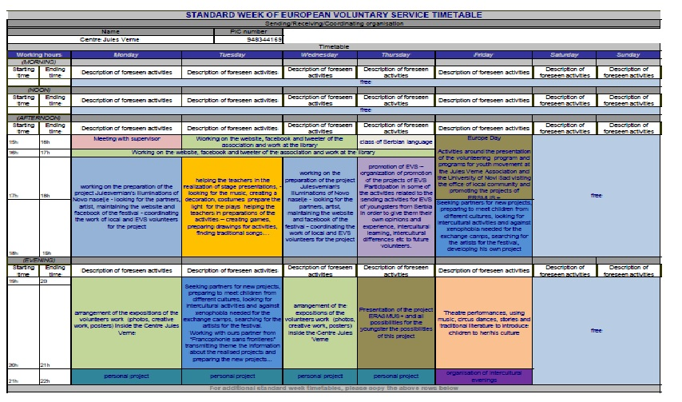
volunteer FO

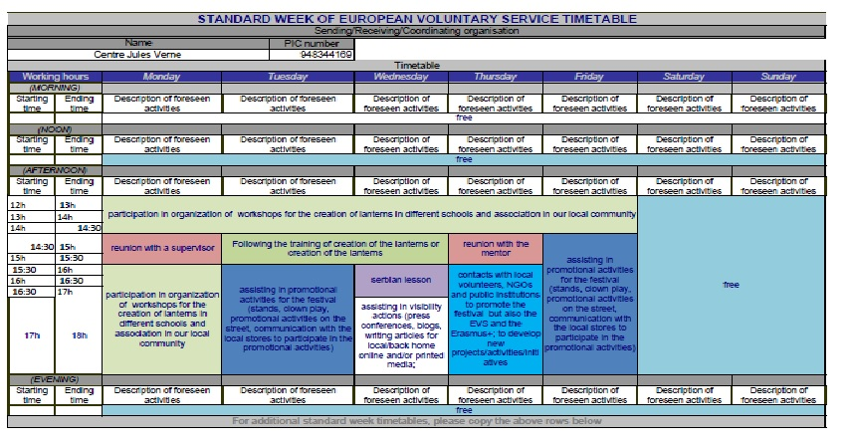

Volunteers are expected to work one week in the morning and one week in the afternoon and evening. But it is quite possible that, because of the work and the needs of the groups, volunteers work only the week A or B for some period. This will happen especially during the theater preparation periods (February and March) and when in the summer the association is open in the morning (second part of June, July, August).

Schedule of French classes in the afternoon and evening are variable and we adapt them to other children’s activities (like school, sport etc.). The schedule for the volunteer (the number of hours spent in the association) during one week will not change.
The volunteers usually work in pairs or in a group of three. They will have the right to change schedules agreeing with their supervisor and tutor. Till now we have never refused the demends of the volunteers to have free days or hours…it is important only to informe all members of the team and to be repecteful with others, with their chedul, their needs etc…
They also have the right to work only in the morning or only in the afternoon and evening but also with agreement with their supervisor and tutor. Some volunteers prefer working in the morning, while others prefer working in the afternoon. But we think that the best way is to work one week in the morning and one week in the afternoon. In this way, the volonteers will meet all childen and all groups and will be able to participate in all projects but also have a feeling that they are informed about everything that is happening in the association. It’s important that they always take into account the interest of the children and other members of the team when they make their schedule. Regarding working in the afternoon, the volunteers usually bring their dinner and eat with other volunteers so they could have more time to discuss with each other and with the supervisor.

The timetable could be changed if exceptional activities occurred; like the festival “The Jules Verne’s illuminations”, exchange projects, exhibitions, end of the year parties; mother’s day, etc. That will not be often.

8.6 Food, accommodation

For the accommodation of all volunteers we have rent two apartments. One flat is is two minutes away by foot from the association Jules Verne and the second apartment is 5-7 minutes of walk from the association. The conditions are the same in both flats. In the apartment, there is a phone, Internet, all facilities in the kitchen and in the rooms. There is a possibility to use the washing machine in our association. The volunteer will be able to contact the volunteers living in the flat at the moment in order to gain more information and the association has prepared a document with photos and explanation to present the future flat to the volunteer - in attachment.

The volunteer will be accommodated in an apartment she / he can share with other EVS volunteers (with 2 other volunteers) or local students, but it will have his/her own furnished and equipped single room. In some rare cases the volunteer (2 of 6 volunteers) can be in double room but not for whole period of the volunteering project (max 6 months). In one of the apartments, one of the rooms, a large one, is split in two for the volunteers to have enough privacy for each of them. We are also taking care that those volunteers who will live in this split room will have different working schedules or shifts so they could have more privacy. This apartment with enough space for 3 volunteers is at a 2-minute walk from the association. The volunteer can, instead of being in this double room, choose to live in a room in private accommodation and the host association could also rent a room for the volunteer.

The volunteers will have Breakfast (at 8:30) and snack (at 11:30) in the association every morning when he / she works in the morning (if the volunteer wants to come in the morning to eat with the children even if he/she does not work in the morning, he/she is more than welcome) The volunteers will receive monthly money for food and he/she will be expected to prepare food himself/herself (all the necessary facilities will be provided). The host organization will take care that the volunteers have a nice pleasant place to live, not too luxury equipped, but with all necessary equipment similar to the conditions for Serbian population. The host association will take care of all charges: rent, apartment insurance, electricity + gas, water, Internet, equipment for the kitchen, for bedrooms etc. Only the bill for the telephone is on the charge of the volunteer.

Blisters, hygiene and cleaning products for the apartment as well as the price of telephone in the apartment are to be borne by the volunteer.
An inventory (at arrival and departure) will be realized with the volunteer and he/she will get the pictures of the apartment in order to know what is in it and how it should be left for other volunteers. On departure, the apartment must be left in the condition it was found in (cleanliness, equipment, furniture). To do this, a deposit of 30.00 € will be levied from the first month payment for the EVS volunteer. The deposit will be returned at the end of the project to the volunteer if the cleanliness and the state of equipment and furniture on arrival are the same at the moment of departure of the volunteer.

A check-up will be done on a regular basis every month, to see if the volunteers need anything more in the appatement, but also to check that everything works well and that there is nothing broken.
If the volunteer has done any damage in the flat on the furniture, walls or floors, the association will pay the reparation and will take the money from the volunteer payment and volunteer could contact CIGNA insurance to reimburse the costs.

The volunteer has the opportunity to change accommodation if for various reasons the one provided by the host organization did not suit him/her. However, one month notice is required and the volunteer must find a replacement for the remaining period of the contract in the apartment, if not, he / she is obligated to cover the cost of their part for the apartment. Research and contracting procedures for the new accommodation are paid by the volunteer. So far the volunteers were more than happy with their housing, and we did not have any problems regarding it.
On the day of the arrival, the host organization will prepare the money for the volunteer (for the following month) and will buy him/her a mobile phone number. The host organization will prepare at the beginning of the month the monthly payment (for the following month) for the volunteer and the volunteer will be obligated to bring to the association the bills for that sum that the organization could present to the compatibility.

Financially - The host organization will provide the volunteer

      - Monthly money for food (105 €) for him/her to prepare himself/herself (all necessary equipment will be provided).
- 55 € pocket money per month
- 10 € money for local transportation and the bike (which must be returned at the end of the EVS in the same condition in which it was given at the beginning of the EVS) if not, the host association can take a sum of the deposit for repairing the bike.

It means 170 € in cash per month

The volunteer can also have

The volunteers will have Breakfast (at 8:30) and snack (at 11:30) in the association every morning when he / she works in the morning (if the volunteer wants to come in the morning to eat with the children even if he/she does not work in the morning, he/she is more than welcome). There will not be a possibility for the volunteer to ask the special kind of breakfast only for him except in the cases for the vegetarians, vegans or allergic regime. In this way the volunteer can also see the cultural habits in Serbia to take for breakfast and for snack. If the volunteer has some ideas to make some his traditional recipes with the children it is more than welcome to do it each Friday. The association will purchase the needed material for this activity.

Each month the volunteer will be required to:
- sign the document that he/she has received the money /170 euros in dinars/
- sign a statement of honor and a document confirming that he/she received the expected amount and received the pocket money. – in attachment
- sign that he/she has received all administrative and educational help as planed – in attachment
- sign the Erasmus plus document – in attachment
- answer to the questionnaire (in order to evaluate their own work and the work of the host association)
- present to the host organization monthly bills for 170 €. (factures for their living costs – food or travel cost) in order to cover the sum he/she has received for the questions of our compatibilities (if he/she doesn’t present the factures the government will consider this sum as a salary and the volunteer should pay 50% of the tax for the salary)

During a EVS project
- The volunteer is obligate to follow the educational trainings organized bay SALTO SEE and will be invited to follow the training organized by his host organization.
- To participate in all reunions with the mentor and supervisor
- To complete all evaluation prepared by the host and sending organization /at list one after the first months, second after the third months on in mi term and one more tree months letter/.
- To cam at the time for the activities and to respect all regulations of the association and the privacy of information of the children.

One month before the end of the project
- The volunteer is also required to complete the final report of the project and present it to the host association.

8.7 Local transport

To come in the association the volunteers don't need the money for the local transport because the apartments are very close to Jules Verne association but the volunteer will still receive money for local transportation - 10 euros, and the association will provide at the same time a bicycle for the volunteer. At his/her arrival the host organization will give to the volunteer the bicycle in the normal driving condition and they will take photos of the bicycle together. The volunteer are also obligated, at the end of their EVS project, to present us the bicycle in the same condition as it was when he/she received it, if not, the structure can take a sum of the deposit for repairing the bike.

The Jules Verne Association is 20 minutes away by bus from the city center. There are 4 possible lines the volunteer can use to get to town. Novi Sad is a beautiful city and well equipped for cycling with roads for bicycles... In these conditions it is more ecological to use the bikes than to take the bus for transportation.

