HERE AND NOW
International training course, May 2016, Slovenia
CALL FOR PARTNERS
»Društvo Lojtra« - NGO Ladder, NGO for personal and professional development of youth is developing a training course about mindfulness. We will apply for funds in Erasmus+ program. The project will last 10 days (1 arrival, 1 departure and 8 working days) and will bring together 8-12 partners, willing to work on chosen topic.
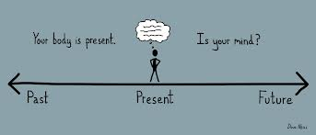

OBJECTIVES
- Increased ability of youth workers for greater understanding and responsiveness to social and cultural diversity of their target groups since Mindfulness and Emotional Literacy approaches' aim is to develop emotional intelligence, empathy and compassion.
- Increased capacities of organisations implementing these innovative approaches in their work and working methodologies which would better respond to the needs of youth.
- Increased motivation and satisfaction in daily work of youth workers since aim of Mindfulness and Emotional Literacy approach is to improve in general well-being of youth workers and prevent burnout syndrome.
- Improvement of quality of work and activities done by youth workers making them more present, fulfilled and engaged since these approaches mostly refer to well-being, emotional intelligence and improvement of mental health of youth workers.

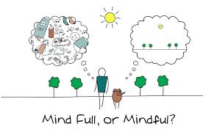

HOW WILL WE DO IT

The main working principles will be:

- Experiential learning
- Participatory learning
- Peer to peer learning
The content of the training course will be focused on three main approaches: mindfulness, emotional literacy and peer learning. On the beginning we will work on first two approaches. Last two days participants will have an opportunity to share their own good practices with others. We believe such a frame will provide great learning outcomes and help us build a strong network for further cooperation.
ACCOMODATION, FOOD, TRAVELING
Food, drinks, accommodation and the program will be covered by Erasmus+. Travel costs will be covered accordingly to Erasmus+ rules.
Accommodation will be arranged in a youth hostel or similar facility. Workshops will be implemented in a working room or outdoor, depends on the weather conditions.
During the training course cooperation from all the participants is obligatory. Avoiding the workshops and ruining group dynamics will result in cancelling reimbursements of traveling costs and all the further cooperation between partners.

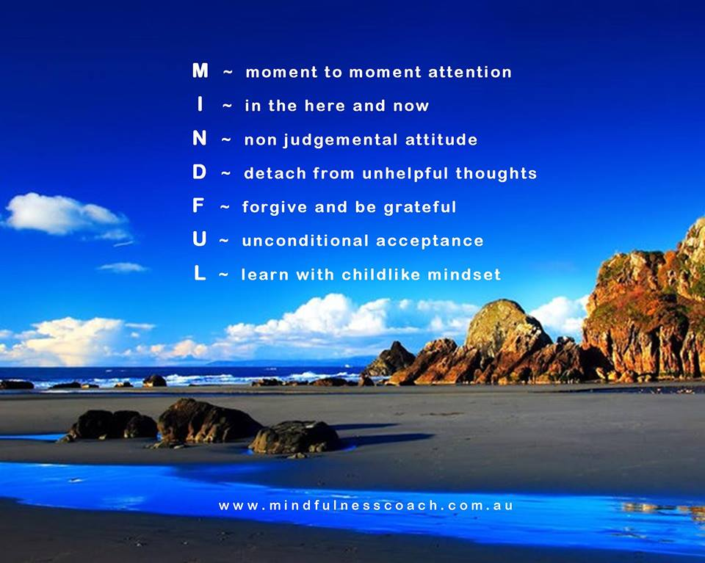

WHAT PARTNERS ARE WE LOOKING FOR?
- 8 - 12 partners legally established in Erasmus+ programme countries (28 EU member states + FYROM, Iceland, Liechtenstein, Norway).
- Non-profit making.
- Willing to contribute and help us create a great learning experience.
- Able to communicate fluently in English.
- Able to communicate regularly (answering the e-mails within 3 days).
- Willing and able to send 2- 3 participants on the training course (gender balanced).
- Willing and able to offer the participants to implement one workshop about mindfulness in a month after the training course.

WHAT PARTICIPANTS ARE WE LOOKING FOR?

- Youth workers, youth leaders, youth trainers willing to work hard (7-8h per day), transfer gained competences in their local community and able to fluently communicate in English.
- Aged between 20 – 30 years.

MAIN ACTIVITIES

- Teambuilding games.
- Workshops about mindfulness and emotional literacy.
- Peer to peer workshops.
- Mountaineering (one day).
- Meditation.
- Journal writing.
- Reflection and evaluation sessions.
- Campfire evenings (probably, not 100% sure).
- Intercultural night.
HOW TO BECOME A PARTNER
- Fill the mandate (attached).
- Fill the partner info form (attached).
Send it back not later than 20. 9. 2015.
ADDITIONAL INFORMATION
If you have any additional question, please do not hesitate to ask:
Aljaž Zupan: aljaz.zupan2@gmail.com, 0038640167575.
