# LAW IN YOUTH WORKS TRAINING COURSE

# 5-11 April FEBRUARY 2015 – ISTANBUL/TURKEY

# UNDER THE SAME SKY

**WHO ARE WE ?**

Our student club focuses on European Union and International issues. We are organizing seminars, conferences, competitions to understand European Union and its current issues. When we look at Turkey as a Candidate Member, and examine its educational, political and social situation, we found out that your project is related with our fundamental problems. We also aim at promoting youth activities in culture art and education. Another important goal of our group is to get our members have a wider understanding of European citizenship and encourage them to participate in multinational activities so that they can learn more about other cultures and also introduce our culture to other countries. All members of our club are getting into this act as students studying European Union Studies and International Relations departments in undergraduate level (3,4 years) . Therefore our staff/person has advanced knowledge level about European Union , politics , Global Issues, Human rights, Active citizenship etc.

**MAIN TOPIC OF THE CONTENT**

The main idea of this training course is to motivate youth workers, youth leaders, trainers and other civil society activist to learn human rights and basic law as tools for increasing the active participation of young people in society and to foster social inclusion of youngsters with fewer opportunities. The lateral objectives of this training course are to enchance the personal and Professional development of the participants, so that they act as multipliers of the gained knowledge within their organizations and their local communities.

**MAIN OBJECTIVES**

* To develop a common understanding about the concept of active participation and to explore basic law and human rights activity as instruments for its promotion especially in terms of strengthening social cohesion and mutual understanding .
* To explore how basic law and human rights  could foster and protect social inclusion and cohesion among the young people.
* Awareness raising about basic law and human rights.
* To build up competences of participants in the field of using human rights as tool for enhancing inclusion.

**WORKING METHODOLOGY:**

The program of the course will be based on non formal education, intercultural dialogue and communication and will be conducted using an interactive and participative approach. The processes of learning from each other and learning by doing will be crucial. The training course will stimulate creativity, active participation, and sense of initiative and involvement of the young people in society. Participants' prior experiences in youth work, particularly at local and regional level, will be important and used in the development of the learning process. Active group/team work, role-plays, outdoor activities and plenary discussions, as well as theoretical inputs will characterize the program of the course in order to cover all aspects of the project themes.

**THE PARTICIPANTS WE WILL BE LOOKING FOR:**

We are looking for 6 persons from each of the stated countries! Participants in this training course should be actively involved in the organisation which they represent, resident in one of the stated above countries and fully able to communicate in English. The selected participants will commit themselves to follow up the outcomes of this training course in their organisation and within their local communities through active youth work and follow up actions.Participants must be 18-30 ages.

**DATES AND WORKING LANGUAGES:**

* Istanbul, TURKEY
* The English language is foreseen as the working language of the Exchange.
* Participants must have sufficient understanding of the working language.
* During the project, the entire cost of accommodation and meals are covered by the project.
* Travel costs will be paid within the rules.
* http://ec.europa.eu/programmes/erasmus-plus/tools/distance_en.htm

**FINANCIAL CONDITIONS**

During the Project, the entire cost of accommondation and meals are covered by the Project.

Travel costs will be paid within the rules.

<http://ec.europa.eu/programmes/erasmus-plus/tools/distance_en.htm>

**APPLICATION**

You must complete application form and mandate.

You must have PIC code!

**Deadline for application : 27.04.2014**

**CONTACT :** [lawyersoffuture@yandex.com](mailto:lawyersoffuture@yandex.com)

**ABOUT ISTANBUL**

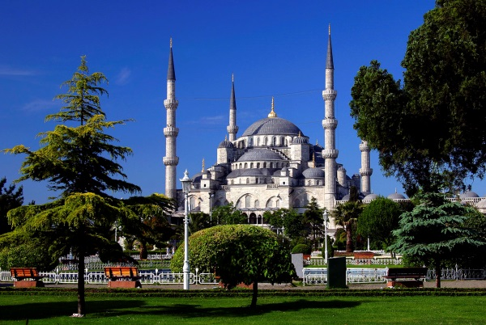**THE BLUE MOSQUE;**

The Sultan Ahmed Mosque (Turkish: Sultanahmet Camii) is a historical mosque in Istanbul, the largest city in Turkey and the capital of the Ottoman Empire (from 1453 to 1923). The mosque is popularly known as the Blue Mosque for the blue tiles adorning the walls of its interior. It was built between 1609 and 1616, during the rule of Ahmed I. Like many other mosques, it also comprises a tomb of the founder, a madrasah and a hospice. While still used as a mosque, the Sultan Ahmed Mosque has also become a popular tourist attraction.

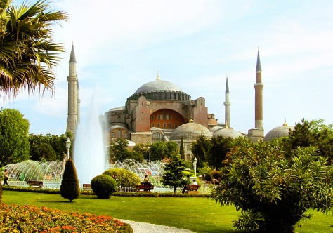**HAGIA SOPHIA;**

Hagia Sophia (from the Greek: Ἁγία Σοφία, "Holy Wisdom"; Latin: Sancta Sophia or Sancta Sapientia) is a former Orthodox patriarchal basilica, later a mosque and now a museum in Istanbul, Turkey. From the date of its dedication in 360 until 1453, it served as the cathedral of Constantinople, except between 1204 and 1261, when it was the cathedral of the Latin empire. The building was a mosque from 29 May 1453 until 1934, when it was secularized. It was opened as a museum on 1 February 1935.

**THE TOPKAPI PALACE;**

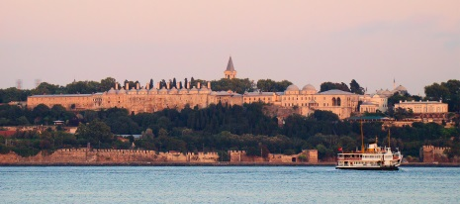The Topkapı Palace is a palace in Istanbul, Turkey, which was the official and primary residence in the city of the Ottoman Sultans for 400 years of their 624-year reign, from 1465 to 1856.

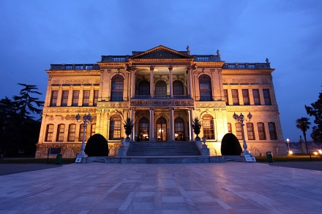**THE DOLMABAHCE PALACE;**

The Dolmabahçe Palace (Turkish: Dolmabahçe Sarayı)in Istanbul, Turkey, located at the European side of the Bosporus, served as the main administrative center of the Ottoman Empire from 1856 to 1922, apart from a twenty-year interval (1889-1909) in which the Yıldız Palace was used.

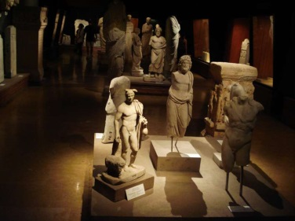**THE ISTANBUL ARCHAEOLOGY MUSEUMS;**

The Istanbul Archaeology Museums (Turkish: İstanbul Arkeoloji Müzeleri) is a group of three archeological museums located in the Eminönü district of Istanbul, Turkey, near Gülhane Park and Topkapı Palace. The Istanbul Archaeology Museums consists of three museums. It houses over one million objects that represent almost all of the eras and civilizations in world history.

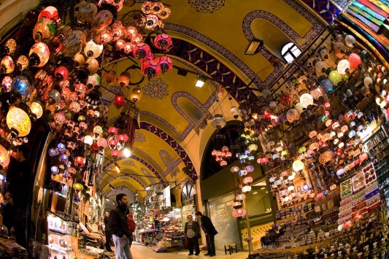**THE GRAND BAZAAR;**

The Grand Bazaar in Istanbul is one of the largest and oldest covered markets in the world, with more than 58 covered streets and over 1,200 shops which attract between 250,000 and 400,000 visitors daily. Opened in 1461, it is well known for its jewelry, pottery, spice, and carpet shops. Many of the stalls in the bazaar are grouped by the type of goods, with special areas for leather coats, gold jewelry and the like. The bazaar contains two bedestens,the first of which was constructed between 1455 and 1461 by the order of Sultan Mehmed the Conqueror. The bazaar was vastly enlarged in the 16th century, during the reign of Sultan Suleiman the Magnificent, and in 1894 underwent a major restoration following an earthquake.

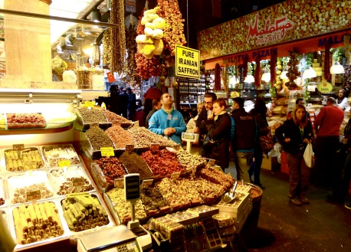**EGYPTIAN BAZAAR ;**

The Spice Bazaar, (Turkish: 'Mısır Çarşısı', or Egyptian Bazaar) in Istanbul, Turkey is one of the oldest bazaars in the city. Located in Eminönü, it is the second largest covered shopping complex after the Grand Bazaar. There are several documents suggesting the name of the bazaar was first "New Bazaar". However, due to the fact that many spices were imported via Egypt in the Ottoman period, the name "Mısır Çarşısı" was favoured by the public. The bazaar was (and still is) the center for spice trade in Istanbul.

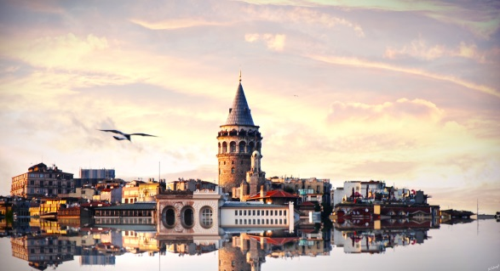**GALATA TOWER;**

The Galata Tower (Galata Kulesi in Turkish) — called Christea Turris (the Tower of Christ in Latin) by the Genoese — is a medieval stone tower in the Galata district of Istanbul, Turkey, just to the north of the Golden Horn. One of the city's most striking landmarks, it is a high, cone-capped cylinder that dominates the skyline and affords a panoramic vista of Old Istanbul and its environs.

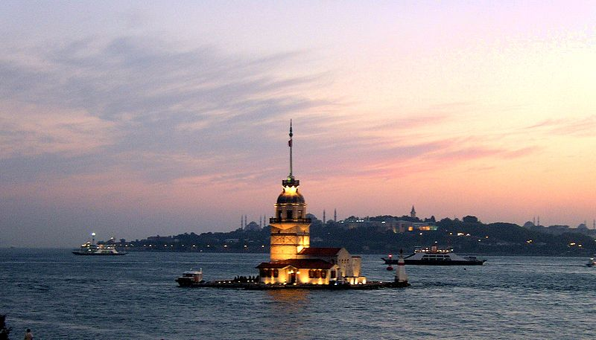**THE MAIDEN'S TOWER**

The Maiden's Tower ([Turkish](http://en.wikipedia.org/wiki/Turkish_language): Kız Kulesi), also known as Leander's Tower (Tower of Leandros) since the medieval [Byzantine](http://en.wikipedia.org/wiki/Byzantine) period, is a tower lying on a small islet located at the southern entrance of the [Bosphorus](http://en.wikipedia.org/wiki/Bosphorus)  strait 200 m (220 yd) from the coast of [Üsküdar](http://en.wikipedia.org/wiki/%C3%9Csk%C3%BCdar) in [Istanbul](http://en.wikipedia.org/wiki/Istanbul), [Turkey](http://en.wikipedia.org/wiki/Turkey).

**ORTAKOY;**

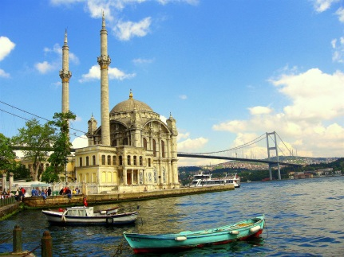Ortaköy is a neighbourhood, formerly a small village, within the Beşiktaş district of Istanbul, Turkey, located in the middle of the European bank of the Bosphorus. Ortaköy was a cosmopolitan area during the Ottoman era and the first decades of the Turkish Republic, with communities of Turks, Greeks, Armenians and Jews. The neighbourhood still hosts many different religious structures. It is also a popular spot for locals and tourists alike, with its art galleries, night clubs, cafés, bars, and restaurants.

**BEYOGLU;**

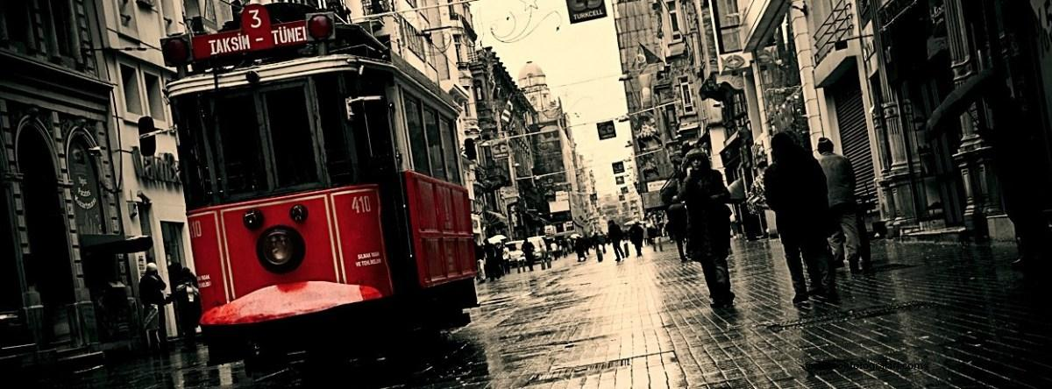Galata, and Beyoğlu further north with its main thoroughfare, the pedestrianized Istiklal Street, and the adjoining Taksim Square is the district of Istanbul north of Sultanahmet/Old City, across the Golden Horn. This district, especially Taksim Square is usually considered the “city center” of Istanbul. Primarily visited for its nightlife, this district has also its own share of sights and accommodation.

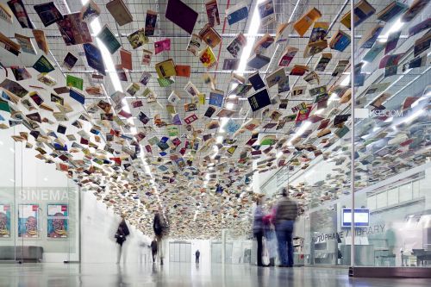**ISTANBUL MODERN ART MUSEUM;**

Istanbul Modern Art MuseuM. İstanbul Modern, is a museum of contemporary art in Istanbul, Turkey, inaugurated on December 11, 2004. The museum, located in a converted warehouse in Tophane district on the Bosphorus, is the first of its kind in Turkey. It is easily reached by tram. Istanbul Modern has exhibitions on two floors. The museum's permanent exhibition, along with the shop and the restaurant, is located on the top floor. Temporary exhibitions are located on the lower floor, along with the cinema and the library.