1. Who we are
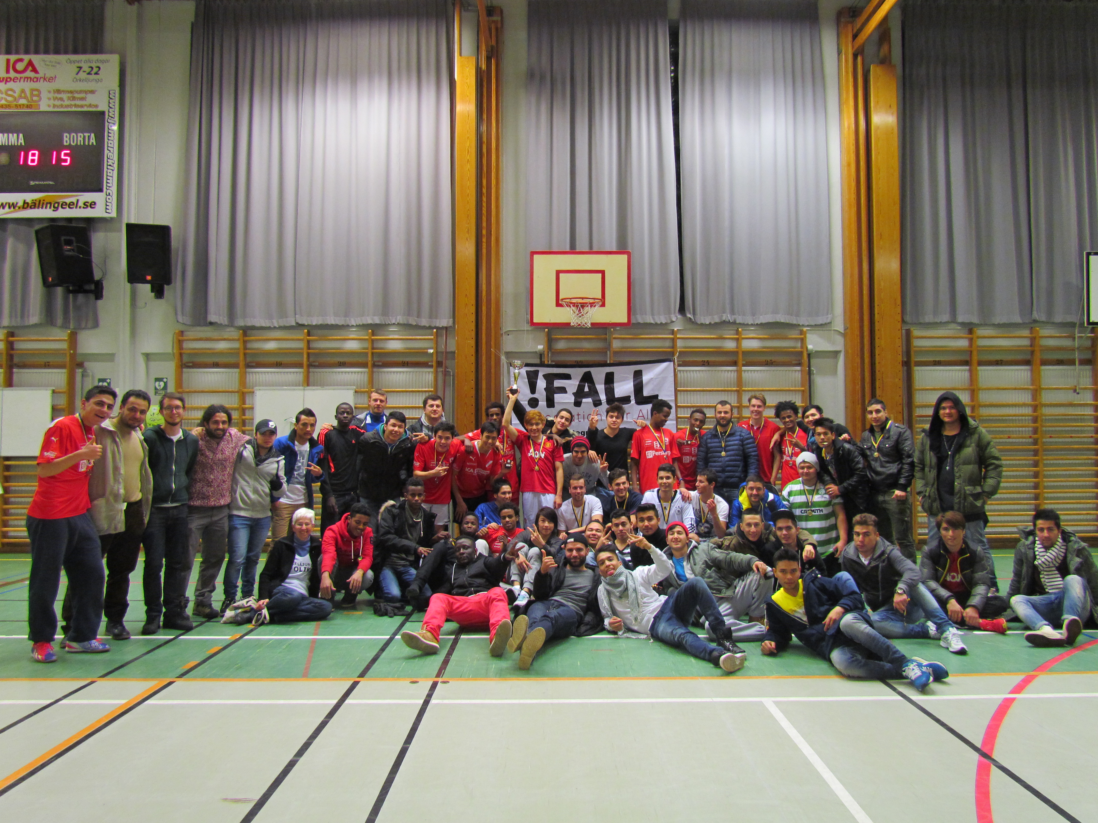
IFALL (www.ifall.se) was founded in 2013 in south of Sweden, Örkelljunga. IFALL has extended network with municipalities, schools and youth centres. It is a volunteer based organization that has 25 active volunteers. The main objective of the organization is to promote integration between cultures and counteract violence between cultures in Sweden and in another countries. In this way we would like to state that we are not only working with integration of immigrants but also we are working with integration of cultures in different levels. Here comes some pictures from IFALL

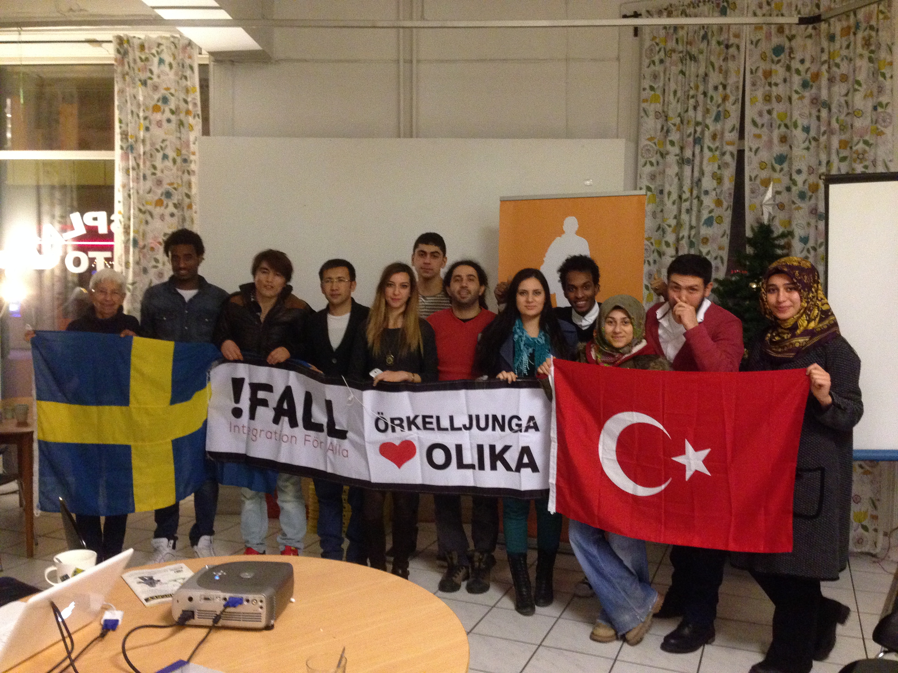
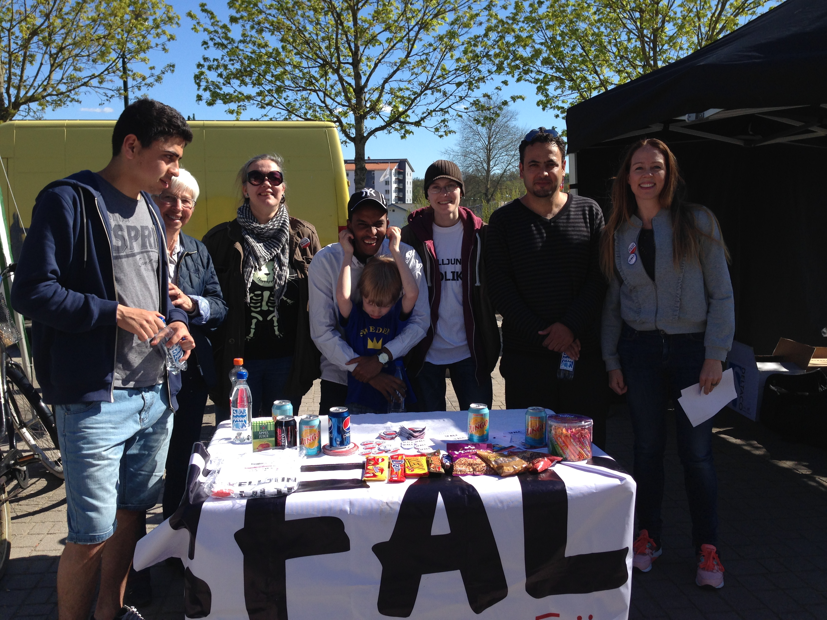
The organization fulfils the main objective through
• Enabling individuals to help themselves so they have a better understanding of her/his own culture and their self-esteem amplifies.
• Providing multi-cultural meeting places where the exchange of experiences, values and cultures promote individual’s life quality
• Building social network between different cultures
• Encouraging the individual to take responsibility in society
• Developing and practicing effective and creative approaches/methods for integration, both formal and non-formal.
• Spreading information in order to increase awareness of the meaning of culture and different cultures.
IFALL works with integration in different levels.
a)Ground Level; We have several activity groups such as language cafe, homework support, sport days, international evenings. These activities are weekly or monthly and our volunteers are planning and organizing. Target group often is immigrant background people or refugees.
b)Intellectual Level; We are applying for adult education and youth projects in local and international levels. Erasmus + and Nordplus are main fonds that we are working with. In this level youth and adults volunteers became more experienced with projects especially about sharing best practices between project partners. This is a kind of platform for our volunteers that they can prepare activities for ground level.
c)Informative Level; We prepare seminars, conferences, panels and handbooks for local people, social worker, teacher, volunteers who can follow new information about integration and cultures.
Nonformal education and methods are applied for these levels of activity. Creative Drama and Film making are some of methods which IFALL uses in trainings.

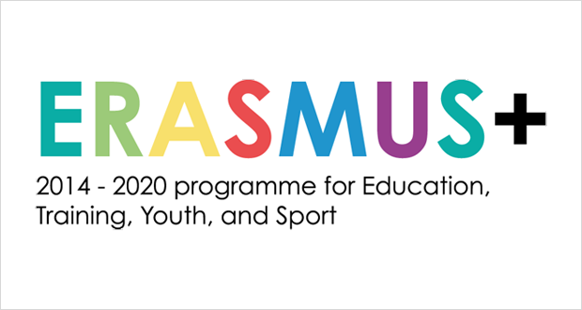
2. EVS – European Volunteer Service in Sweden.
IFALL is cooperating with local and international organizations for EVS projects. Örkelljunga Kommun and Klippan Kommun are main local partners in European Volunteer Service for long-term volunteership in Örkelljunga Sweden. IFALL has been cooperating for different Erasmus Plus projects. In this Erasmus + Team EVS project.

The project ”Erasmus + Team” would like to promote volunteering through Erasmus + especially about European Volunteer Service. Promotion of Erasmus + will lead better understanding of European Citizenship, integration between minority and majority society and increasing cooperation of local organization for European project. The project ”Erasmus + Team” will include long-term EVS with 6 months and IFALL will host 4 young people in Örkelljunga Sweden. They are going to help for promotion of Erasmus +, volunteering and building a network among organizations in Örkelljunga and Skåne for Erasmus +. IFALL will be coordinator and hosting organization and rest of the organization will be partner and sending organization.
Objectives:
- To promote Erasmus Plus locally and give youth more opportunities within their local communities and within Europe to encourage intercultural values.
-To increase the awareness of volunteering and therefore increase the possibility of future employment for young people.
-To raise the profile of local Swedish and European organizations which can increase opportunities and networks and help these organizations’ development and capacities.
-To increase sensitivity between and towards minority and majority issues within Sweden, including people from migrant backgrounds.
Typical activities/tasks for the volunteers
- to learn Swedish in education centre
- to help other volunteers about activity groups such as language café, homework support, sport activities like football and volleyball, film evenings, art and craft and choir.
- to update project website, blog and weekly mails
- to communicate with Swedish and European future volunteers answering questions about how to apply for a project especially EVS, giving advice how to find a project
- to write articles about what is happening in other projects and taking pictures to be published on IFALL web page and facebook
- to help some administrative work such as membership registration and care.
- to plan and organize international evenings for immigrants and local people.
- to join international project meeting with project coordinators in Sweden.

3. Conditions
- 4 EVS volunteers will be in Sweden for 6 months from 1st of april 2016 until 1st of october 2016.
- Accommodation will be provided in Örkelljunga with shared room and kitchen in a cottage. It is near to centre (12 min by walk)
- Volunteer will get 220 Euro for Food. They will cook and arrange their meals.
- Volunteer also will get 115 Euro pocket money monthly.
- Örkelljunga is small town so local transport will be based on bike. Volunteer will get bike.
- Travel cost from sending organization to Örkelljunga will be covered according to Erasmus Plus new regulations.
- Insurance will be fixed by Sending organization.

4. Örkelljunga and IFALL
Örkelljunga is small town which has about 9 000 residents. The town is situated at the south Sweden. It is located central for reaching big cities in Sweden like Malmö, Göteborg and in Denmark like Copenhagen, Helsingör. Örkelljunga is surrounded by forest and has many lakes. It is possible to make fishing, canoeing, kayak, camping, hiking, and swimming. In Örkelljunga you can find shops, restaurants, supermarkets, medical care, pharmacy, post offices, indoor swimming pool and gym.

During the winter months, when it is often cold and dark, it can be a bit more challenging for some volunteers, so it is good to be aware that Örkelljunga is not a big city with plenty of evening activities. Some volunteers use the weekends to visit other places near Örkelljunga. It is possible to do winter sport nearby which name is Vallåsen Ski Center.
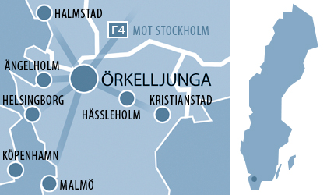

Even if Örkelljunga is small town people are well educated and can speak several languages. There is no big gap between economical situations of people. Our office is central and it is kind of a meeting place for volunteers and people. Local people have positive image about our organization.

How to apply:
Please send partner identification form to Necmettin Meletli neco@ifall.se until 22th of September. We will inform the selected organization after that date.

