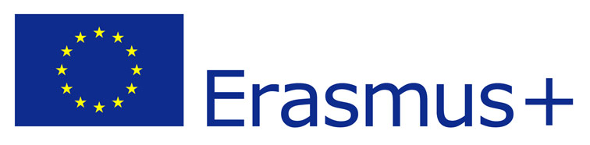
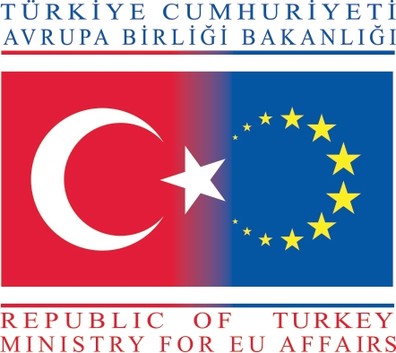
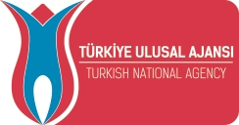

Youth mobility
Youth Exchanges - Partner Countries

“Intercultural Dialogue through Gender Equality”
22- 29 January 2016
Antalya-Turkey

Project Summary

Barrier-free Society and Youth Association will organize a youth exchange on 22–29 January 2016 for young people both for Program and South Mediterranean Countries in Antalya, Turkey.
In spite of progress made at the political level, gender equality issues continues to persist in many parts of the world and violence against women continues to persist in many parts of the world and sometimes a cliché in EuroMed area. We still have a long road ahead of us.
Our main aim is to increase intercultural dialogue around gender issues. We are planning to implement a multilateral youth exchange about gender issues: gender, gender roles in social etc. We believe the importance of learning from each other rather than learning from books or media.
At the end of the youth exchange we hope to promote dialogue among young people and break stereotypes around gender among different cultures and religions.

Target Group
Youth workers are who;
- + 18
- interested in intercultural dialogue and gender equality
- can commit to stay for the whole duration of the project
- can work in English

Budget of the project
The accommodation, food and visa for all participants will be covered in total by project budget.
Travel costs up to limited amounts for countries according to programme rules of Erasmus+. Each participant has to provide us invoice, flight tickets and boarding cards to organizer.

How to become a partner
Eligible partners are who;
- is from a Programme or South Mediterranean country
- is interested in intercultural dialogue and gender equality
- can send 7 participate to the project

If you are interested in the project
Please send us the following 2 forms;
- partnership info table (email the word document)
- mandate form (sing, scan and then email us)(we will ask the originals later)

Contact
Hilal Celik
Email: etgd.proje@gmail.com

