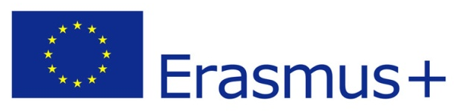

Mobility of Youth Workers–Training Course

“Mixed-ability Training Course for Inclusion of Young People with Disabilities”

31 October – 7 November 2015
Ankara-Turkey

Project Summary

Barrier-free Society and Youth Association will organize a training course on 31 October – 7 November 2015 for youth workers in Ankara, Turkey.
Young people with disabilities are affected by discrimination and face additional barriers in most areas of the society. It is also not easy for young people with disabilities to enjoy the opportunities offered by this European mobility programmes. One out of seven people has some form of disability, but this percentage is not reached amongst young people benefiting from Erasmus+ programme.
The aim of this training course is to train youth workers to think more inclusively and to involve young people with disabilities in their activities and projects. Our target group is youth workers who are interested and motivated to work on disability issues. It is a mixed-ability projects where peers with and without a disability have an experience together and learn from each other. At the end of the training course, we believe we will stimulate the participation of young people with disabilities to youth activities and projects and it will be a life-changing experience for many of our trainees.
The methods of the training course are based on non-formal education. It will be used peer-learning, field visit games, talks, simulations, and other non-formal methods to reach our aim and objectives. We will have 8 different kinds of partners in this project from different experiences, and backgrounds. In this training course, we will be 32 people, from 9 different counties.

Target Group:
Youth workers are who;
- + 18
- Interested in disability issues
- can commit to stay for the whole duration of the project
- can work in English

Budget of the project:
The accommodation, food and visa for all participants will be covered in total by project budget.
Travel costs up to limited amounts for countries according to programme rules of Erasmus+. Each participant has to provide us invoice, flight tickets and boarding cards to organizer.
There will be a Participation fee: 25 € per participants.

How to become a partner:
Eligible partners are who;
- is from a Programme country
- is active on disability issues
- Works or planning to work with young people with disabilities (from physical to learning disabilities)
- can send 3 participate to the project

If you are interested in the project;
Please get your PIC (Participant Identification Code) and let us know. It is a code of your organisation for EU projects. For more info, visit the following website
http://ec.europa.eu/education/participants/portal/desktop/en/home.html

Please send us the following 2 forms;
- partnership info table (email the word document)
- mandate form (sing, scan and then email us)(we will ask the originals later)

Contact:
Hilal Celik
Email: etgd.proje@gmail.com

