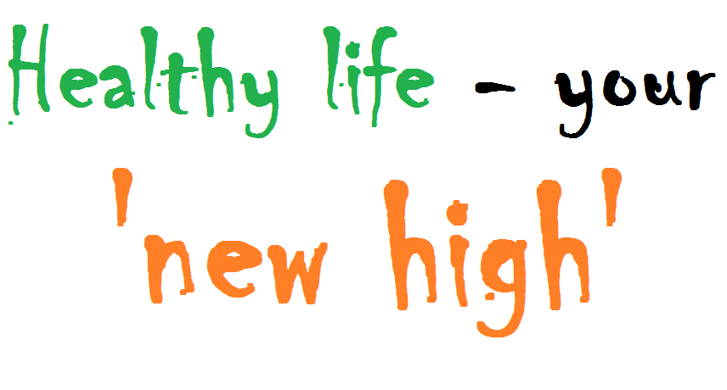

MAIN ACTIVITIES DESCRIPTION
In order to ensure the achievement of the proposed objectives, the promoters planned to develop the following activities by the EVS volunteers involved within the project:
- organizing 8 information campaigns regarding the negative effects of drugs, cigarettes and alcohol consumption in 8 educational institutions from AR and TM for 1000 beneficiaries; in order to develop the campaigns, the volunteers will prepare and realize a general plan of the initiatives, will create a design together with the other stakeholders involved, will identify the target group and will plan the presentation sessions according to the locations, will deliver the presentations and will distribute promotional materials for sustaining their message. Altogether, the volunteers will realize a small evaluation session of the information they delivered to the participants at the end of their presentations and the information campaigns that they will develop. (months 2 -8 of the voluntary stages)

- organizing 8 workshops for promoting a healthy lifestyle in 8 educational institutions from Arad and Timisoara with the participation of 200 youngsters and students; the volunteers will prepare the design of the workshops, will select the target groups, will establish and prepare the future location for the development of the workshops, will prepare the materials and the other resources necessary and will deliver the workshops as well as will evaluate their activities, at the end. (months 2 -8 of the voluntary stages)

- organizing 2 public events in connection with the education and awareness raising of young generation as far as it concerns the negative effects of drugs, cigarettes and alcohol consumption with the occasion World No Tobacco Day (31st of May) and International Day against Drug Abuse and Illicit Trafficking (26th of June); the volunteers will identify other stakeholders with whom they will cooperate, will establish the program of the activities for the respective days, will realize the resource plan, will distribute promotional materials for informing the young population about the events, will support the events by engaging those present and will request for feedback from the participants. During the event, the volunteers will take into consideration the organization of some manifestations, of some debates on the themes proposed as well as a flash mob (months 2-3, respective 4-5)

- prepare, organize and implement sportive activities, for spending free time, games and educational and personal development workshops for 100 young pupils and children during the entire project (months 3-4, 6-9)

- develop an information and awareness raising campaign in connection with the importance of using bicycle as s mean of transportation as well as a method of spending free time in a pleasant and healthy way in the same time among 50 young people (months 3-4, 6-9)

- develop and consolidate a cyclist amateur club with at least 20 members from AR and TM and the organization of 5 connected activities (outdoor tours, cycling events in urban areas as well as in mountain areas from the county etc.) (months 6-9)
During the first month of the voluntary stage, the volunteers will be accommodated with the new hosting communities, will get to meet the local stakeholders and will prepare the proposed activities. The volunteers will come from 4 different countries, the first group being hosted in Arad city and the second one in the city of Timisoara. Besides the planned and mentioned activities, the volunteers will be encouraged to come up with their own initiatives and other ideas for activities and actions for the local community as long as they help achieving the planned objectives. In this way, the promoters will offer the necessary space for the volunteers to exercise their own creativity and their entrepreneurial spirit. The volunteers will be responsible for putting the ideas into practice and achieving the proposed results as well as they will be stimulated to learn on their own, through the method learning by doing and by experimenting.
The role of the partner organizations involved will be to promote the vacant places within the project, to recruit and select together with the coordinating organization the future EVS volunteers who will be engaged. Also, they will assume the task of preparing the volunteers before the voluntary stage by offering them Pre Departure Training as well as support them in connection with all the practical arrangements necessary for the well going of the project. During the voluntary stages, the sending organizations will maintain the contact with the volunteers sent as well as the coordinating organization in order to follow up their progress, the development of the project and will stimulate the volunteers to get involved later on in follow-up activities and dissemination activities of their results and experiences achieved during the voluntary stage, once this will be finished. The partner organizations will also have an important role in the processing of ensuring the visibility and promotion of the activities that the volunteers will be developing as well as the financer in their own countries.
***

ZURY Association
Andrei Șaguna Street bl. A5, 3rd floor, ap. 12
postal code: 300119
Timișoara, Timiș county, Romania
web-site: www.zury.org
e-mail: zury.association@gmail.com

