Mandate

I, the undersigned,

[forename and surname of the legal representative of the partner organisation],

representing,
[full official name of partner organisation] [ACRONYM]
[official legal status or form]
[official registration No]
[full official address]
[VAT number],

hereinafter referred to as "the partner organisation" or "my organisation",

for the purposes of participating in the project Map your piece of Europe! under the Erasmus+ programme (hereinafter referred to as "the project") hereby:
1. Mandate
NOMADWAYS
Association de loi 1901
N° W801002620
1 passage Hédin, 80230 Saint Valery sur Somme, FRANCE
801 341 371 00012 (SIREN)
represented by Anne Merlin, president of the association
(hereinafter referred to as "the coordinator”)
To submit in my name and on behalf of my organisation the project application for funding within the Erasmus+ programme to INJEP in France
hereinafter referred to as "the National Agency”
In case the project is granted by the National Agency, to sign in my name and on behalf of my organisation the grant agreement and its possible subsequent amendments with the National Agency.

2. Mandate the coordinator to act on behalf of my organisation in compliance with the grant agreement.

I hereby confirm that I accept all terms and conditions of the grant agreement and, in particular, all provisions affecting the coordinator and the other beneficiaries. In particular, I acknowledge that, by virtue of this mandate, the coordinator alone is entitled to receive funds from the National Agency and distribute the amounts corresponding to my organisation's participation in the project.

I certify that the information related to my organisation contained in this application is correct and that my organisation has not received/applied for any other EU funding to carry out the activity which is the subject of this project application.

I hereby accept that my organisation will do everything in its power to help the coordinator fulfil its obligations under the grant agreement, and in particular, to provide to the coordinator, on its request, documents or information may be required in relation to the grant agreement.

I hereby declare that the organisation I represent is not in any of the situations of exclusion set out in the project application and that it has the operational and financial capacity to complete the proposed action or work programme as set out in the project application.

I hereby declare to agree on behalf of my organisation that the provisions of the grant agreement shall take precedence over any other agreement between my organisation and the coordinator that may have an effect on the implementation of the grant agreement, including this mandate.

This mandate shall be annexed to the project application and shall form an integral part of the grant agreement in case the project is selected for funding.

SIGNATURE
[forename, surname, function of the legal representative of the partner organisation]

[signature]

Done at [place], [date]
Anne Merlin
NOMADWAYS
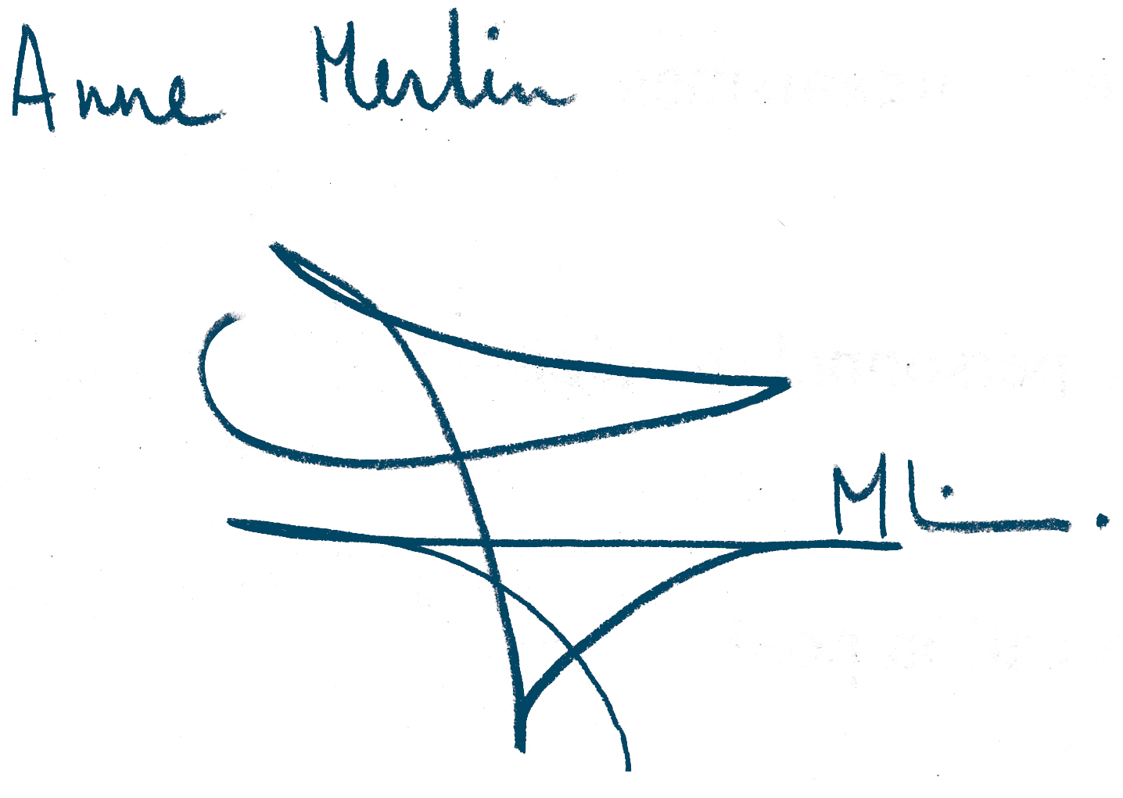

Done at Saint Valery sur Somme, Tuesday the 10th of February 2015

One original version of this Annex to be included for each partner organisation except for the coordinator.
To be deleted or filled in according to the "Legal Entity" form
To be deleted or filled in according to the "Legal Entity" form

