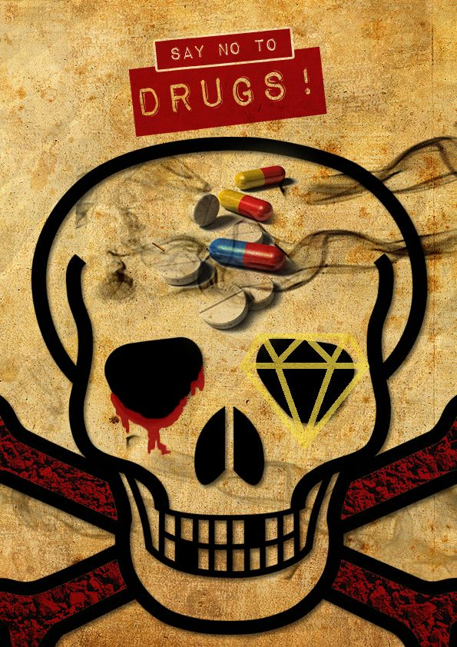

Say No – KA1 Project of Thinker and Talker Youth Group

The main aim of this project is to raise the awareness about drug addiction among young people.To do this we'll use lots of activities before,during and after the project.Raising awarness about this issue is important for us because the treatment of addiction isn't successful most of the time.Only 40% of patients recover.Thus, not starting to use drugs is the best treatment for this matter so we want youngsters to think in that way too.That's why we write this project and we are willing to work with our partners actively in this field.

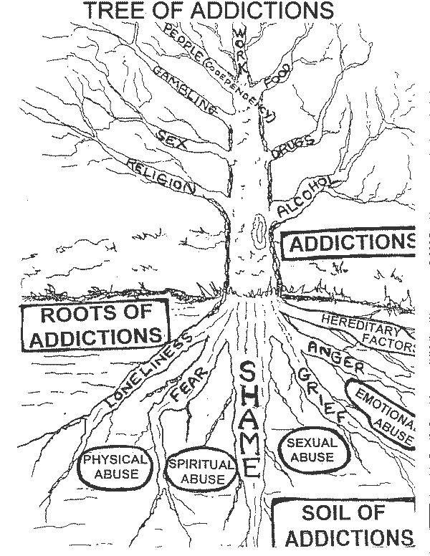

Our project will take 7 days, in Bursa,Turkey.During this 7 days we'll find slogans,have round table discussions,have workshops like photography,short-film making etc.We want 6 people from every partner country (1 leader – 5 young people) For leaders there is no age limit however for youngsters the age gap is 18-25.

Name of the Project : Say NO
Dates: 01 February – 07 February
Location: Bursa, Turkey
Contact Person : Aslı Kara
Email : kara_asli@ymail.com

