**Call for partners**

**KA1-YOUTH EXCHANGE**

[**European Youth Treasure Hunting**](https://www.salto-youth.net/tools/otlas-partner-finding/profile/project/edit/3640/)

**Romania, Brasov, 22-28 June 2015,**

**partner search: Romania, Sweden, Croatia, Poland, Germany, Austria, Greece.**

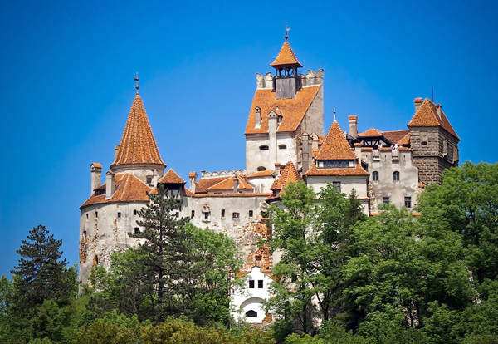

## Name of the project: [European Youth Treasure Hunting](https://www.salto-youth.net/tools/otlas-partner-finding/profile/project/edit/3640/) – mobility as a tool in education.

# **Applicant:** NGO"A bit of happiness" by Youth HUB AUSF

**Place:** Brasov, Romania

**Partners:** 5 participants (4 youngsters 15 - 25 years old, 1 youth worker; it includes young people with limited opportunities - social and economic obstacles) from each partner country - Romania, Sweden, Croatia, Poland, Germany, Austria, Greece.

**22- 28 June 2015, 5 days of activities plus 2 days for traveling**

**Short description:**

Objective: Youth empowerment by self–discovering, learning by doing and travelling.

Contribute to self-motivation discovering, increase entrepreneurial behaviour and career focus.

Make youth aware of the fact they are living, studying, working and having fun together in EU.

**Activities:**

- discover each other

- discover and present themselves

- learn about each partner country, culture and tradition

- european citizenship

- built up personal brand - become visible, online, in writing and in person

- young entrepreneur - own contribution and visit to young local entrepreneur

- explore your future - career options

**Methods**: Nonformal methods of training, debate, workshops, visit, outdoor activities.

**Requirements for partners**: Each participant country should drive one activity in this youth exchange

**Project schedule:**

**Project start: 1 March**

Preparation meeting on Skype: 1 March, signing the partnerships, starting participants selection and travel details

1May – youth workers team in contact

22-28 June – youth exchange

July & August – Evaluation and Dissemination

**Project end: 31 August**