
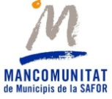
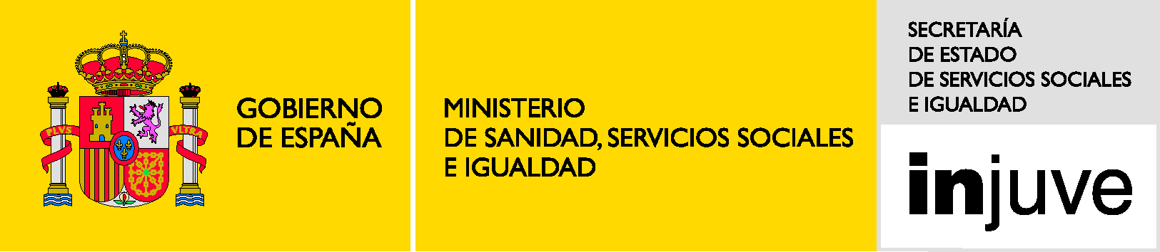
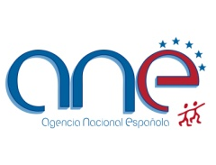
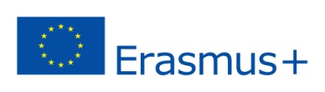

OPEN HANDS TO HUMAN RIGHT

Hello friends!!!

Gandia Youth Council are looking for partners from other countries of Erasmus + Programme to do a project within the framework “KA1 - Mobility of youth workers”. The activities will take place over seven days (excluding travel time) in May 2015 in Gandia (Spain). The profile of participants will be committed youth workers, youth leaders, volunteers and other multipliers from Erasmus + Programme countries and partner countries neighbouring the EU, and they have to be older than 18 years old. The course will be in English.

THE AIMS AND THE OBJECTIVES OF THIS TRAINING COURSE
Disseminate and inform about the Erasmus Plus program through the cohesion of formal education and non-formal. | Promote the active participation of young people in Europe through lifelong learning. | Promotion of active European citizenship. | Unite the different cultures of the different countries participating in the project. | Provide to the municipality of Gandia and young people from other countries the possibility of promoting the development of a cultural and linguistic diversity. | Promoting tolerance of groups at risk of social exclusion (LGBT, gender equality, religion...) | Promote and defend human rights.

METODOLOGY
Non-formal education | Space for ​​active participation | Networking

FINANCES
The travel costs reimbursement will be based on the travel distance that which must be calculated using the distance calculator supported by the European Commission (http://ec.europa.eu/programmes/erasmus-plus/tools/distance_en.htm). | Meals and accommodations are covered 100% as part of the activity.

TO BECOME A PARTNER
Your organization has to be registered on the EU portal (PIC number). | Is very important to upload on the EU portal the proof of legal status and financial capacity. | We need your partner information (background, activities and personal experiences). | We need the legal representative. | We need your logo to make the material. | Send an e-mail to: secretaria@cjg.es with the mandate.
The deadline is 26 SEPTEMBER!!! Should you need any further information, do not hesitate to contact us directly!

Sincerely,

Project coordinator.

