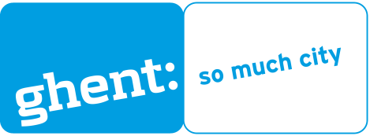 | Albane Vangheluwe  Youth Service City of Ghent, Belgium  Albane.Vangheluwe@gent.be  +32 9 269 81 44

To get a better understanding of your project, please provide us with some extra information on following topics
Name of the organization
City/region and country
Participant Identification Code (PIC) for EU programmes | In order to submit an application Erasmus+, all applicants must provide their PIC. In case you don’t have, you should obtain it by registering your organisation in the Education, Audiovisual, Citizenship and Volunteering Participant Portal
Population
Contact person: Name, email
Role in the organization
Type of organization and main areas of work (Public body/ nonprofit nongovernmental organization/ Nonprofit civil society organization with legal status). Please, provide a short detail of the organization.
Experience in the domain of youth / youth work/ non formal learning/ competence instruments/ urban renewal/ public space
What could be your role and added value to the project?
More info on the urban renewal project that you want to involve young people in (scale, spatial and/or social intervention,…)
How will you organize the participation of youngsters in this project?
What are the links with other Erasmus+-sectors training and/or education?
How will you integrate non formal learning in the above-mentioned project?
Do you already have experience/a method to acknowledge non formal learning?
How many participants do you want to delegate and what are the skills/ expertise/role of the delegated persons involved in this project?
Is there a possibility that the visit can take place in your city?
What is your idea/proposal for a 5 days program of the exchange visit (which type of activities, venue (s), working methods used etc.)
What do you hope to gain out of this exchange for your organization/ city?
Extra information? Notifications?

Thank you very much! Kind regards!

