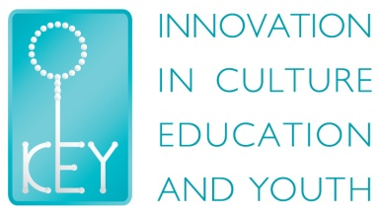

Youth Training

“Youth For Inclusion”

# Limassol, Cyprus, 14/04/2015 – 21/04/2015

**KEY – Innovation in Culture, Education and Youth** is a youth organization promoting non formal learning, active participation of young people in the society, intercultural dialogue and awareness on social issues that influence young people. We are open to all young people who share our vision. Our organization was formed by volunteers and youth workers with experience in non formal education and international youth events and activities.

**“Youth For Inclusion”** is a project that aims to provide the needed support to people who work with youngsters (volunteers, youth workers, project managers, trainers and facilitators of organizations) and at their organizations in the field of social inclusion. The participants (and their organizations) will get the proper training on how to improve the policy regarding social inclusion of young people.

Participants will learn how to implement several activities (such as campaigns, festivals, etc.) in order to be able to contribute at the change of the policy regarding youth social inclusion.

In that way, the participating organizations will be able to raise funds at their countries in order to contribute and affect the policy about youth social inclusion and understand in a better way the issues of young people. This will help the organizations to plan and implement better projects regarding youth social inclusion and more young people will be benefited

**Working Methods**

The implementation of this training will be based on a diversity of non-formal education methods (like role play, debate, indoor and outdoor activities, simulation games and case studies), encouraging the participants for active participation, self expression and share of good practices. Also, the participants will have the opportunity to show their skills and team spirit. This process will lead to the creation of dissemination and exploitation activities for their projects and build strategies and develop competences.

**Practical information**

**Dates: 7 days**

**Starting**: Tuesday, 14/04/2015

**Ending**: Tuesday, 21/04/2015

**Venue:**

* Hosting Facilities in Limassol Region

**Participants:**

* Maximum 24 participants from 8 countries (3 Participants per country)
* Participants with knowledge of English Language

**Registration**

* Visa costs of selected participants will be covered by the sending National Agencies. Please check with your National Agency if any additional participation conditions apply.
* Part of Travel Expenses and Full Hosting costs (accommodation, food, programme activities, local transport) will be covered by the Hosting Organization.

**Information**

Deadline for applications : 22 September 2014

Panayiotis Panagides: E-mail: [ppanagides@yahoo.com](mailto:ppanagides@yahoo.com) or [keycyyouth@gmail.com](mailto:keycyyouth@gmail.com)