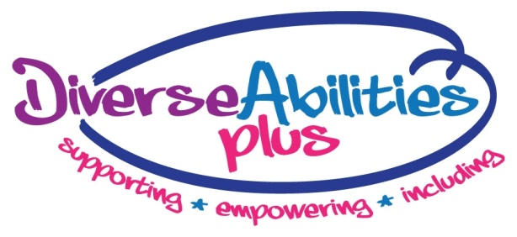

**DIVERSE ABILITIES PLUS**

**EVS APPLICATION FORM**

Diverse Abilities Plus is an independent charity in Dorset which since 1955 has provided support and education services for children and adults across the county with physical and learning difficulties. We are the only local charity that endeavours to be a ‘lifetime partner’ providing support from childhood to adulthood and empowering all the people we support to lead happy, secure, independent lives.

Diverse Abilities Plus offers a range of services to the people we support:

Children’s services:

• A dedicated specialist day school for children between the ages of 2-19 with profound disabilities

• A short-stay residential home providing short breaks for up to 4 children or young people with complex physical and/or learning difficulties, often with associated health issues

• A domiciliary service for children and young people offering flexible support with individual tailored programmes

• A comprehensive holiday, after school and weekend activity programme for children and young people with disabilities between the ages of 8 – 18

• Support and signposting, school holiday activities, a Youth Club and a Parent Befriending Service for families with a child or children with disabilities.

Adult services:

• A day service for adults with disabilities providing opportunities for socialising and trying new skills and experiences

• Individual supported living with dedicated 24/7 support for adults in homes fully equipped to address individual requirements.

Advice:

• An advocacy and advisory service, helping people with disabilities with benefit claims, advocacy and power of attorney.

**Part A) You and your Sending Organisation**

|  |  |
| --- | --- |
| **Your Details** | **Sending Organisation Details** |
| **Name:** | **Name:** |
| **Surname:** | **Address:** |
| **Age:** |  |
| **Gender:** | **Postcode:** |
| **Country:** | **Country:** |
| **Phone:** | **Phone:** |
| **Email:** | **Email:** |

**How would you rate your English skills?**

|  |  |  |
| --- | --- | --- |
| **Spoken** | **Written** | **Understanding** |
|  |  |  |

**Part B) Your motivation**

**1) Why are you interested in volunteering for a year abroad and why do you believe volunteering is important? (200 words max.)**

|  |
| --- |
|  |

**2) Why did you choose England for your EVS? (100 words max.)**

|  |
| --- |
|  |

**3) Why did you choose this particular project? (200 words max.)**

|  |
| --- |
|  |

**4) What is your interest in disability? Why do you think it is important to support people with disabilities? (200 words max.)**

|  |
| --- |
|  |

**5) What would you like to gain from the year and what are your plans afterwards? (200 words max.)**

|  |
| --- |
|  |

**Part C) Your experience and opinions**

**6) What experience do you have in fundraising? (200 words max.)**

|  |
| --- |
|  |

**7) What do you think are the main reasons people donate to charitable organisations? (200 words max.)**

|  |
| --- |
|  |

**8) What strengths will you bring to our organisation? (200 words max.)**

|  |
| --- |
|  |

**Part D) Other information**

**9) Do you have any additional support needs? If yes, please describe**

|  |
| --- |
|  |

**10) Additional information – please use this box to tell us anything else in support of your application**

|  |
| --- |
|  |

**Please email completed application to** [**sarah.harrison@diverseabilitiesplus.org.uk**](mailto:sarah.harrison@diverseabilitiesplus.org.uk)

**by 19th September 2014.**